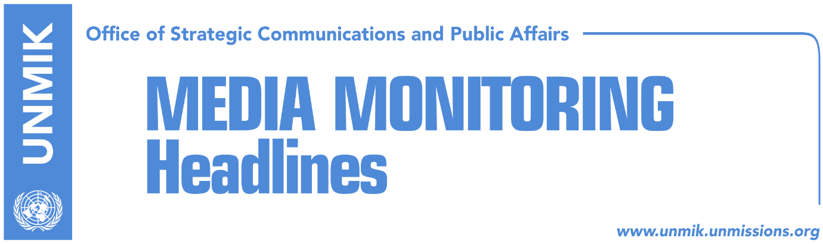

Main Stories 11 November 2017

- Sputnik: Kosovo supported by U.S. to ask for deadline on dialogue (Lajmi)
- MPs seek new resolution for the next phase of dialogue (RFE, RTK)
- Diettmann: Kosovo should become UN Member (NIN, RTK)
- Apostolova reiterates: Kosovo should combat corruption (Lajmi)
- Minister Hasani ready for Belgrade, in CEFTA without UNMIK (Klan Kosova)

Kosovo Media Highlights

Sputnik: Kosovo supported by U.S. to ask for deadline on dialogue (Lajmi)
The United States of America request for the dialogue between Pristina and Belgrade to conclude within 18 months and to be proceeded with an international conference. According to Sputnik, Pristina has already submitted a proposal to the European countries which seeks a deadline on Brussels Agreements. According to Sputnik, the proposal suggests an optimal period of 18 months to conclude the dialogue with Belgrade, which should proceed with an international conference.

“Pristina has already received positive response from some countries, but not from the main one, Germany,” notes the article.
According to the article, the proposal was made by Kosovo’s Deputy Prime Minister, Enver Hoxhaj.

For the next year, the proposal foresees discussions on the position of Serb community in Kosovo, resolution for the joint debts issue, property issue and Kosovo’s membership at the United Nations.

MPs seek new resolution for the next phase of dialogue (RFE, RTK)
Kosovo Assembly MPs from both govern and opposition political parties, consider that the legislation should endorse a new resolution which would determine the new phase of the dialogue with Serbia, the level of representation and responsibilities of the representative.

Kosovo Assembly MP from the Alliance for the Future of Kosovo (AAK), Ahmet Isufi, told Radio Free Europe that there is a need for a national consensus that would determine the format of the discussions and a platform that would guarantee protection of Kosovo’s interests. According to him, this requires consent among the political leaders. “The Assembly should come up with e resolution which would authorize state authorities on how should the dialogue proceed and who would represent Kosovo,” Isufi said.
Driton Selmanaj, MP from the Democratic League of Kosovo (LDK), also considers that a new resolution of the Assembly of Kosovo is required. He also considers that the Assembly should examine the situation of implementation of the reached agreements and benefits from the process.

Diettmann: Kosovo should become UN Member (NIN, RTK)
German Ambassador to Serbia, Axel Dittmann, told NIN magazine in Belgrade that Germany has recognized Kosovo, therefore it supports its membership at all international organisations, including the United Nations.
“The negotiating framework for which Serbia has given its consent, determines that one of the conditions for Serbia's accession to the EU is a comprehensive normalization of relations, including the signing of a legally binding agreement. Serbia has taken a strategic decision to become a member of the European Union and the Union supports it in implementing the reforms and achieving this goal," Ambassador Dietmann reportedly said.

Apostolova reiterates: Kosovo should combat corruption (Lajmi)
The EU Representative to Kosovo, Nataiya Apostolova praised the efforts of the government of Kosovo on moving forward with the Agenda of European Reforms. However, she also mentioned major problems of Kosovo stressing that local authorities should be doing more in the war against organized crime and corruption as well as on building independent judiciary. During the conference “European Reform Agenda: Progress report on good governance and rule of law,” Apostolova also said that financing of political parties and nomination of independent bodies also continue to be a problem.

Minister Hasani ready for Belgrade, in CEFTA without UNMIK (Klan Kosova)
Kosovo’ Minister for Trade and Industry Bajram Hasani, will be participating in two weeks at the CEFTA meeting of Ministers from the member countries of the region. Since 2007, Kosovo was represented there by UNMIK however, this time the Minister will request there for Kosovo to be represented without UNMIK. “We consider that the easiest way would have been for UNMIK to give up this agreement in order to leave space to Kosovo to be represented; however, if UNMIK does not do this, and we have requested also from the Office of the European Union to make pressure on UNMIK to give up, there is the second way, that of recognition of Kosovo by each country separately,” he said. Hasani said that CEFTA Secretariat and diplomatic representatives are already informed about Kosovo’s intention. He warned that if UNMIK logo will continue to be present at these meetings, Kosovo will consider leaving CEFTA and added that this is not a decision only of his ministry but that steps are coordinated with the Prime Minister of Kosovo.
“I have not heard about this plan at the UN Mission in Kosovo,” said an UNMIK spokesperson. The Office of the European Union in Kosovo did not respond to the question on this matter.

Disclaimer
This media summary consists of selected local media articles for the information of UN personnel. The public distribution of this media summary is a courtesy service extended by UNMIK on the understanding that the choice of articles translated is exclusive, and the contents do not represent anything other than a selection of articles likely to be of interest to a United Nations readership. The inclusion of articles in this summary does not imply endorsement by UNMIK.

