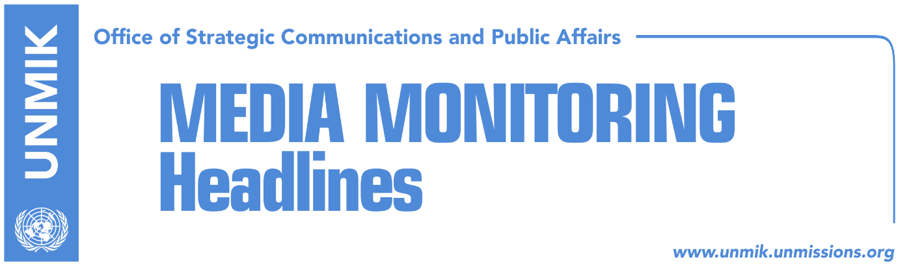

Main Stories 13 November 2017

- Hoxhaj: Dialogue between Kosovo and Serbia to have a deadline (Express)
- Bulliqi to present findings on demarcation today (RTK)
- Jevtic: No more justifications, time to establish association (Tanjug/Telegrafi)
- Simic: We are part of Serbian team in Brussels dialogue (Epoka)
- Government alarmed by threat from Kosovars returning from Syria (Koha)
- FYROM reacts against Haradinaj’s decision on Kumanova case (Telegrafi)

Kosovo Media Highlights

Hoxhaj: Dialogue between Kosovo and Serbia to have a deadline (Express)
Deputy Prime Minister of Kosovo, Enver Hoxhaj, has requested for the dialogue between Pristina and Belgrade to have a deadline instead of continuing eternally. He said that the result of this process should be Kosovo’s membership at the United Nations and mutual recognition. He considers that except for the government, the Parliament and the President should also be involved. He said that he has requested a deadline for the dialogue three years ago. “The European Union should put much more pressure on Serbia so that dialogue can maintain its credibility. The parties can safeguard international prestige if we move on to the final phase which should conclude with a peaceful agreement, Kosovo’s membership at the United Nations and mutual recognition,” he said.

Bulliqi to present findings on demarcation today (RTK)
Head of the State Commission for Demarcation and Maintenance of the Border, Shpejtim Bulliqi, will present today to the Kosovo Assembly Commission for European Integration, the findings from the field on demarcation of the border with Montenegro. A few days ago, members of this Commission informed Prime Minister Ramush Haradinaj about their work on collecting and processing of the data from the field as well as from their visit to Croatia and Slovenia.

Jevtic: No more justifications, time to establish association (Tanjug/Telegrafi)
Deputy Prime Minister of Kosovo and Minister for Communities and Returns, Dalibor Jevtic, spoke from Belgrade about the establishment of the Association of Serb-majority Municipalities. He said that there will be no more justifications, nor impeding of the establishment of the Association. “The fact is that we have had the parliamentary and local elections, and this can be the reason that some significant processes have been interrupted,” he said. “I think that there are no more justifications and this is important. Establishment of the Association of the Serb Municipalities should establish in a concrete manner as signed and agreed in Brussels,” Jevtic said.

Simic: We are part of Serbian team in Brussels dialogue (Epoka)
Igor Simic, Kosovo Assembly MP from the Serbian List, told Radio Free Europe that establishment of the Association of the Serb-majority Municipalities will be very soon in the agenda. He assesses the internal dialogue in Serbia as a good chance where everyone can clearly express their position. Simic said that the Serbian List is part of the Belgrade team in the Brussels dialogue, and according to him, his party will never offer support for constitutional changes, required for transformation of the Kosovo Security Force.

Government alarmed by threat from Kosovars returning from Syria (Koha)
The paper reports on its front page that the Kosovo government fears Kosovars that have returned from conflict zones in the Middle East and views them as actors of potential terror attacks in the country. The government has included this alarm in its 2018-2022 anti-terror state strategy. “Despite the fact that terror organizations are losing ground and control in conflict zones, ideologically they continue to have support and influence in other countries, including the region,” the draft strategy notes. “Kosovo faces the threat from people that have returned from conflict zones, and people involved in terror acts, who are interested to damage Kosovo as a country with ethnic and religious diversity and a democratic government and secular society. As we have seen from many examples in Europe, radicalized individuals can carry out acts of extreme violence against the people and institutions in their own countries, therefore, we cannot rule out terror attacks in Kosovo too”.

FYROM reacts against Haradinaj’s decision on Kumanova case (Telegrafi)
The government of the former Yugoslav Republic of Macedonia (FYROM) has reacted against the decision of the Kosovo government to allocate funds for the families of the convicted group in the so-called Kumanova case saying it is in conflict with European values. FYROM Foreign Minister, Nikola Dimitrov, said in a meeting with Kosovo’s Minister for European Integration, Dhurata Hoxha, that the decision goes against the spirit of the region’s European perspective. Last Friday, the government of Kosovo, decided to allocate €290,000 as support for families of convicted persons from Kosovo in the Kumanova case.

Disclaimer
This media summary consists of selected local media articles for the information of UN personnel. The public distribution of this media summary is a courtesy service extended by UNMIK on the understanding that the choice of articles translated is exclusive, and the contents do not represent anything other than a selection of articles likely to be of interest to a United Nations readership. The inclusion of articles in this summary does not imply endorsement by UNMIK.

