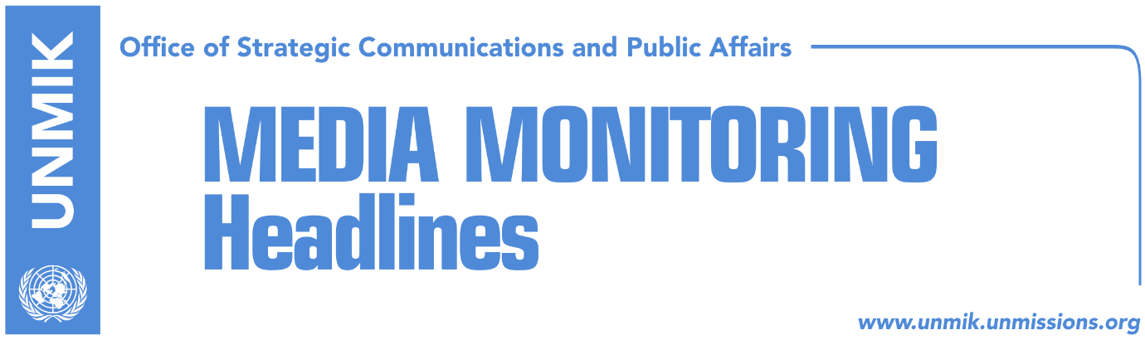

Main Stories 14 November 2017

- Thaci: Border agreement, accurate and professional (Telegrafi)
- Mustafa: New commission must present facts it said it has (Koha)
- Analysts: Demarcation causes rift between coalition parties (Zeri)
- Orthodox Church wins court battle for land in Pristina (Kallxo/Insajderi)
- EU disagrees with Kosovo’s threat to leave CEFTA (Koha)
- Orthodox Church wins court battle for land in Pristina (Kallxo/Insajderi)
- Serbia alarmed: Izetbegovic claims Bosnia might recognize Kosovo (Epoka)

Kosovo Media Highlights

Thaci: Border agreement, accurate and professional (Telegrafi)
In his remarks at the conference “NATO and the Western Balkans: Regional Dynamic in the Era of Global Security Challenges”, President of Kosovo Hashim Thaci said that the border demarcation agreement with Montenegro is “good, clear, accurate, professionally elaborated and supported by international community.” Thaci said any attempt to discredit the agreement is a waste of time and damages Kosovo’s Euro-Atlantic perspective.

Mustafa: New commission must present facts it said it has (Koha)
Isa Mustafa, leader of the Democratic League of Kosovo (LDK) and former Prime Minister when the border demarcation agreement with Montenegro was signed, said on Monday that the citizens of Peja and the Rugova region know where the border with Montenegro is. “They reelected their mayor [Gazmend Muhaxherri] who without hesitation argued that the border lies as defined by the State Commission. The question arises why these professors and other members of the new government commission say they have facts and documents that Kosovo has lost 8,000 hectares of land. They need to present their facts,” Mustafa wrote in a Facebook post.

Analysts: Demarcation causes rift between coalition parties (Zeri)
Political analysts said the border demarcation agreement with Montenegro has caused the first cracks in the coalition between the Democratic Party of Kosovo (PDK) and the Alliance for the Future of Kosovo (AAK). Yesterday, head of the government’s commission on border demarcation, Shpejtim Bulliqi, told a parliamentary committee that Kosovo has lost land to Montenegro through the 2015 agreement. PDK MPs said Bulliqi failed to present any new findings while AAK urged the commission to continue its work responsibly and without time constraints. Analyst Mazllum Baraliu admits the issue is seen differently by PDK and AAK but considers it not likely to be cause for coalition’s break-up. Imer Mushkolaj, meanwhile, said PDK’s reaction is expected as the party has consistently maintained support for the 2015 agreement.

EU disagrees with Kosovo’s threat to leave CEFTA (Koha)
The European Union opposes Kosovo’s threat to leave the Central European Free Trade Agreement (CEFTA) because of UNMIK’s presence, Pristina-based TV station KTV reported on Monday evening. The EU Office in Pristina has reminded Kosovo’s road toward the European family includes fostering good relations with neighboring countries and that any concern about the rules of this agreement should be addressed through the CEFTA Secretariat. The EU Office however did not reply to the TV station’s question when Kosovo will be represented on its own as foreseen by the Brussels agreement.

Orthodox Church wins court battle for land in Pristina (Kallxo/Insajderi)
The Court of Appeal has upheld a previous ruling granting the Orthodox Church ownership over the land inside the University of Pristina campus which the latter claims as its own. The ruling is said to have been made as a result of absence of University of Pristina representatives at the court hearing.

Serbia alarmed: Izetbegovic claims Bosnia might recognize Kosovo (Epoka)
Member of the Presidency of Bosnia and Herzegovina, Bakir Izetbegovic, said that his country might recognize Kosovo. This has caused harsh reactions in Serbia. Nebojsa Stefanovic, Minister of the Internal Affairs in Serbia, said that the President of Serbia should gather the National Security Council within 48 hours. “This body will consider further steps and our position to such movements,” Stefanovic said. According to him, such statements worsen the relations between Bosnia and Herzegovina and Serbia. “I do not know if he understands that such statements complicate the situation in the region, especially after all the signals of cooperation between the two countries,” Stefanovic said. The President of Republika Srpska, Milorad Dodik, said that Bosnia and Herzegovina will not recognize Kosovo. “Kosovo will not be recognized, especially not if Izetbegovic says so, because recognition depends on Republika Srpska. I can say that recognition of Kosovo depends more on me than on Izetbegovic. He is a failed politician, who speaks about the same issues his father did, and which preceded a war in the region,” Dodik said.

Disclaimer
This media summary consists of selected local media articles for the information of UN personnel. The public distribution of this media summary is a courtesy service extended by UNMIK on the understanding that the choice of articles translated is exclusive, and the contents do not represent anything other than a selection of articles likely to be of interest to a United Nations readership. The inclusion of articles in this summary does not imply endorsement by UNMIK.

