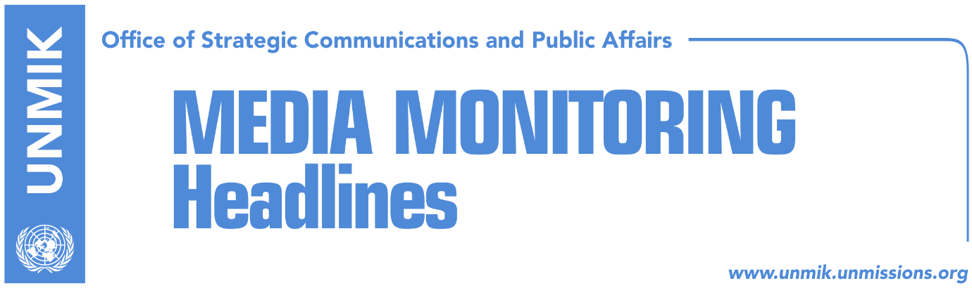

Main Stories 15 November 2017

- The U.S. Embassy disappointed on border commission report (media)
- UN Security Council discusses Kosovo (dailies)
- Schwendiman: No one can intimidate me (Koha Ditore)
- UP with new legal procedure against Serb Orthodox Church (Epoka)
- COMKFOR: KFOR’s presence in Kosovo has no time limit (Koha Ditore)
- Prosecution: Lumezi’s file was not forged (Epoka)

Kosovo Media Highlights

The U.S. Embassy disappointed on border commission report (media)
The U.S. Embassy has issued a press release which expresses disappointment on the new border commission’s report to the Assembly Committee on European Integration. “Its assertions are unsubstantiated, misleading, and wrong. The existing agreement reflects an accurate process of determining the border, confirmed by Kosovo’s state commission and numerous internationally recognized experts. In 2015, the State Department confirmed that the original agreement accurately reflected the boundary that has existed between Kosovo and Montenegro since 1974. No facts have emerged since to call that decision into question. Questioning the agreement and dragging out the process of ratification threatens Kosovo’s relationships with its neighbors and the EU, and leaves Kosovo and its citizens isolated. It is time for Kosovo’s institutions to work to promote the interests of Kosovo’s citizens in this matter. We urge Kosovo’s politicians to look beyond their personal partisan interests and party politics and focus on the needs of their citizens by ratifying the existing agreement as soon as possible,” notes the press release.

UN Security Council discusses Kosovo (dailies)
Media, both print and online, cover yesterday’s session of the UN Security Council on Kosovo, most of which highlight ambassador Vlora Citaku’s address where she said that Kosovo remains strongly committed to the EU-facilitated dialogue with Serbia and criticized Serbia for hindering Kosovo’s membership to Interpol and UNESCO saying the decision of Chinese authorities not to grant visas to Kosovo officials largely contributed to the withdrawal from Interpol bid. Citaku disputed figures presented by Belgrade authorities that the number of displaced Serbs is 200,000 saying they were inaccurate. She also requested redefinition of the UN’s role in Kosovo saying the mission is of a peacekeeping nature and peace has already been achieved in Kosovo. Bota Sot quotes Citaku as saying that no one can place a veto on creation of Kosovo armed forces.

Serbia’s Foreign Minister, Ivica Dacic, on his part criticized authorities in Kosovo for not establishing the Association/Community of Serb-majority municipalities and urged them to do so as soon as possible.

Meanwhile, most media highlight the statement of the Special Representative of the UN Secretary-General and UNMIK chief, Zahir Tanin, saying that the time for action now moves ahead of the time for excuses. SRSG Tanin said that signs of political will and commitment to move forward are increasingly evident. Tanin commended the parties for integration of Serb judges and prosecutors to the Kosovo’s justice system while with regards to CEFTA, he underlined that Pristina representatives attend all meetings and that UNMIK’s presence is limited by legal statutes. “This participation continues strictly to the extent required by CEFTA members to ensure its functionality, which in turn supports economic opportunity throughout the region,” Tanin said.

Deputy U.S. Ambassador to the UN, Michele Sison said the recent elections in Kosovo are an indicator of progress. She noted that the U.S. continues to support the dialogue for normalization of relations between Pristina and Belgrade. She also said it was time for UN to change its mission and also reduce the frequency of Security Council reporting.

The Ambassador of the United Kingdom at the United Nations, Matthew Rycroft, supported the initiative of the United States, France and Kosovo to change the format of the UN mission in Kosovo. “It is time for UNMIK to work less and not more,” said the UK diplomat adding that Britain is disappointed that this initiative is not receiving support of the other parties.

The Russian Ambassador to the UN, Vasilly Nebenzia, said Moscow does not share the optimistic picture Citaku presented at the session. He said dialogue between Belgrade and Pristina is stalling and that events in Kosovo risk presenting a threat for the whole region. “The project of the Republic of Kosovo has clearly failed,” said the Russian representative. He said the creation of a Kosovo army is in “direct conflict” to the UN SC resolution 1244.

On the other hand, Deputy Ambassador of China, WU Haitao appealed to the involved parties “in the process of the solution of crisis in Kosovo” to refrain from inflammatory rhetoric, stressing that Resolution 1244 is an excellent framework for dialogue.

Schwendiman: No one can intimidate me (Koha Ditore)
David Schwendiman, Specialist Prosecutor with the specialist chambers, said he would do his outmost to protect witnesses of crimes alleged to have been committed by former Kosovo Liberation Army members. In a meeting with reporters in The Hague, Schwendiman said his office is aware of the danger potential witnesses face and that he would not be taking instructions from anyone in carrying out his duties. “No one can tell me what to do. No one can have influence over me. No one can intimidate me,” Schwendiman said.

UP with new legal procedure against Serb Orthodox Church (Epoka)
Court of appeals in Pristina has confirmed the verdict of the Basic Court in Pristina which has decided that the space of four hectares within University of Pristina campus, belongs to the Serb Orthodox Church. However, General Secretary of the Pristina University Rectorate, Esat Kelmendi, told Radio Free Europe that the matter is not over and that by the end of this week, the University will request for the legal process to return at point zero. “The current management will again initiate the procedure at the Basic Court. It will raise new charges because, luckily, rejection of our accusation does not mean loss of the right to raise new charges. The University of Pristina is preparing a new file and I believe that by the end of the week we will press new charges at the competent Court,” Kelmendi said.

COMKFOR: KFOR’s presence in Kosovo has no time limit (Koha Ditore)
KFOR Commander, Major General Giovanni Fungo, said in a farewell press briefing that the presence of NATO peacekeeping troops in Kosovo is not tied to any timeframe and that once certain conditions are met, “we will change the structure, the mission and the tasks.” COMKFOR also noted he doesn’t see Serbia as a threat to security in Kosovo and commended Kosovo institutions for measures against foreign fighters. Asked about transformation of the Kosovo Security Force (KSF), Major General Fungo reaffirmed the view that the process should take place through constitutional changes.

Prosecution: Lumezi’s file was not forged (Epoka)
The Basic Prosecution in Pristina, department for Serious Crimes, has concluded collection of information and required facts related to the claims of the former Rector of Pristina University, Enver Hasani, that the file Aleksander Lumezi, Chief Prosecutor of Kosovo, on the judicial exam was forged. A press release issued by the Prosecutorial Council of Kosovo says that investigations on this case were commenced by a local prosecutor under continuous monitoring of a EULEX prosecutor. “After detailed analyses of all information and gathered evidence, as well as statement by all official individuals, who were responsible for administration of the process, and application and registration of the bar examination as well as issuing of certificates for passing this exam in the nineties, the Basic Prosecution has concluded that Mr. Hasani’s claims are not true, as they are not based on facts and gathered evidence.

Disclaimer
This media summary consists of selected local media articles for the information of UN personnel. The public distribution of this media summary is a courtesy service extended by UNMIK on the understanding that the choice of articles translated is exclusive, and the contents do not represent anything other than a selection of articles likely to be of interest to a United Nations readership. The inclusion of articles in this summary does not imply endorsement by UNMIK.

