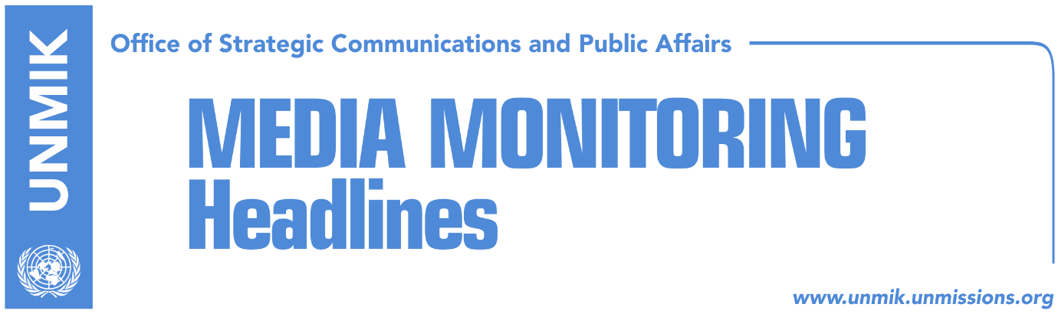

Main Stories 16 November 2017

- Border demarcation not in Haradinaj’s Brussels agenda (RTV21/Telegrafi)
- Collaku: Only ratification of demarcation ends isolation (media)
- Findings on demarcation require further analysis (Epoka)
- Foggo: Border demarcation to be resolved through productive dialogue (RTK)
- SL cuts off communication with Thaci under Belgrade’s directives (RFE/Zeri)
- Vucic implies difficult decisions on Kosovo (media)
- Stoltenberg: Changes to KSF mandate only according to Constitution (Koha)

Kosovo Media Highlights

Border demarcation not in Haradinaj’s Brussels agenda (RTV21/Telegrafi)
Kosovo government spokesperson, Arber Vllahiu, said that the main focus of Prime Minister Ramush Haradinaj’s visit to Brussels is the Stabilisation and Association Agreement (SAA) while the border demarcation with Montenegro issue is not in his agenda. However, Vllahiu did not rule out the possibility of the border demarcation coming up in bilateral meetings PM Haradinaj is to have with EU senior officials. Media also report that ahead of his trip to Brussels, Haradinaj met President Hashim Thaci at the Pristina Airport.

Collaku: Only ratification of demarcation ends isolation (media)
Bekim Collaku, Chief of Staff of Kosovo President Hashim Thaci, told Gazeta Express on Wednesday that ratifying the border demarcation deal with Montenegro without wasting anymore time is the only option to end isolation for Kosovars and to secure further support from the European Union. Collaku said it was critical to ratify the deal now as the EU is preparing a new enlargement strategy for Western Balkans countries. He further said that not only the EU but Kosovo’s state institutions too are responsible for the delay, as they have failed to meet their obligations on the matter. Collaku also said he was pessimistic that the new state commission for the border delineation will bring new facts.

Findings on demarcation require further analysis (Epoka)
Florim Isufi, member of the Border Demarcation Commission, told the paper on Wednesday that this commission has found some facts that contest the current versio of the border demarcation agreement with Montenegro. Isufi did not comment on the new facts saying only that they require detailed and authentic analysis. He also said that the commission will very soon come up on the border demarcation with Montenegro.

Foggo: Border demarcation to be resolved through productive dialogue (RTK)
Admiral James Foggo, Commander of the Joint NATO Forces in Naples, said that demarcation of the border between Kosovo and Montenegro is a matter that should resolve through productive dialogue. “I think that having a NATO member state for a neighbor is a good thing for Kosovo. Therefore, I welcome a productive dialogue between the government of Kosovo and the government of Montenegro,” said Foggo adding that dialogue is important and there is a need for discussions. Speaking about transformation of the Kosovo Security Force into armed forces, Foggo said that this is a process that should not happen without constitutional changes. “I think that this is something that both your President and your Parliament understand. This is not a decision that I or we can make in this case, but it is within Kosovo institutions. Because NATO is also more than interested to do something on coordination with the Constitution of Kosovo in order for KSF to transform into something that you want,” Foggo said.

SL cuts off communication with Thaci under Belgrade’s directives (RFE/Zeri)
Days ago, the Serbian List has announced it was cutting off all forms of communication with President of Kosovo, Hashim Thaci, whom they accuse of unconstitutional policies that damage the Serb community. Bekim Collaku, Thaci’s chief of staff, said the Serbian List’s move was unexpected while the allegations contained in a letter to Thaci are groundless. “I think the only author of this letter is the government of Serbia which initiated and imposed such a decision,” Collaku told RFE. Analysts meanwhile, see the Serbian List’s action as a way of pressuring Kosovo institutions into implementing obligations from the Brussels agreement as soon as possible.

Vucic implies difficult decisions on Kosovo (media)
Serbian President Aleksandar Vucic said on Wednesday after meeting EU High Representative Federica Mogherini, that dialogue between Belgrade and Pristina must continue but only under the patronage of the European Union. Vucic’s remarks were a response to Pristina’s request for the United States of America to be involved as mediators of the Brussels dialogue. Vucic told reporters after the meeting that a difficult period awaits Serbia vis-à-vis Kosovo and added that the further normalization of relations with Kosovo is a condition for opening and concluding chapters for EU membership. Pristina-based news website Gazeta Express covers the meeting under the headline Mogherini reminds Vucic: You cannot join EU without recognizing Kosovo.

Stoltenberg: Changes to KSF mandate only according to Constitution (Koha)
NATO chief Jens Stoltenberg reiterated on Wednesday that Kosovo’s army cannot be formed by ignoring the Constitution of Kosovo. “I have made it clear on several occasions: any change to the mandate of the Kosovo Security Force needs to be done in accordance with the Constitution and it requires constitutional amendments. This is our approach: any transformation must be done in line with the Constitution,” Stoltenberg said after meeting Serbian President Aleksandar Vucic in Brussels.

Disclaimer
This media summary consists of selected local media articles for the information of UN personnel. The public distribution of this media summary is a courtesy service extended by UNMIK on the understanding that the choice of articles translated is exclusive, and the contents do not represent anything other than a selection of articles likely to be of interest to a United Nations readership. The inclusion of articles in this summary does not imply endorsement by UNMIK.

