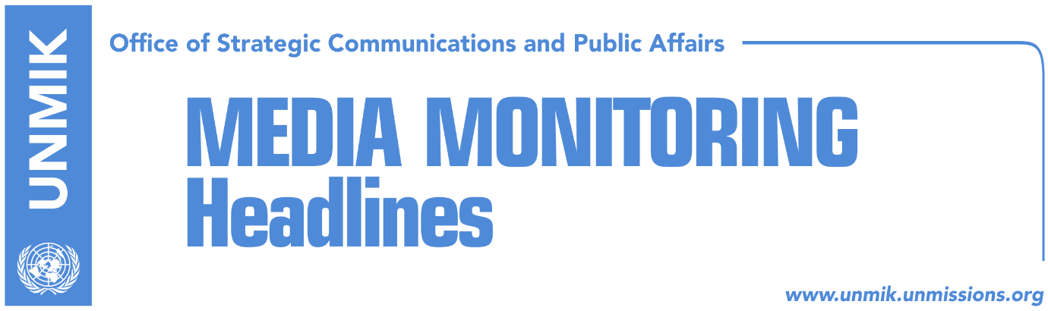

Main Stories 29 November 2017

- EU: Pristina and Belgrade decide on the format of the dialogue (RTK)
- Kosovo’s borders changed in EU documents (Koha Ditore)
- LDK and PDK with complaints for Pristina, Prizren and Dragash (Epoka)
- Kosovo fails to remove UNMIK from CEFTA preamble (Koha Ditore)
- Pacolli visits the U.S. (Epoka)
- Cooper: Everyone should agree to KSF transformation (RTK)
- Explosive and weapons smuggled through Pristina Airport (Koha)

Kosovo Media Highlights

EU: Pristina and Belgrade decide on the format of the dialogue (RTK)
Maja Kocijancic, Spokesperson of the EU High Representative for Foreign Policy and Security, said on Tuesday that any change of the format of the dialogue between Pristina and Belgrade, including involvement of the United States, should be supported by both parties. The European Union is a facilitator of the dialogue. It belongs to the two parties to agree on the content, format, speed or agenda,” Kocijancic said. She added that Brussels and Washington are in close cooperation with regards to all activities related to Western Balkans, and this according to her, implies the dialogue between Kosovo and Serbia.

Kosovo’s borders changed in EU documents (Koha Ditore)
The paper reports on the front page that Kosovo has filed a statement to the European Commission objecting to the way its borders were depicted in the Transport Community Treaty with the Western Balkans. The issue was confirmed by the Kosovo’s Ministry of Foreign Affairs but its officials did not specify where the problem lies exactly. The Ministry did also not explain why it signed the treaty if Kosovo borders were not depicted accurately in it. The paper also reached out to the European Commission for comment but did not receive one.

LDK and PDK with complaints for Pristina, Prizren and Dragash (Epoka)
Kosovo’s Central Election Commission is expected to announce today the final results of the local mayoral elections, however, some of the political parties have warned that they would not recognize current results and that they will continue with complaints at respective institutions. The Democratic League of Kosovo (LDK) contests the election results in Pristina and Dragash, while the Democratic Party of Kosovo (PDK) those in Prizren. PDK deputy leader, Memli Krasniqi said his party will follow legal procedures after the announcement of the results. LDK has also explained through a press release that they will use all constitutional and legal mechanisms in defense of people’s will expressed during local elections, especially in places such as Pristina and Dragash, “where irregularities were evidenced.”

Kosovo fails to remove UNMIK from CEFTA preamble (Koha Ditore)
Kosovo will continue to be represented through UNMIK at the Central European Free Trade Agreement (CEFTA) after Serbia refused to accept Kosovo being represented as an equal party to the agreement, the paper reports. Kosovo’s Minister of Trade and Industry, Bajram Hasani, said the proposal of Kosovo being represented through a footnote was raised at the recent CEFTA meeting but “the Serbian side opposed the idea saying it needed additional consultations.” Hasani also said that the idea of Kosovo leaving CEFTA as sign of protest, once supported by him, was not on the table anymore for the fact that Kosovo is now in a more favourable position being that it will chair CEFTA meetings in 2018.

Pacolli visits the U.S. (Epoka)
Deputy Prime Minister of Kosovo, and Minister for Foreign Affairs, Behgjet Pacolli traveled on Tuesday to the United States of America, where he is expected to meet with senior representatives of the White House, U.S. State Department, Congressmen and other senior personalities. Pacolli will also address the Conference of the Atlantic Council “Coming Storm? Shaping a Balkan Future in an Era of Uncertainty,” which will be held today 29.11.2017, in Washington. Other Foreign Ministers of the region are also expected to participate at the Conference.

Cooper: Everyone should agree to KSF transformation (RTK)
After her meetings with the President of Kosovo Hashim Thaci and Prime Minister of Kosovo Ramush Haradinaj, the US Deputy Assistant Secretary of Defense, Laura Cooper, met with the Minister of Kosovo Security Force, Rrustem Berisha. A press release issued by the Ministry quotes Cooper as saying that she is pleased to hear about the achievements and successes of the Kosovo Security Force, “especially as her country is a contributor of these successes. She guaranteed help of her state and stressed the importance of gaining engagement of all important factors for KSF changes, in this case, including those of non-majority community.

Explosives and weapons smuggled through Pristina Airport (Koha)
A luggage filled with explosives managed to be loaded undetected onto an airplane at Pristina Airport this month, but was discovered by security personnel who were carrying out an exercise to test the functioning of the security system at the airport. A source from the government of Kosovo told the paper that the luggage carrying a large amount of explosives managed to pass the security scanner. Furthermore, the paper reports of another instance when an armed passenger also managed to pass the security scanners at the airport. Relevant authorities did not provide a comment but sources said the government of Kosovo is alarmed at the tests findings and the security situation in the Pristina airport and has asked the management to take immediate measures to address these concerns.

Disclaimer
This media summary consists of selected local media articles for the information of UN personnel. The public distribution of this media summary is a courtesy service extended by UNMIK on the understanding that the choice of articles translated is exclusive, and the contents do not represent anything other than a selection of articles likely to be of interest to a United Nations readership. The inclusion of articles in this summary does not imply endorsement by UNMIK.

