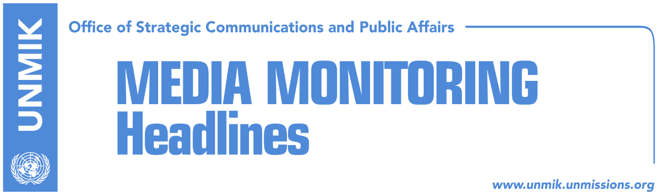

Main Stories 30 November 2017

- Haradinaj: Kosovo ready to repatriate citizens who fought for IS (Zeri)
- Pacolli discusses demarcation and dialogue in Washington (Indeksonline)
- Hoxhaj: Agreement with Serbia can happen within next two years (RTK)
- Ministry of Interior confirms security failure at Pristina Airport (Koha)
- Tahiri: Border with Albania, in consultation with EU (Epoka)
- Vulin: Association/Community is not an NGO” (Kosova Sot)
- Great Britain’s Minister of Armed Forces to visit Kosovo (RTK)
- University of Pristina presses charges against church (RTK)

Kosovo Media Highlights

Haradinaj: Kosovo ready to repatriate citizens who fought for IS (Zeri)
Prime Minister of Kosovo, Ramush Haradinaj, said Kosovo is ready to repatriate its citizens who fought alongside the so-called Islamic State in Syria and Iraq. “Kosovo is their homeland and we are ready to repatriate all those that wish to return. Kosovo takes on the responsibility for securing everyone’s lives,” Haradinaj said yesterday at the presentation of a UNDP report on factors that lead people of Kosovo joining foreign conflicts.

Pacolli discusses demarcation and dialogue in Washington (Indeksonline)
Kosovo’s Foreign Minister Behxhet Pacolli is visiting the United States of America where he has met with Assistant Secretary of State for Europe and Asia, Wess Mitchell, and Deputy Assistant Secretary of State, Hoyt Yee. “We reconfirmed our cooperation and excellent relations in all areas. The U.S. will continue to provide strong support to Kosovo. We are in full harmony for every step and action. The ratification of the border demarcation agreement with Montenegro and the start of dialogue between Kosovo and Serbia remain key issues. Our strategic partnership and alliance remains unwavering and eternal,” Pacolli posted on Facebook.

Hoxhaj: Agreement with Serbia can happen within next two years (RTK)
Kosovo’s Deputy Prime Minister, Enver Hoxhaj, said at the conferences for Balkans organized in Washington by the Atlantic Council, that dialogue between Kosovo and Serbia should move to a final phase and the full normalisation of relations. Hoxhaj said this could be reached in two years and that this agreement would require the support of the international community, especially of the European Union and the United States of America. Hoxhaj further argued that internal dialogue on Kosovo in Serbia initiated by Serbian President Aleksandar Vucic, “is creating the same narrative as the one used during Milosevic’s time”. He added that Serbia’s campaigns against Kosovo affect the process of dialogue, reached agreements and the agreements that should be reached in the final phase. He said there is no reason for Kosovo to continue with dialogue if it does not become a member of the United Nations and if mutual recognition with Serbia is not reached.

Ministry of Interior confirms security failure at Pristina Airport (Koha)
Kosovo’s Ministry of Interior has confirmed that security tests carried out at the Pristina Airport have resulted in a number of flaws, the paper reports on the front page. The Ministry said that after the end of the test, whose goal was to measure security at the Pristina International Airport, they presented the findings to the airport’s management and immediate concrete measures were taken to address these shortcomings. Yesterday, the paper reported that a luggage filled with explosives managed to be loaded undetected onto an airplane at Pristina Airport this month, but was discovered by security personnel who were carrying out an exercise to test the functioning of the security system at the airport.

Tahiri: Border with Albania, in consultation with EU (Epoka)
The paper quotes on its front page Ramush Tahiri, political analyst, as saying that the governments of Kosovo and Albania should be careful with the practical removal of borders as announced for January 1 next year. According to Tahiri, Pristina and Tirana must coordinate their actions with the European Union which calls for the integrated management of borders. “This certainly needs to be done in coordination with the European Union, because how can an aspiring member state reach special agreements. There was a case earlier when the EU called for the reintroduction of double borders and we certainly don’t want to harm Albania because of Kosovo,” Tahiri added.

Vulin: Association/Community is not an NGO” (Kosova Sot)
Serbia’s Minister of Defence, Aleksandar Vulin, accused Prime Minister of Kosovo, Ramush Haradinaj, for trying to invalidate Brussels agreements. “Brussels agreement is more than clear. It is signed and contains clear and precise obligations for establishing the association [Association/Community of Serb-majority municipalities] and it is no NGO. Haradinaj is aware of the facts that Brussels agreement does not work in favour of Kosovo’s independence and he is doing all he can not to implement it,” Vulin said.

Great Britain’s Minister of Armed Forces to visit Kosovo (RTK)
John Mark Lancaster, Minister of Armed Forces of Great Britain will be visiting the Kosovo’s Ministry of Security Forces and Kosovo’s Security Forces (KSF) today. He will also meet with the Prime Minister of Kosovo, Ramush Haradinaj. Minister of Kosovo’s Security Forces will organise an official reception for the British Minister and the rest of the delegation.

University of Pristina presses charges against church (RTK)
The University of Pristina “Hasan Prishtina” has initiated new charges against the Orthodox Church built at University campus. This time, the university has also sued the Municipality of Pristina due to the non-enactment of the "discriminatory" legal regulation. The basis of the lawsuit is to establish the right of exploitation and return of possession. The lawsuit relates to the property of 4.27.15 hectares, which according to the plaintiff was in free use and unimpeded by it, as it was part of the university campus according to the Urban Detail Plan of the University Center in Pristina.

Disclaimer
This media summary consists of selected local media articles for the information of UN personnel. The public distribution of this media summary is a courtesy service extended by UNMIK on the understanding that the choice of articles translated is exclusive, and the contents do not represent anything other than a selection of articles likely to be of interest to a United Nations readership. The inclusion of articles in this summary does not imply endorsement by UNMIK.

