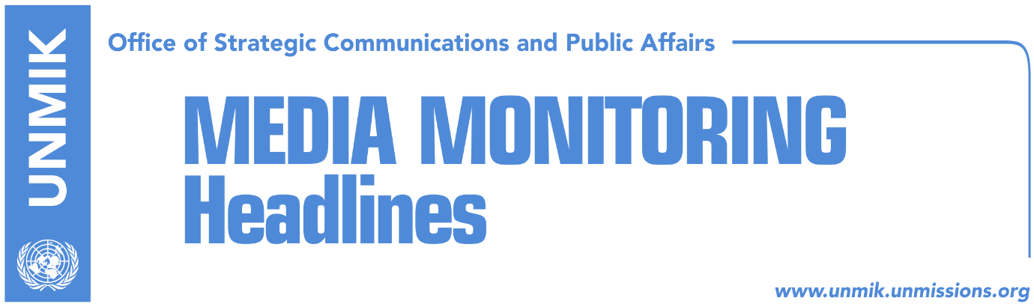

Main Stories 7 December 2017

- Ruling coalition struggles for votes to pass 2018 budget (Zeri)
- Thaci to take part in meeting of Western Balkan leaders in Bulgaria (dailies)
- Thaci in Sofia: Regional cooperation accelerates path toward EU (RTK)
- Reactions over President Thaci’s remarks during Canada visit (media)
- Peci proposes sending demarcation deal to Constitutional Court (Bota Sot)
- Phillips suggests direct US involvement in Kosovo-Serbia talks (Koha)
- Minister Tahiri seeks punitive measures against colleague Gashi (Telegrafi)
- DPM Jevtic calls on Serbs to return to Kosovo (Koha)
- Non-membership in INTERPOL impedes Kosovo fight against radicalism (Koha)

Kosovo Media Highlights

Ruling coalition struggles for votes to pass 2018 budget (Zeri)
After two days of debate, the draft budget for 2018 failed to get the approval of Kosovo MPs receiving only 58 votes in favour while the opposition MPs did not take part in the vote at all. Vetevendosje said the 2008 budget is that of survival not of economic development while the Democratic League of Kosovo (LDK) said the budget does not correspond to the government’s programme mentioning in this regard the plan for transformation of the Kosovo Security Force which is included in the government’s agenda but no funds for it have been planned in the next year’s budget. Meanwhile, Finance Minister Bedri Hamza said Kosovo next year is expected to experience the highest economic growth since 1999 and said opposition’s criticism is unprofessional and political.

Thaci to take part in meeting of Western Balkan leaders in Bulgaria (dailies)
President of Kosovo, Hashim Thaci, has travelled to Bulgaria to take part in the meeting of the Western Balkan leaders and a World Bank conference. Thaci is also expected to meet his Bulgarian counterpart, Rumen Radev.

Thaci in Sofia: Regional cooperation accelerates path toward EU (RTK)
Kosovo President, Hashim Thaci, attended on Wednesday evening the meeting of leaders of the region, where he also met with Bulgarian Prime Minister, Boyko Borisov. Thaci said regional cooperation accelerates the path of all countries in the region toward the European Union.

Reactions over President Thaci’s remarks during Canada visit (media)
Several online media report that following Kosovo President Hashim Thaci’s remarks during his recent visit to Canada, the Russian Embassy there tweeted: “after Thaci’s recent visit to Ottawa and his anti-Russian comments to Canadian media we would like to take this opportunity to remind everyone that Kosovo is Serbia”. The U.S. House Foreign Affairs Committee Democrats then retweeted to the post saying “we would like to take this opportunity to remind everyone that Kosovo is independent and Crimea is Ukraine”.

Peci proposes sending demarcation deal to Constitutional Court (Bota Sot)
The head of the Kosovo Institute for Policy Research and Development (KIPRED), Lulzim Peci, has proposed sending the border demarcation agreement with Montenegro to the Constitutional Court to look into the legality of the deal before having the MPs vote on it. Peci said the Court could verify whether the principle of determining the borderline based on cadastral zones is in accordance to the Constitution of Kosovo.

Phillips suggests direct US involvement in Kosovo-Serbia talks (Koha)
David Phillips, professor at Columbia University in New York, suggested on Wednesday greater international involvement in dialogue between Kosovo and Serbia. During a debate at the European Parliament, Phillips said the U.S. need to be involved more in the process and also suggested a “contact group” but only consisting of “countries that have positive interests in the matter, and not countries like Russia whose only interest is to use the process for its own purposes and to obstruct Kosovo”. Phillips said Washington should have its own envoy in the process. According to Phillips, there should be a shuttle diplomacy in the process, whereby the Prime Ministers of the two countries would have the lead role and Presidents would have only a ceremonial role. He added that the process of talks should include the issue of missing persons, the full integration of the Serb minority in Kosovo’s system, and a contact person with representatives of Serb-majority municipalities. He added that the future army of Kosovo should be accepted in NATO’s Partnership for Peace Program.

Minister Tahiri seeks punitive measures against colleague Gashi (Telegrafi)
In an interview to RTV Dukagjini, Minister of Justice Abelard Tahiri called on relevant institutions to take punitive measures against Deputy Prime Minister and Minister of Diaspora, Dardan Gashi, after a video surfaced of him shooting from a gun into the air as he was reportedly celebrating the acquittal of Deputy Prime Minister Fatmir Limaj. Tahiri said such acts set a bad example. “A Kosovo deputy prime minister seen in such images is very unpleasant and unjustifiable,” Tahiri said.

DPM Jevtic calls on Serbs to return to Kosovo (Koha)
Kosovo’s Deputy Prime Minister and Minister for Communities and Returns Dalibor Jevtic met displaced Serbs from Kosovo in the Serbian city of Smederevo and urged them to return to their properties. He said the ministry he leads will put in place all necessary conditions to enable their return. “Our main goal is the return of each Serb family to Kosovo,” Jevtic said adding that usurped property will be resolved in a concrete manner whereby a special judicial panel will be set up to deal with cases of usurped property.

Non-membership in INTERPOL impedes Kosovo’s fight against radicalism (Koha)
Although the number of Kosovars that join extremist groups in Syria and Iraq has almost stopped completely, radicalism and violent extremism remain a challenge for Kosovo and continuous work is needed in this respect. This was said at a debate in Brussels organized by the UNDP about radicalism in Kosovo. It was also said that Kosovo, together with its international partners, has made significant progress in preventing violent extremism and radicalism. Kosovo’s Interior Minister, Flamur Sefaj, highlighted the problem that Kosovo authorities face with access to data and called for an agreement with EUROPOL and membership in INTERPOL.

Disclaimer
This media summary consists of selected local media articles for the information of UN personnel. The public distribution of this media summary is a courtesy service extended by UNMIK on the understanding that the choice of articles translated is exclusive, and the contents do not represent anything other than a selection of articles likely to be of interest to a United Nations readership. The inclusion of articles in this summary does not imply endorsement by UNMIK.

