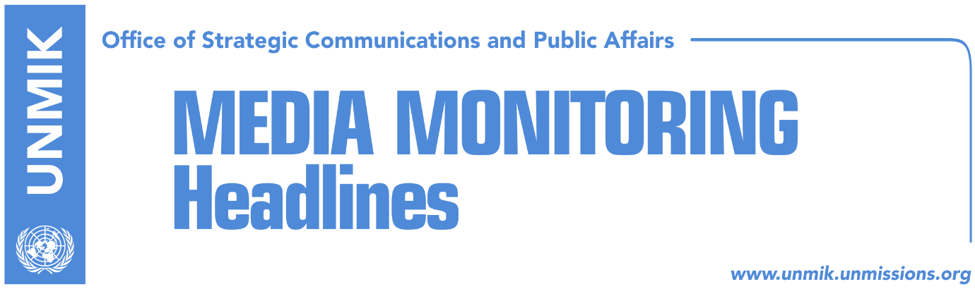

Main Stories 11 December 2017

- Pacolli: Dialogue with Serbia starts at the beginning of January (RTK)
- Non-endorsement of border deal threatens relations with the West (Koha)
- Budget for 2018 approved in principle (Epoka)
- Analysts: Vetevendosje heading towards a fallout (Zeri)
- Government of Kosovo: Peace is achieved through equality (Bota Sot)
- Thaci: Kosovo has the most modern constitution in south-east Europe (Koha)
- Couci: KFOR is the only armed force in Kosovo (Zeri)
- Parties launch Istog election campaign (Lajmi)
- Kosovo taxpayers to continue paying for electricity in the north (Koha Ditore)

Kosovo Media Highlights

Pacolli: Dialogue with Serbia starts at the beginning of January (RTK)
Kosovo’s Minister for Foreign Affairs, Behgjet Pacolli, said that the dialogue between Pristina and Belgrade will start with an increased intensity in the beginning of January. Pacolli told the public broadcaster that he expects reach of final agreement for reconciliation by the end of 2018. ‘We will conclude the dialogue during 2018. I very much hope that the dialogue will end with peace treaty between Kosovo and Serbia. Both Kosovo and Serbia need this treaty just as the future of the populations of the region,” Pacolli said.

Non-endorsement of border deal threatens relations with the West (Koha)
The paper reports on the front page of increased efforts to convince ruling parties to support the border demarcation agreement with Montenegro ahead of it being included in the Assembly’s agenda. Sources said that the agreement has not been added to the procedure so far precisely because of these efforts. At present, only the Democratic Party of Kosovo (PDK) and the New Kosovo Alliance (AKR) support the agreement while the Alliance for the Future of Kosovo (AAK) and Initiative for Kosovo (NISMA), though part of the government, have said they would not support the deal. Analysts meanwhile warn that the failure to ratify the agreement would have serious repercussions for Kosovo and could also worsen its relations with the West.

Budget for 2018 approved in principle (Epoka)
The Assembly of Kosovo continued on Sunday its plenary session to vote the draft law for the budget of Kosovo for 2018. 62 MPs voted for and two were against the budget of almost two billion Euros. This budget foresees economic growth of 4.6 percent with the nominal one reaching six percent. Respective Assembly commissions were asked to review the draft Law and present recommendations to the Assembly. Opposition political parties, Vetevendosje and the Democratic League of Kosovo (LDK), did not vote. Prime Minister Ramush Haradinaj said that he had expected the opposition political parties MPs to vote.

Analysts: Vetevendosje heading towards a fallout (Zeri)
Political analysts the paper has spoken to consider that the recent publication of telephone messages between Vetevendosje officials showing the deputy leader of the party, Aida Derguti, voicing insults to former leader, Albin Kurti, shows the divisions and discontents between different groups inside the party. Analyst Mazllum Baraliu said an uncivilized communication vocabulary as used by Derguti can bring nothing good and can even damage the stability and the power of Vetevendosje. Meanwhile, Derguti apologized through a Facebook post for the words she used against Kurti saying it is a result of deep political and organizational disagreements with certain people at Vetevendosje. The party itself has not commented on the recent developments but its presidency is expected to meet later today.

Government of Kosovo: Peace is achieved through equality (Bota Sot)
On the International Human Rights Day, the government of Kosovo issued a press release saying that peace is achieved through equality for all people, regardless of their religion, race, gender, or orientation. “The Government of Kosovo is committed to be with its citizen, to create well-being for everyone, preserve and cultivate the values of tolerant society and advance the rights for everyone,” the statement reads.

See the full statement: http://www.kryeministri-ks.net/?page=2,9,7389

Thaci: Kosovo has the most modern constitution in south-east Europe (Koha)
On the occasion of the Human Rights Day, President of Kosovo, Hashim Thaci, wrote on Facebook that Kosovo has the most advanced constitution in south-east Europe which guarantees rights to all communities, regardless of their ethnicity, gender, or religion.

Couci: KFOR is the only armed force in Kosovo (Zeri)
KFOR Commander, General Salvatore Couci, told Serbian media that KFOR is the only army in Kosovo that maintains peace. “Kosovo Security Force is not an armed force, they react in case of natural disasters. They are well trained for this, but if Kosovo institutions want to transform it into an army, then this is a process which also according to NATO Secretary General should commence in compatibility with the Constitution.”

Parties launch Istog election campaign (Lajmi)
The two candidates for Istog mayor, Haki Rugova from the Democratic League of Kosovo (LDK) and Gani Dreshaj from the Alliance for the Future of Kosovo (AAK) will start their five day election campaign today. Elections in Istog will be held on 17 December. According to the CEC preliminary results of the runoff in Istog, Haki Rugova won the election in this municipality, but the situation changed after counting conditional votes and those sent by mail.

Kosovo taxpayers to continue paying for electricity in the north (Koha Ditore)
Following the decision of the Kosovo Energy Regulatory Office to ban the unpaid electricity bills in the north being charged to the rest of Kosovo consumers, the paper reports that these losses will nevertheless continue to be paid by Kosovo taxpayers. In the inability to secure unobstructed access to electricity metres in the northern municipalities, the government of Kosovo is expected to cover these losses but has not yet determined which concrete action it will pursue. Minister of Economic Development, Valdrin Lluka, told the paper that the government will temporarily have to cover these losses.

Disclaimer
This media summary consists of selected local media articles for the information of UN personnel. The public distribution of this media summary is a courtesy service extended by UNMIK on the understanding that the choice of articles translated is exclusive, and the contents do not represent anything other than a selection of articles likely to be of interest to a United Nations readership. The inclusion of articles in this summary does not imply endorsement by UNMIK.

