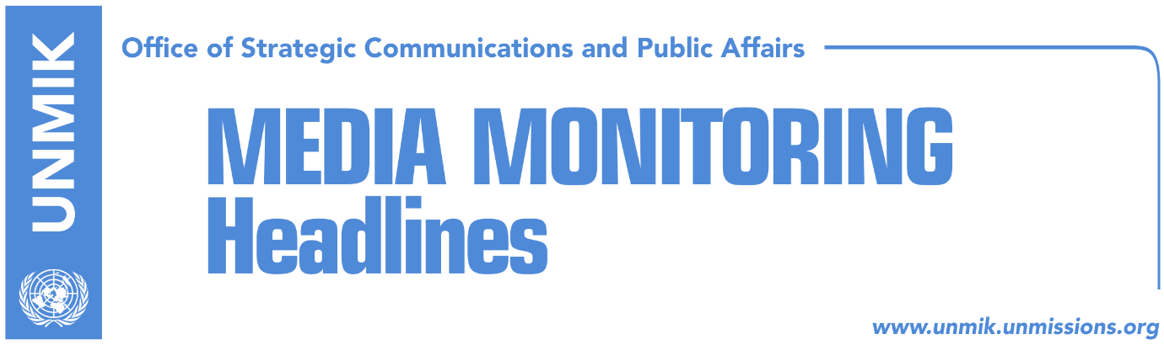

Main Stories 14 December 2017

- Ymeri: Vetevendosje has been facing disagreements for a year (KTV)
- Vetevendosje MP Aliu accuses leader Ymeri of being against Kurti (Koha)
- Cuoci: Region ready for peace, Russian influence must be verified (Koha)
- Border demarcation in the Assembly next week (RTK)
- Limaj: Consensus is needed on demarcation (Epoka)
- Agreement reached for construction of new power plant (Zeri)
- Veseli visits United Kingdom (Epoka)
- Trepca could bankrupt due to lack of board (Epoka)

Kosovo Media Highlights

Ymeri: Vetevendosje has been facing disagreements for a year (KTV)
Vetevendosje leader, Visar Ymeri, said in an interview to KTV that for a year now Vetevendosje is facing issues with lynching of certain persons inside the party and that there are different views amongst the membership on how Vetevendosje ought to function. He said no one in Vetevendosje should consider oneself as more important than the organization they are part of. “Vetevendosje movement can move forward with all of us. Albin Kurti has an irreplaceable contribution for the Movement and no one is denying that. What I am saying is that the political organization and the idea that Vetevendosje wants to present is that people are implementing factors of this idea and serve in its function,” Ymeri said.

Vetevendosje MP Aliu accuses leader Ymeri of being against Kurti (Koha)
Vetevendosje MP, Liburn Aliu, told KTV on Wednesday that MP Dardan Molliqaj had no right to ask former leader Albin Kurti not to run for reelection at the general convention of the party and that the current leader, Visar Ymeri, also sides with Molliqaj. Aliu suggested that the best way to resolve the current crisis is to set the date for the general convention and elect a new leader but stressed that no one can be discouraged from running for the post.

Cuoci: Region ready for peace, Russian influence must be verified (Koha)
The paper runs a front-page interview with General Salvatore Cuoci, the new commander of KFOR troops, highlighting his remarks that the region is ready for peace and that KFOR and NATO need to verify if Russia’s presence in the region, primarily in Serbia, goes beyond humanitarian activities. Cuoci commented on the transformation of the Kosovo Security Force into the Armed Forces saying that it is a political issue and that the process needs to happen in line with the Constitution. “We are not against this transformation, we think the transformation is a political decision that this country and its institutions need to take. Our wish certainly is for this decision to be made within the constitutional framework, because this is going to be very important and I think this is the only way to go about the transformation,” the new COMKFOR is quoted as saying. Cuoci also praised Kosovo’s authorities for their commitment in fighting extremism and added that in the event of riots in the country KFOR has ready plans to aid Kosovo’s institutions in facing any problem.
Border demarcation in the Assembly next week (RTK)
The agreement for demarcation of the border between Kosovo and Montenegro is expected to reach the Assembly very soon. The Prime Minister of Kosovo Ramush Haradinaj has requested a few weeks ago from the MPs to vote it. Deputy Head of the Committee for Foreign Affairs, Time Kadrijaj explained that the reached agreement and the report of the new Commission will be voted at the Assembly. “The agreement was signed between Kosovo and Montenegro and as such will be sent at the Assembly, we will see how it will be voted at the Parliament,” she said. She added that the report will reach the Assembly Committee next week for analysis and then it will be proceeded at the Assembly.

Limaj: Consensus is needed on demarcation (Epoka)
Deputy Prime Minister of Kosovo Fatmir Limaj said that the government of Kosovo will try to build a national consensus on demarcation of the border with Montenegro and the dialogue with Serbia. He said he expects cooperation of the opposition political parties. Analyst Ymer Mushkolaj also considers that consensus on these matters is necessary. According to him if such consensus is not reached than institutional blockades are expected to return.

Agreement reached for construction of new power plant (Zeri)
The government of Kosovo confirmed through a press release it had reached an agreement with the U.S. company “Contour Global” for the construction of the “Kosova e Re” power plant. The commercial part of the agreement is expected to be signed over the coming days and the project, according to the government, will represent the largest investment in Kosovo’s recent history. The construction of the plant is set to begin in 2018 and conclude by 2023. “Once completed, this project will ensure energy independence for the state and the people of Kosovo,” the government said.

See the full statement at: http://www.kryeministri-ks.net/?page=2,9,7403

Veseli visits United Kingdom (Epoka)
The leader of the Democratic Party of Kosovo (PDK) and Assembly President, Kadri Veseli, has traveled on Wednesday to the Great Britain invited by the Conservatory Party. Veseli is expected to meet leaders of this party and discuss their good experiences, transfer of expertise as well as assistance of conservators to strengthen the Democratic Party of Kosovo through drafting of a new modern program in the future.

Trepca could bankrupt due to lack of board (Epoka)
The government of Kosovo has not completed procedures on nomination of the supervising board members for Trepca, which would enable implementation of the Law on Trepca endorsed a year ago. According to this Law, the supervising board had to be nominated within six months after its endorsement by the Assembly of Kosovo. However, according to Trepca representatives the matter was neglected by Kosovo institutions. Haki Shatri, economy adviser to the Prime Minister said the government has advertised the positions for the board, and a commission to assess applications has been established. "Without nomination of the new board, procedures for registration of Trepca at the Ministry for Trade and Industry as a public enterprise cannot begin,” Shatri said adding that the remaining procedures might last one month.

Disclaimer
This media summary consists of selected local media articles for the information of UN personnel. The public distribution of this media summary is a courtesy service extended by UNMIK on the understanding that the choice of articles translated is exclusive, and the contents do not represent anything other than a selection of articles likely to be of interest to a United Nations readership. The inclusion of articles in this summary does not imply endorsement by UNMIK.

