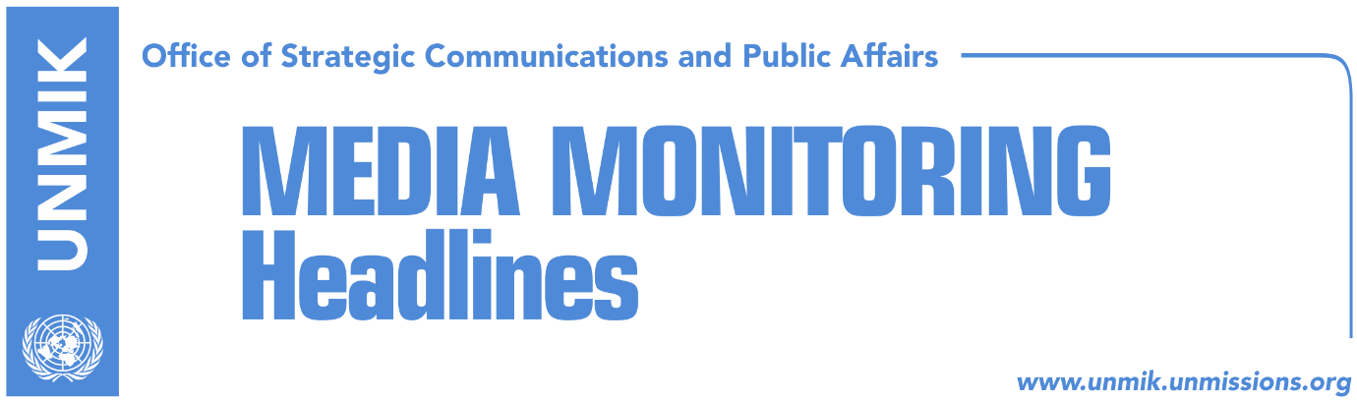

Main Stories 15 December 2017

- Haradinaj promises visa liberalization in March 2018 (media)
- Army and Association, among government priorities for 2018 (Koha)
- Pacolli links visa liberalisation date with ratification of demarcation deal (Koha)
- Hoxhaj: Serbia’s pressure on recognising countries undermines dialogue (Zeri)
- Trendafilova: Whoever intimidates witnesses will be criminally prosecuted (RTK)
- Europol confirms start of cooperation with Kosovo (Zeri/Koha)
- Rakic did not manage to take oath of office at 12.44 (Klan Kosova/Zeri)
- “Resolution 1244 is dead, Serbs to take oath according to Constitution” (Bota Sot)
- Williems: EU expects Kosovo to obey to the rule of law (Epoka)
- Dacic: Kosovo is Serbia’s Jerusalem (RTK)

Kosovo Media Highlights

Haradinaj promises visa liberalization in March 2018 (media)
Kosovo Prime Minister, Ramush Haradinaj, promised on Thursday that the formation of the Kosovo Armed Forces and visa liberalization will happen in March next year. “Kosovars will be able to travel without visas starting from March next year. The Kosovo Security Force can transform into an army before that time,” Haradinaj was quoted as saying in RTK. The broadcaster also reported that Haradinaj will travel to Brussels on December 18 to discuss these two issues.

Army and Association, among government priorities for 2018 (Koha)
The paper reports on its front page that the Kosovo government has announced four strategic priorities for next year, among which are the formation of the Kosovo Armed Forces and the Association/Community of Serb-majority municipalities. The ratification of the border demarcation agreement with Montenegro is not among the priorities. These objectives are part of the government’s draft annual program which has yet to be adopted. The documents include 45 draft laws that will be sent to the Assembly and 35 strategies.

Pacolli links visa liberalisation date with ratification of demarcation deal (Koha)
Kosovo’s Deputy Prime Minister and Foreign Minister, Behgjet Pacolli, said in an interview to RTV Dukagjini that the visa liberalisation date is strongly linked to the process of border demarcation with Montenegro and that if Kosovo assembly ratifies the deal in February of 2018, people of Kosovo could move freely to EU in June. However, Pacolli said he did not know what would happen with the visa liberalisation process if the border agreement is not approved in February.

Hoxhaj: Serbia’s pressure on recognising countries undermines dialogue (Zeri)
Kosovo’s Deputy Prime Minister, Enver Hoxhaj, reacted to the statement of the Serbian President, Aleksandar Vucic, that Kosovo risks being left without more recognitions. In a Twitter post, Hoxhaj said it was unacceptable for Vucic to misuse the climate change summit in Paris to attack Kosovo’s statehood. “Serbia’s aggressive campaign and pressure to countries that have recognised Kosovo’s independence is undermining the dialogue and normalization of relations,” Hoxhaj wrote.

Trendafilova: Whoever intimidates witnesses will be criminally prosecuted (RTK)
Head of the Specialized Chambers, Ekaterina Trendafilova, told Belgrade-based Tanjug news agency that this court will prosecute criminally all those that in any manner intimidate security of the victims and witnesses or exercise any kind of pressure on the judges. “Investigations will proceed and we will not hesitate to implement the law,” Trendafilova said. The Special Chambers will be dealing with trials of alleged war crimes committed by some former members of the Kosovo Liberation Army.

Europol confirms start of cooperation with Kosovo (Zeri/Koha)
Kosovo’s Interior Minister, Flamur Sefaj, met yesterday an EU delegation led by Pedro Serrano, EU’s Deputy Secretary General for Security and Defence. The EU officials informed Sefaj that Europol, EU’s law enforcement agency, has decided to put Kosovo on the list of priorities and sign a working contract. The Ministry of Interior hailed the move saying it was a result of continuous work and inter-institutional cooperation.

Rakic did not manage to take oath of office at 12.44 (Klan Kosova/Zeri)
Klan Kosova reported that Goran Rakic got sworn in yesterday as Mitrovica North mayor by putting his signature on a document bearing the stamp of the Republic of Kosovo. Meanwhile, the constitutive session of the municipality’s assembly did not manage to take place at 12.44 as originally planned being that Albanian municipal councilors were late.

“Resolution 1244 is dead, Serbs to take oath according to Constitution” (Bota Sot)
The paper quotes some MPs and legal experts as saying that the Serb mayors and municipal councilors should have taken the oath of office in accordance with the laws and the Constitution of Kosovo. Attorneys and legal experts also told the paper that UNSC Resolution 1244 should not have been part of the document with which the Serb mayors and councilors took the oath of office. They argued that “the Resolution is now dead” and that “Kosovo Serbs must learn to act independently from Serbia”.

Williems: EU expects Kosovo to obey to the rule of law (Epoka)
The Dutch Ambassador to Kosovo Gerries Williams, said on Thursday that the European Union expects from Kosovo to obey to the rule of law and based on the principal that no one is above the law. Williems made these comments at a press conference where the research “Integrity scanning in the justice system” was presented.

Dacic: Kosovo is Serbia’s Jerusalem (RTK)
Serbia’s Foreign Minister, Ivica Dacic, said Serbia and Israel have friendly traditional relations and that Kosovo is Serbian Jerusalem. “Kosovo is our Jerusalem,” Dacic said on Thursday at a press conference on the occasion of the 25th anniversary of diplomatic relations between Yugoslavia and Jerusalem. He further added that Serbia values Israel’s principled position of not recognizing unilateral declaration of independence of Kosovo, which according to him “reflects positively on the quality and content of the relations between the two countries in general.”

Disclaimer
This media summary consists of selected local media articles for the information of UN personnel. The public distribution of this media summary is a courtesy service extended by UNMIK on the understanding that the choice of articles translated is exclusive, and the contents do not represent anything other than a selection of articles likely to be of interest to a United Nations readership. The inclusion of articles in this summary does not imply endorsement by UNMIK.

