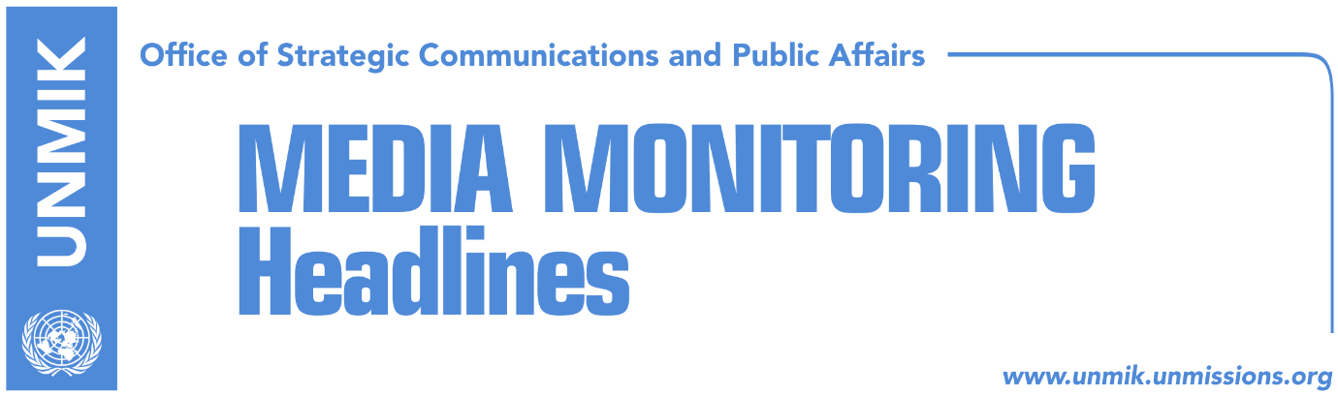

Main Stories 20 December 2017

- Kosovo Assembly presidency fails to schedule new plenary session (dailies)
- “Montenegro PM set to visit Kosovo in January” (Zeri/Express/Koha)
- President Thaci brings two news for Kosovo citizens (media)
- Opposition parties want government to lead Brussels dialogue (Zeri)
- 100 days in government, Haradinaj reports to the President (media)
- Hoti: Haradinaj-led government incapable of big decisions (Epoka e Re)
- Putin: We’ll support any solution agreed by Belgrade and Pristina (media)
- FM Pacolli: Slovenia to support Kosovo’s Interpol and UNESCO bid (Epoka)
- Haradinaj: Others will no longer have to pay for electricity in the north (media)

Kosovo Media Highlights

Kosovo Assembly presidency fails to schedule new plenary session (dailies)
The presidency of the Kosovo Assembly failed to schedule the date for the upcoming plenary session for the lack of quorum. Deputy President of the Assembly, Xhavit Haliti, said the presidency will also meet today in an effort schedule the session which will include second review of next year’s budget and setting of the date for President Hashim Thaci’s annual address.

“Montenegro PM set to visit Kosovo in January” (Zeri/Express/Koha)
Zeri quotes reports from Gazeta Express saying that Prime Minister of Montenegro, Dusko Markovic, is expected to visit Kosovo early next year on the invitation of Kosovo Prime Minister, Ramush Haradinaj. Meanwhile, Koha quotes officials from the government of Montenegro saying there has been no agreement on the timing of the visit and that Montenegro considers the border demarcation issue to be closed.

President Thaci brings two news for Kosovo citizens (media)
Kosovo President Hashim Thaci posted on Facebook on Tuesday that he has two good news for Kosovo at the end of the year. “Together with U.S. Ambassador in Kosovo, Greg Delawie, and USAID chief, James Hope, we signed today the amendment of the Agreement on the Development Objectives Grant between Kosovo and the United States, in the amount of US$ 30 million. These funds will be invested in support of the areas of rule of law, good governance, attracting investments in private sector and human capacity building. Tomorrow another agreement will be signed, for the energy sector, for the construction of the Kosova e Re power plant, in the amount of €1.3 billion,” Thaci wrote.

Opposition parties want government to lead Brussels dialogue (Zeri)
The paper quotes on the front page representatives of opposition parties saying that the Kosovo Assembly resolution giving the government power to be in the lead of the Pristina-Belgrade dialogue is still applicable and that President of Kosovo, Hashim Thaci, has no legitimacy to run the negotiations.

100 days in government, Haradinaj reports to the President (media)
Kosovo Prime Minister, Ramush Haradinaj, will submit today at noon a 100-day report about the work of his government to President Hashim Thaci. At 13:00, Haradinaj will submit the same report to Assembly President Kadri Veseli and then they will jointly address the media.

Hoti: Haradinaj-led government incapable of big decisions (Epoka e Re)
Head of the Democratic League of Kosovo (LDK) parliamentary group, Avdullah Hoti, said in an interview with the paper that the government led by Ramush Haradinaj is fragile and has no power to take big decisions. “This is the weakest government Kosovo has had since 1999. It was formed to finish big jobs but the only big job it is doing is appointed an enormous number of cabinet members consisting of 22 ministers, five deputy prime ministers, over 70 deputy ministers as well as support staff which totals over 520 people,” Hoti said. He added that the government has no economic reform plan and not commitment to fighting corruption and that the motion of no-confidence is one of the possible options to overthrow it.

Putin: We’ll support any solution agreed by Belgrade and Pristina (media)
Russian President Vladimir Putin said on Tuesday that Russia would support any solution on the Kosovo issue as agreed between Belgrade and Pristina. After meeting Serbian President Aleksandar Vucic, Putin said Russia supports Serbia’s territorial integrity and sovereignty and that the situation in Kosovo should be resolved through political means and based on UNSC Resolution 1244. “We will support any solution that is accepted by Belgrade and Pristina,” he said. Vucic thanked Putin for Russia’s support and assured him that Serbia would continue to have a military neutral position.

FM Pacolli: Slovenia to support Kosovo’s Interpol and UNESCO bid (Epoka)
Kosovo’s Deputy Prime Minister and Foreign Minister, Behgjet Pacolli, is visiting Slovenia where he had separate meetings with Foreign Minister Karl Erjavec, President Borut Pahor, and Parliament Speaker Milan Brglez. Pacolli said he received from his interlocutors full support for Kosovo’s membership bids to the Council of Europe, Interpol, and UNESCO.

Haradinaj: Others will no longer have to pay for electricity in the north (media)
Kosovo Prime Minister, Ramush Haradinaj, said on Tuesday that citizens living in other parts of Kosovo will no longer have to pay for the electricity that is used in the north. Haradinaj made these remarks after a meeting with Kosovo Power Corporation director Arben Gjukaj. Haradinaj also said that Kosovo is faced with an electricity crisis because it buys electricity but added that the situation will not get any worse.

Disclaimer
This media summary consists of selected local media articles for the information of UN personnel. The public distribution of this media summary is a courtesy service extended by UNMIK on the understanding that the choice of articles translated is exclusive, and the contents do not represent anything other than a selection of articles likely to be of interest to a United Nations readership. The inclusion of articles in this summary does not imply endorsement by UNMIK.

