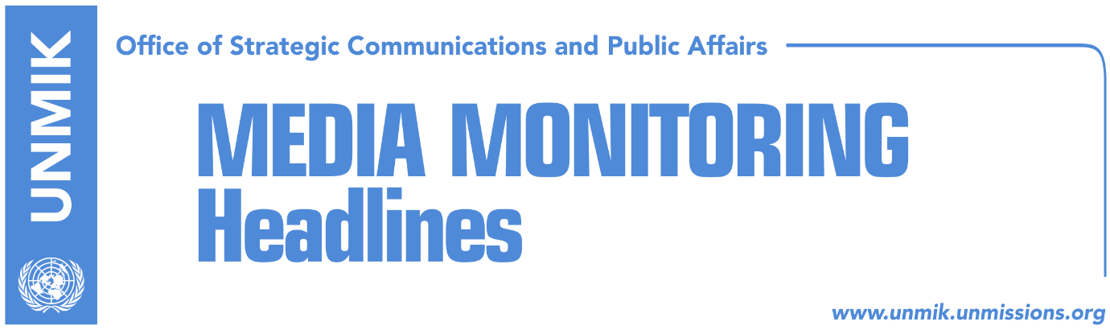

Main Stories 22 December 2017

- President Thaci gives end-of-year press conference (media)
- Opposition likely to boycott President Thaci’s speech (Zeri)
- Veseli: Future of KSF is in NATO (Zeri)
- Haradinaj: We will investigate post-war killings (Zeri)
- Hoxha: Kosovo to apply for EU candidate status in 2018 (RTK/EO)
- PM Haradinaj meets Pristina Mayor, Ahmeti (Epoka e Re)
- Haradinaj raises salaries of senior officials, some public servants (media)
- Nexhat Daci elected president of Kosovo Arts and Sciences Academy (media)

Kosovo Media Highlights

President Thaci gives end-of-year press conference (media)
All media cover Kosovo President Hashim Thaci’s end-of-year conference on Thursday, highlighting his remarks that he will not return to the Democratic Party of Kosovo (PDK) and that he could run for another mandate as Kosovo President. Thaci also said he would not be part of the government or assembly again. President Thaci said: “demarcation [with Montenegro] must be ratified in order to have visa liberalization. The European Union does not change, and we need to take our decisions. The matter is now in our hands, not in the EU”. Kosova Sot and Zeri highlight Thaci’s remarks that Kosovo authorities have a 40-day deadline to ratify the border deal with Montenegro. “If we don’t ratify demarcation, we will pay a high price,” Thaci said. Bota Sot quotes Thaci as saying that there is no alternative to dialogue between Pristina and Belgrade. Media also report that Thaci is also scheduled to deliver an end-of-year address to the Assembly today. Bota Sot notes in one of its front-page headlines that The year of the President, accusations and “clashes” with the European Union over the special court.

Opposition likely to boycott President Thaci’s speech (Zeri)
Opposition parties are likely to boycott the annual address of President Hashim Thaci set to take place today, the paper reports on the front page. “Hashim Thaci is not a unity leader as in his mandate he protected PDK interests more than those of the state. It is therefore not worth listening to his speech,” Vetevendosje MP, Shqipe Pantina said adding however that their parliamentary group has not yet discussed whether to take part in today’s Assembly session. Avdullah Hoti from the Democratic League of Kosovo (LDK) also said they did not yet decide whether to stay for Thaci’s address stressing that their decision would be announced later today.

Veseli: Future of KSF is in NATO (Zeri)
Kosovo Assembly President, Kadri Veseli, visited yesterday the Kosovo Security Force Ministry and underlined that KSF’s future is in NATO. “KSF is the most reputable institution in Kosovo and the Assembly is ready to take any decision that is in the interest of our country,” Veseli said.

Haradinaj: We will investigate post-war killings (Zeri)
Prime Minister of Kosovo, Ramush Haradinaj, said in a Facebook post that the post-war killings of political activists will be investigated saying they were a “painful wound.” Haradinaj said further that the unsolved killings after 1999 conflict “are a shame for Kosovo, society, and rule of law institutions.”

Hoxha: Kosovo to apply for EU candidate status in 2018 (RTK/EO)
Minister of European Integration, Dhurata Hoxha, said Kosovo plans to apply for EU candidate status next year. In an end-of-year press briefing, Hoxha spoke of the work her ministry has done during the first 100 days and noted in this respect that the Stabilisation and Association Agreement (SAA) is being adequately implemented.

PM Haradinaj meets Pristina Mayor, Ahmeti (Epoka e Re)
Prime Minister of Kosovo, Ramush Haradinaj, met yesterday Pristina Mayor, Shpend Ahmeti, and discussed cooperation between the government and the municipality, with particular focus on issues such as the legal status of the Youth and Sports Centre, Pristina ring road and heating.

Haradinaj raises salaries of senior officials, some public servants (media)
Most media report that Kosovo Prime Minister Ramush Haradinaj has decided to increase the salaries of senior public officials and a certain part of civil servants. Under the leading front-page headline The scandalous “success” of Haradinaj’s 100 days, Koha Ditore reports that this decision will cost the state budget additional millions of euros.

Nexhat Daci elected president of Kosovo Arts and Sciences Academy (media)
All media report that Nexhat Daci has been elected president of the Kosovo Arts and Sciences Academy (ASHAK). Daci, former President of the Kosovo Assembly, was president of ASHAK in the 1999-2002 period.

Disclaimer
This media summary consists of selected local media articles for the information of UN personnel. The public distribution of this media summary is a courtesy service extended by UNMIK on the understanding that the choice of articles translated is exclusive, and the contents do not represent anything other than a selection of articles likely to be of interest to a United Nations readership. The inclusion of articles in this summary does not imply endorsement by UNMIK.

