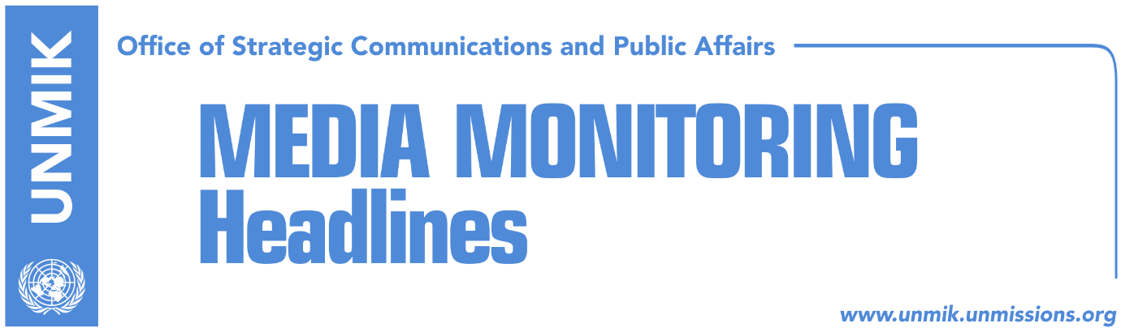

Main Stories 5 January 2018

- Quint Member States react to the efforts to abolish the Special Court (dailies)
- U.S. will not block any initiative by Russia at Security Council (Koha Ditore)
- Lekaj: Law on Special Court has to be abolished (Epoka e Re)
- Deda: Quint issued final warning regarding special court (Koha)
- Vetevendosje does not accept its MPs resignations pending discussion (Koha)
- Jevtic: Serbian List will not vote for Kosovo army (Zeri/Lajmi)
- Haliti: Endorsement of demarcation is unavoidable (RTK)
- Philips: Border contests exist in many countries (RTK)
- Pacolli: We are getting ready to apply for CoE and Interpol membership (Zeri)
- Teachers’ trade unions warn of strike (Koha Ditore)

Kosovo Media Highlights

Quint Member States react to the efforts to abolish the Special Court (dailies)
Quint member states issued on Thursday a press release where they express their deep concern “by ongoing efforts to undermine the work of the Specialist Chambers, as well as by the December 29 presidential pardons of three individuals convicted of murder in the so-called “Hajra Family Case.” The Chambers, in particular, are an important part of Kosovo´s commitment to the rule of law and Kosovo´s work to address crimes committed on its soil. The Quint countries have been long-standing and true friends of Kosovo, including at the most difficult times. From our support to the NATO intervention, to the sacrifice of our soldiers in Kosovo, to our early recognition of Kosovo’s independence and our ongoing support to your development, we have worked hard to support your country. Your success is in our interest. However, we will always insist that Kosovo should uphold justice. There is no reason to stop the work of the Specialist Chambers, and we call on any head of institutional bodies, party leaders, or Member of Parliament to abandon any thought of repealing or re-negotiating any aspect of the Law on the Specialist Chambers,” notes the press release.

https://xk.usembassy.gov/quint-member-states-statement/

U.S. will not block any initiative by Russia at Security Council (Koha Ditore)
The U.S. authorities have warned Kosovo institutions that a plan B regarding special court could be put into play if Assembly repeals law on specialist chambers, the paper reports on the front page. Sources told the paper that this message was conveyed yesterday to Prime Minister of Kosovo, Ramush Haradinaj, by the acting U.S. Ambassador, Stephen Banks. Banks reportedly made it clear to Haradinaj that the U.S. would not attempt to block any possible initiative by Russia at the Security Council regarding the establishment of a similar court by the UN. “He [Banks] reminded Haradinaj that the Russian initiative will of course be based on Resolution 1244 and will refer to UNMIK as the supreme ruling authority in Kosovo,” the source said.

Lekaj: Law on Special Court has to be abolished (Epoka e Re)
Deputy leader of the Alliance for the Future of Kosovo (AAK) and Minister of Infrastructure, Pal Lekaj, said the Law on Special Court has to be abolished. He said the initiative of the MPs has to be supported and only after abolishment, the Kosovo should establish a court which deal with the alleged cases. Lekaj does not believe that such action could affect relations with the internationals, and added that the Democratic League of Kosovo (LDK) is objecting the initiative for political gain.

Deda: Quint issued final warning regarding special court (Koha)
Kosovo MP from Alternativa, Ilir Deda, said the statement issued by Quint countries is the final warning for Kosovo leaders against the initiative to abolish law on specialist chambers. Deda said the Quint warned Kosovo it would suffer grave consequences if it approves the repealing of the law. “I deeply believe there is no citizen in Kosovo that supports the collapse of our country ahead of the tenth anniversary of independence,” Deda said.

Vetevendosje does not accept its MPs resignations pending discussion (Koha)
Vetevendosje has come out with a position on the recent resignation of several of its MPs including leader Visar Ymeri after a meeting yesterday. Fatmire Mulhaxha-Kollcaku, deputy leader, said Vetevendosje has decided not to accept the resignations of its officials until all concerns are discussed. Mulhaxha-Kollcaku denied the possibility of the party splitting and underlined that resignations in question do not include complete resignations from the party but only the senior functions inside it.

Jevtic: Serbian List will not vote for Kosovo army (Zeri/Lajmi)
Kosovo’s Minister for Communities and Returns, Dalibor Jevtic, said the Serbian List will not vote in favour of Kosovo Security Force’s transformation into a Kosovo army. “Serbian List has a clear position regarding the army and we will not vote for it,” Jevtic said.

Haliti: Endorsement of demarcation is unavoidable (RTK)
Deputy President of the Assembly of Kosovo, Xhavit Haliti, continues to insist that endorsement of the Agreement for demarcation of the border with Montenegro is unavoidable. According to him, the issue should not be sent at the Assembly without assuring sufficient votes. Haliti considers that demarcation matter is a done deal as it was signed with representatives of the population of Kosovo. He considers that Kosovo should accept the Agreement in order not affect relations with Montenegro, a country which is now also a NATO member.

Philips: Border contests exist in many countries (RTK)
Director of Peace-Building and Human Rights Program, Columbia University's Institute for the Study of Human Rights, David Philips, took to his Twitter account to write that “Brussels must rescind its ridiculous rule conditioning Visa Liberalization for Kosovo with a Border Demarcation Agreement between Kosovo and Montenegro. Border disputes exist between many countries from ex-Yugoslavia. Targeting Kosovo proves Brussels bias against Albanians.”

Pacolli: We are getting ready to apply for CoE and Interpol membership (Zeri)
Kosovo’s Deputy Prime Minister and Foreign Minister, Behgjet Pacolli, said he has set up a working group to make all necessary preparations for Kosovo’s application to the Council of Europe. He said the 11-member group also includes experts from the civil society and that they are intensively working on drafting an action plan. Pacolli said he expects Kosovo to be ready “soon” to apply for CoE membership and added that they are also making preparations to renew Kosovo’s Interpol membership bid.

Teachers’ trade unions warn of strike (Koha Ditore)
Leaders of the teachers’ trade unions have warned they would go on strike following the statement of Prime Minister Ramush Haradinaj who called on the teaching staff to perform their duties in a professional manner. Union leaders said they expected Haradinaj to come out in support of their demands for a pay raise and not insult them.

Disclaimer
This media summary consists of selected local media articles for the information of UN personnel. The public distribution of this media summary is a courtesy service extended by UNMIK on the understanding that the choice of articles translated is exclusive, and the contents do not represent anything other than a selection of articles likely to be of interest to a United Nations readership. The inclusion of articles in this summary does not imply endorsement by UNMIK.

