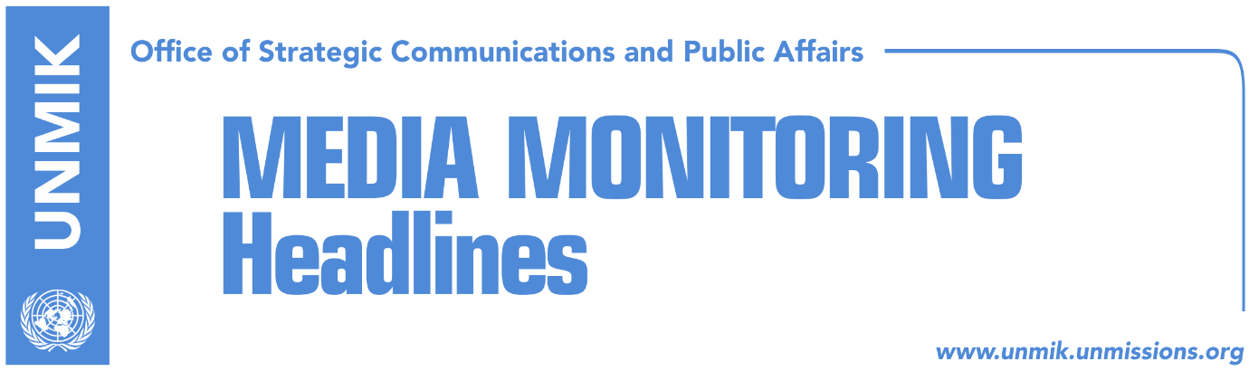

Main Stories 17 January 2018

- Kosovo Serb politician gunned down in Mitrovica North (media)
- UNMIK chief strongly condemns Ivanovic’s murder (media)
- U.S. Ambassador calls for swift and professional investigations (media)
- Russian Foreign Ministry strongly condemns “despicable act” (media)
- Serbian President Vucic to visit Kosovo over the weekend (media)
- Kosovo chief negotiator calls on Belgrade to return to talks (Klan Kosova)
- Berisha: Special court is dangerous for Kosovo (Epoka)
- Pacolli: Kosovo will soon apply for Council of Europe membership (Epoka)

Kosovo Media Highlights

Kosovo Serb politician gunned down in Mitrovica North (media)
All daily newspapers report this morning on the murder of Kosovo Serb politician Oliver Ivanovic in front of his office on Tuesday morning in Mitrovica North. Under the leading front-page headline Tense situation after Oliver Ivanovic’s murder, Koha Ditore reports that Ivanovic was gunned down by unknown assailants from a moving vehicle. The paper further notes that Ivanovic’s murder has furthered the crisis in relations between Kosovo and Serbia. The Serbian delegation in the EU-brokered talks in Brussels has stopped the process. Meanwhile, Kosovo politicians have promised they will resolve the case and called on Belgrade not to politicize the case. Serbian officials in Belgrade said on Tuesday that Ivanovic’s murder was “a terrorist act” and “a political assassination”, whereas Kosovo leaders said the murder was “an isolated act” and that it could be related to structures that operate in the north. Kosovo Assembly President and Democratic Party of Kosovo (PDK) leader, Kadri Veseli, condemned the murder and said judicial mechanisms will undertake all required legal measures to shed light to this serious case as soon as possible and for the crime perpetrators to be brought to justice. Kosovo President Hashim Thaci strongly condemned the murder. “I call on the justice authorities to expose the circumstances of his assassination as soon as possible and the perpetrators of the crime come to justice,” Thaci said in a statement. He also called on all communities in the northern part of Kosovo to cooperate with judicial authorities. The Kosovo government said in a statement that Ivanovic’s murder is “a challenge to the rule of law and all attempts to restore order across Kosovo’s territory”. “Violence is unacceptable, no matter from where it comes and toward whom it is directed,” the government said. The European Union and NATO in different press releases, called on all parties to remain calm and allow law enforcement mechanisms to do their job. Kosovo Police have not disclosed any details about the investigation and have not confirmed any suspects. Following Ivanovic’s murder, the Kosovo government convened the National Security Council. Kosovo Police Director Shpend Maxhuni said police have undertaken all necessary measures, and Prime Minister Ramush Haradinaj said that if necessary Kosovo could ask the American Federal Bureau of Investigations (FBI) to assist in the investigations. Under the front-page headline The north may be destabilized, Zeri reports that the Kosovo Intelligence Agency (KIA), Assembly Committee on Internal Affairs, and security experts, are warning about potential instability in the north following Ivanovic’s murder. The paper also recalls a recent press release issued by the U.S. State Department warning US citizens who are planning to visit Kosovo, in particular the northern part - North Mitrovica, Leposavic, Zubin Potok, and Zvecan - that there might be civil unrest.

UNMIK chief strongly condemns Ivanovic’s murder (media)
The Special Representative of the Secretary-General and Head of UNMIK, Zahir Tanin, was shocked by the murder of Oliver Ivanovic – leader of the civic initiative Freedom, Democracy, Justice – near his office in North Mitrovica this morning, and strongly condemns the act. He trusts the investigative authorities will work swiftly and effectively, and assures that all the international agencies on the ground are ready to support the authorities in any manner which may assist the swift apprehension of those responsible for this crime. “I extend my own and the entire UN family’s deepest condolences to the family and friends of Mr. Ivanovic”, SRSG Tanin stated.

U.S. Ambassador calls for swift and professional investigations (media)
The United States Ambassador to Kosovo, Greg Delawie, called on Kosovo’s justice institutions to investigate the murder of Oliver Ivanovic swiftly and professionally, “and bring the perpetrators to justice”. “We urge all sides to avoid dangerous rhetoric and remain calm at this sensitive time, and recommit themselves to continue to work towards the normalization of relations and improvement of the lives of the citizens of Kosovo and Serbia,” Delawie said in a statement.

Russian Foreign Ministry strongly condemns “despicable act” (media)
The Russian Ministry of Foreign Affairs issued a statement following the murder of Oliver Ivanovic saying it “strongly condemns the despicable act.” “Settling political bills in this way will only lead to an increased atmosphere of terror and it will bring back interethnic conflict in the region … We call upon all international institutions in Kosovo to take comprehensive measures to prevent possible incidents province in accordance with the existing mandates,” the statement noted.

Serbian President Vucic to visit Kosovo over the weekend (media)
Most media report that Serbian President Aleksandar Vucic will visit Kosovo on Saturday and Sunday following the murder of Oliver Ivanovic. Vucic is scheduled to stay in Mitrovica North on Saturday and then visit Gracanica and Llapllasello to meet with local Serbs. Vucic said in a statement that Ivanovic’s murder was “a terrorist act” and that Serbia will be part of the investigations. Kosovo’s Minister of Justice, Abelard Tahiri, meanwhile told Pristina-based news website Gazeta Express that so far Kosovo institutions have not received any request from the Serbian government or anyone else to get involved into the investigations. “We have not been informed even by EULEX whether they have received any such requests,” Tahiri said.

Kosovo chief negotiator calls on Belgrade to return to talks (Klan Kosova)
Avni Arifi, the head of the Kosovo delegation in the EU-brokered talks in Brussels, called on the Belgrade delegation to return to the negotiations. After the Serb delegation returned to Belgrade following the news of Oliver Ivanovic’s murder, Arifi told Pristina-based TV station Klan Kosova that there is no alternative to dialogue. “We call on the Serbian side to implement all agreements reached so far, to discuss any challenges in the process and to work for the normalization of relations”.

Berisha: Special court is dangerous for Kosovo (Epoka)
In a front-page interview to the paper, NISMA MP Zafir Berisha said he continues to be against the special court that will address war crimes allegations in Kosovo. According to Berisha, the special court is dangerous for Kosovo and it needs to be annulled. He argued that revoking the law on the specialist chambers would not threaten Kosovo’s relations with its international partners. Berisha also said that the current version of the border demarcation agreement with Montenegro will not be ratified by the Assembly.

Pacolli: Kosovo will soon apply for Council of Europe membership (Epoka)
Kosovo’s Foreign Minister, Behgjet Pacolli, said on Tuesday that Kosovo will soon apply for membership of the Council of Europe but he did not mention any specific date. “We expect Kosovo to become a full member and the 48th country of the Council of Europe by 2020!” Pacolli said after meeting the Working Group on Kosovo’s membership in the CoE.

Disclaimer
This media summary consists of selected local media articles for the information of UN personnel. The public distribution of this media summary is a courtesy service extended by UNMIK on the understanding that the choice of articles translated is exclusive, and the contents do not represent anything other than a selection of articles likely to be of interest to a United Nations readership. The inclusion of articles in this summary does not imply endorsement by UNMIK.

