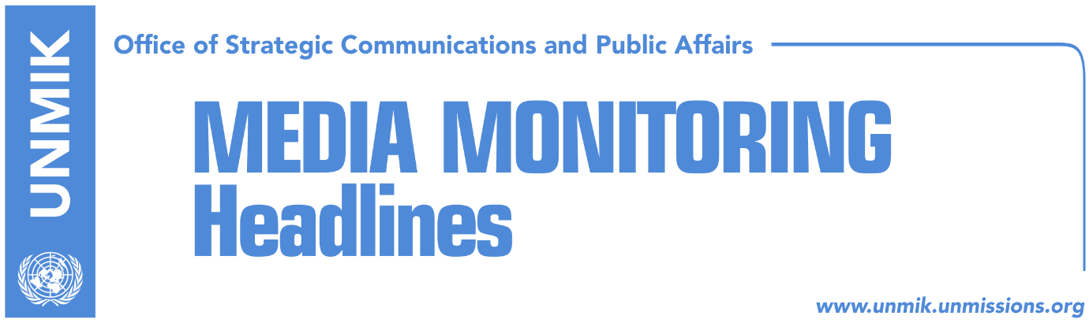

Main Stories 22 January 2018

- Thaci: Dialogue to resume at most senior level (RTK)
- Haradinaj’s response to HRT on Special Court (RTK)
- Tahiri: Special Court is a done deal (RTK)
- Kosovo Assembly presidency to meet today (Koha Ditore)
- Corteville: U.S. Embassy discussing measures if specialist court is repealed (Zeri)
- Mitrovica North conditions opening of bridge with concrete barrier (Koha)
- Kurti wins overwhelming majority of votes for top Vetevendosje post (dailies)
- Sejdiu: Serbian secret services know who killed Ivanovic (RTK/RTV21)
- Gerxhaliu: Kosovo to be equal member of CEFTA (Epoka e Re)

Kosovo Media Highlights

Thaci: Dialogue to resume at most senior level (RTK)
The President of Kosovo, Hashim Thaci, took to Facebook to write that Kosovo will continue with the dialogue for normalization of inter-state relations with Serbia until a historic agreement of peace and reconciliation is reached. He also valued the visit of the Serbian President to Kosovo Aleksandar Vucic after the murder of the Serb politician, Oliver Ivanovic saying he was pleased that during his visit to Kosovo, Vucic several times stressed the importance of the dialogue, as the only way to normalization and reconciliation. “Excluding some populist statements which are almost unavoidable during such visits, the visit of the Serbian counterpart concluded without any incidents,” Thaci wrote. “This civilized manner proves our civic and state maturity. Tolerance and understanding should remain leading principals also when inter-state relations in our region are concerned. Such agreement is necessary, because it brings clear perspective for Euro-Atlantic integration for both countries,” Thaci concluded.

Haradinaj’s response to HRT on Special Court (RTK)
The Prime Minister of Kosovo, Ramush Haradinaj was asked by the Croatian national broadcaster, HRT, if he fears the Special Court. “I have experience, I do not worry much,” Haradinaj initially said. “It is not the first time for Albanians; during Yugoslavia, half a million Albanians were in jails. Later UNMIK came, and also put us in jails. Then EULEX lately. However, Kosovo overcomes these obstacles, because it is our freedom, our right and our war. Our war was clean, war for freedom,” Haradinaj said.

Tahiri: Special Court is a done deal (RTK)
Kosovo’s Minister of Justice, Abelard Tahiri, spoke to RTK about the initiative to abolish the Special Court. “As we are all informed, it was a group of Kosovo Assembly MPs that made efforts to abolish the Special Court. It remained where it is and I will not comment is if it was a right initiative or not, but I will work in accordance to the laws in power,” Tahiri said. “I heard many statements that this Court is not judging the war but certain individuals. To be honest it sounds a bit of nonsense to me, because you cannot judge certain individuals who led the war and not judge the KLA war. It is impossible,” Tahiri said.

Kosovo Assembly presidency to meet today (Koha Ditore)
The presidency of the Kosovo Assembly is scheduled to have a meeting today but it is not clear whether the initiative for abrogating law on specialist chambers is in its agenda. The meeting was originally expected to begin at 11.00hrs but has been moved to 9.

Corteville: U.S. Embassy discussing measures if specialist court is repealed (Zeri)
The U.S. consular chief in Pristina, Brian Corteville, said in an interview to the paper that that they are discussing measures against Kosovo leaders if they continue to pursue initiative for repealing the specialist chambers. He said he hoped Kosovo leaders will heed international advice and if not, visa refusal could be one of the measures taken against them. However, Corteville underlined that this is something that will depend on the political situation.

Mitrovica North conditions opening of bridge with concrete barrier (Koha)
The paper reports on the front page that the local authorities in Mitrovica North, through the government of Serbia, has conditioned resumption of construction works for the revitalization of the main Mitrovica bridge with construction of a 1 meter-high concrete barrier citing security concerns. The government of Kosovo has not commented on these requests saying that the revitalization of the bridge will be addressed in the Pristina-Belgrade dialogue in Brussels.

Kurti wins overwhelming majority of votes for top Vetevendosje post (dailies)
Albin Kurti has been elected Vetevendosje leader by winning almost 99 percent of the party members’ votes. Kurti was the only candidate running for the post while the papers note that the recently resigned officials have not taken part in the voting process. Pristina Mayor, Shpend Ahmeti, did however vote later in the day although in a recent interview he said he did not support Kurti’s platform, Koha Ditore reports.

Sejdiu: Serbian secret services know who killed Ivanovic (RTK/RTV21)
Former President of Kosovo, Fatmir Sejdiu, spoke on RTV 21 about the recent developments in Kosovo. Asked about the Special Court, Sejdiu said that all those who acted against the law should be held responsible. He also said that demarcation of the border with Montenegro should conclude once and for all. “It is important for us to have good relations with Montenegro, but at the same time to make it clear what can be built together to end this sensitive process,” Sejdiu said. Speaking about the visit of the Serbian President to Kosovo, Sejdiu said that his visit is not completely sincere, “but let us take it as an effort which helps to shed light to the murder.” “I am convinced that Serbian services know who killed Oliver Ivanovic,” Sejdiu concluded.

Gerxhaliu: Kosovo to be equal member of CEFTA (Epoka e Re)
Safet Gerxhaliu from the Kosovo Chamber of Commerce said Central Europe Free Trade Agreement (CEFTA) had a more political than economic context in Kosovo and that Kosovo should be an equal member if it wants to benefit from the agreement. “I wish to believe that we will depoliticize this process so that Kosovo becomes equal otherwise the unequal presence in these initiatives is destined for failure,” Gerxhaliu said.

Disclaimer
This media summary consists of selected local media articles for the information of UN personnel. The public distribution of this media summary is a courtesy service extended by UNMIK on the understanding that the choice of articles translated is exclusive, and the contents do not represent anything other than a selection of articles likely to be of interest to a United Nations readership. The inclusion of articles in this summary does not imply endorsement by UNMIK.

