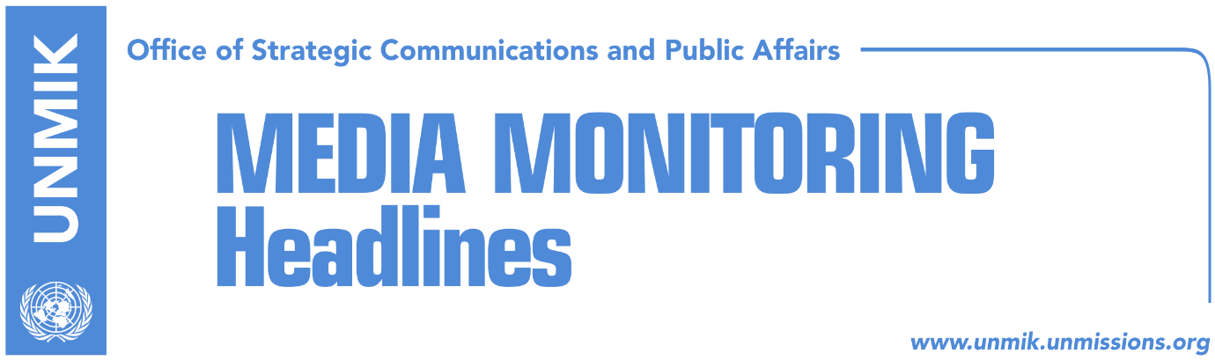

Main Stories 9 February 2018

- Haradinaj: Kosovo should forgive, but not forget the past (VoA/RTK)
- Quint countries welcome statement by leaders of special court (Epoka)
- Jashari: Specialist court to be abrogated (Epoka e Re)
- Hahn: Agreement between Pristina and Belgrade still a blank paper (Epoka)
- Hoxhaj: Dialogue with Serbia meaningless without visa liberalisation (Koha)
- Poll: Half of respondents don’t believe in end of dialogue this year (Zeri)
- Haradinaj meets CIA chief Pompeo and Assistant Secretary Mitchell (Koha)
- U.S. confirms support for Kosovo (Epoka e Re)
- Border commission seeking new facts (Koha Ditore)
- Apostolova meets Serbian List caucus leader (Klan Kosova)

Kosovo Media Highlights

Haradinaj: Kosovo should forgive, but not forget the past (VoA/RTK)
Kosovo Prime Minister Ramush Haradinaj in an interview for Voice of America on Thursday said that the only agreement that would bring peace among the people of Kosovo would be the mutual recognition with Serbia. However, according to him, this would imply that Kosovo would forgive, but not forget about the past. With regard to the EU Western Balkans Strategy launched by the European Commission, Haradinaj said that Kosovo should do its homework, even though according to him, it has been left aside by not receiving a timeline for its accession. He said that a solution needs to be found because the EU cannot say to Kosovo it has a European perspective while at the same time it cannot get closer to the EU because of some countries did not recognise it. ​He said that the specialist chambers has divided the Kosovo society with some voicing concerns it will serve as an “ethnic” court but noted that the initiative for abrogation of the specialist chambers cannot bring any changes to the court itself.

Quint countries welcome statement by leaders of special court (Epoka)
The embassies of France, Germany, Italy, the United Kingdom, and the United States have issued a statement welcoming the recent statements by Kosovo’s political leaders committing to abandon efforts to abrogate the Specialist Chambers. “We expect Kosovo’s leaders to keep their word and all Kosovo institutions to honor this commitment. Only by upholding the rule of law and ensuring justice for all victims can Kosovo affirm its maturity as a state and its readiness to fully integrate into Europe and the international community. Standing by the Specialist Chambers will enable continued support from Kosovo’s closest friends and allies as we celebrate the many achievements made in the decade since independence,” the statement noted.

Jashari: Specialist court to be abrogated (Epoka e Re)
In an interview to the paper, Xhavit Jashari head of the KLA War Martyr Families’ Association, said that he was disappointed at the withdrawal of support by Kosovo leaders in respect to the initiative to abrogate law on specialist chambers saying the move was “immoral” and “inhumane”. He called on Kosovo leadership to forward the initiative to the Assembly for vote. “If this issue is brought to the Assembly, we strongly believe the MPs will vote for abrogation of Specialist Court,” Jashari said. He said that the switch of position by the Kosovo leaders shows “their readiness to be servile to internationals” and that KLA associations will not remain idle to “allowing such a court that steps on the sovereignty of the people.”

Hahn: Agreement between Pristina and Belgrade still a blank paper (Epoka)
The EU enlargement commissioner, Johannes Hahn, said at a conference on the enlargement strategy for the Western Balkans that the agreement for normalisation of relations between Pristina and Belgrade will depend on the court of the dialogue and that for the time being this agreement is “a blank piece of paper.” “I don’t want to prejudge but it is important for the two sides to find a solution leading to a legally-binding document,” Hahn underlined. He added that the enlargement strategy gives a clear perspective to Kosovo.

Hoxhaj: Dialogue with Serbia meaningless without visa liberalisation (Koha)
Kosovo’s Deputy Prime Minister, Enver Hoxhaj, said dialogue between Kosovo and Serbia would be meaningless if Kosovo is not included in the visa liberalisation regime. “If Serbia is rewarded multifold because of the dialogue with Kosovo, Kosovo should also be rewarded in the same way,” Hoxhaj said in meetings with European Parliament members in Strasbourg.

Poll: Half of respondents don’t believe in end of dialogue this year (Zeri)
The Kosovo Democratic Institute presented findings of their recent poll regarding expectations of the people from the final stage of Pristina-Belgrade dialogue. According to the results, 51 percent of respondents don’t believe the dialogue will be concluded in 2018, 22 believe it will while 27 percent are not sure. Jeta Krasniqi, KDI project manager, said dialogue between Kosovo and Serbia continues to be without an epilogue in sight. She said further that it is yet unknown what topics will be included in the process and whether there will be other international actors involved. The poll also showed that 51 percent of Albanian respondents answered in favour of the U.S. involvement in the negotiations in contrast to 17 percent of the Serb community interviewees.

Haradinaj meets CIA chief Pompeo and Assistant Secretary Mitchell (Koha)
Prime Minister of Kosovo, Ramush Haradinaj, met the head of the Central Intelligence Agency Mike Pompeo during his visit to the U.S. In a Facebook post, Haradinaj said the two discussed security challenges in Kosovo and elsewhere. “Kosovo and the U.S. are strategic partners in many fields especially in that of security. Kosovo is blessed not to be alone in facing regional and global challenges,” he wrote. Haradinaj also met the U.S. Assistant Secretary for European and Eurasian Affairs, Wess Mitchell, and spoke to him about the need to increase the role of the U.S. in the Balkans.

U.S. confirms support for Kosovo (Epoka e Re)
Kosovo leaders – Prime Minister Ramush Haradinaj and President Hashim Thaci – took part in a reception hosted by the Kosovo Embassy in the U.S. to mark the tenth anniversary of independence. On this occasion, the U.S. President’s National Security Advisor, Herbert Raymond McMaster, said the U.S. would continue to support Kosovo in strengthening its democratic institutions and the rule of law, protection of human rights, and economic development.

Border commission seeking new facts (Koha Ditore)
The paper reports on the front page that the Kosovo government’s commission on border demarcation with Montenegro is in the process of seeking new facts in an effort to pave way for the ratification of the border agreement by the Assembly. However, head of the commission Shpejtim Bulliqi said the commission concluded its work entrusted on by the government and submitted all relevant reports. He said that there could be additional work on the mapping material which can be attached to the report at some later stage.

Apostolova meets Serbian List caucus leader (Klan Kosova)
The head of the European Union Office in Kosovo/EU Special Representative, Nataliya Apostolova, met on Thursday the Serbian List caucus leader, Sasa Milosavljevic. “I met today Srpska Lista caucus leader, Sasa Milosavljevic and discussed with him the new Western Balkans Strategy, process of reforms, EU-facilitated dialogue between Kosovo and Serbia and the need for implementation of all reached agreements,” Aposotolova wrote on Twitter.

Disclaimer
This media summary consists of selected local media articles for the information of UN personnel. The public distribution of this media summary is a courtesy service extended by UNMIK on the understanding that the choice of articles translated is exclusive, and the contents do not represent anything other than a selection of articles likely to be of interest to a United Nations readership. The inclusion of articles in this summary does not imply endorsement by UNMIK.

