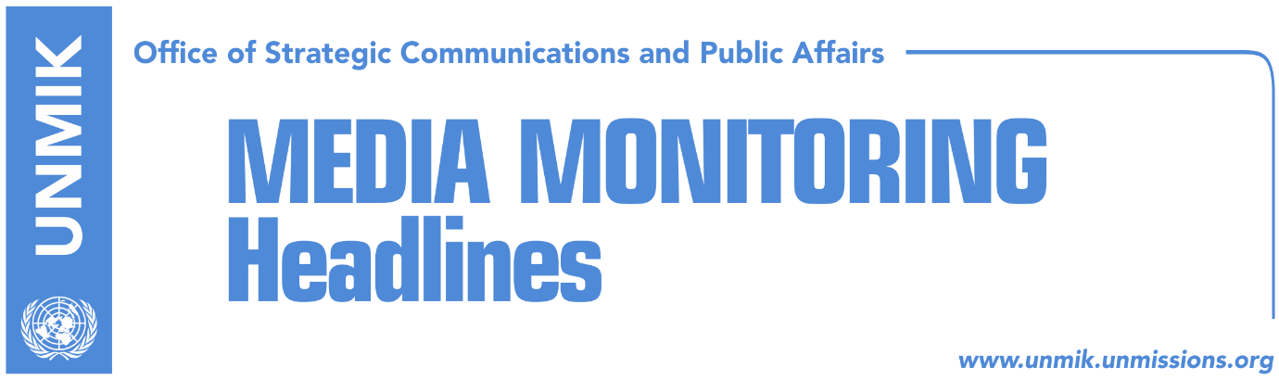

Main Stories 17 February 2018

- Clinton: Kosovo deserves our congratulations and continued support (Koha)
- Assembly to vote demarcation agreement on Sunday (Gazeta Express)
- Apostolova expects swift ratification of demarcation agreement (media)
- Fajon welcomes agreement on border demarcation (media)
- Rohan: Kosovo should not focus on U.S. and Russia but on EU membership process (Koha)
- Pacolli to Kosovo people: This summer you will travel freely (RTK)

Kosovo Media Highlights

Clinton: Kosovo deserves our congratulations and continued support (Koha)
Former U.S. president Bill Clinton, took to Facebook to congratulate Kosovo people on the tenth jubilee of independence.
“Today the proud people of Kosovo deserve our congratulations and continued support. Exactly ten years since their independence, we celebrate their achievements: delivering fair and credible elections, strengthening the judiciary, and laying the groundwork for an economy that’s attractive to international investors. The enduring peace in Kosovo remains a beacon of hope for all conflict-ridden societies around the globe,” he wrote.
“Nineteen years ago, NATO’s Operation Allied Force ended a bloody ethnic cleansing in Kosovo led by the dictator Slobodan Milosevic, which by then had killed more than twelve thousand people and displaced more than a million Kosovars. As the conflict drew to a close and the refugees began returning to their cities and villages, I traveled to Kosovo to thank the US forces, and meet the local leaders. I also visited an elementary school in Ferizaj. I told the parents and children gathered there that while their friends and allies in NATO had won the war to allow them to return to their homes, only they could win the peace. I knew they were strong enough to rebuild their lives, but rebuilding their society would be harder—building a new nation required former antagonists to work together, to find their common humanity and shared dreams amidst their many differences and grievances.”

https://web.facebook.com/notes/president-bill-clinton/kosovo-deserves-our-congratulations-and-continued-support/10156197081729866/

Assembly to vote demarcation agreement on Sunday (Gazeta Express)
Kosovo Assembly President Kadri Veseli, said on Friday after the meeting with Kosovo Assembly’s Presidency that the session on ratification of the agreement on demarcation of the border with Montenegro, will convene on Sunday at 18:00 hours. Veseli said the decision was taken in compliance with the laws of Kosovo and the Assembly’s regulation.
He told journalists that the ratification of the demarcation will happen and Kosovo loses no territory as alleged by opposition parties.

Apostolova expects swift ratification of demarcation agreement (media)
Head of the EU Office in Kosovo, Nataliya Apostolova, hosted on Friday a meeting with the President of Kosovo Hashim Thaci and political leaders.

“I welcome the joint declaration between presidents of Kosovo and Montenegro on demarcation as a significant step in direction of visa free regime for Kosovo. At a meeting in the presence of Kosovo President Hashim Thaci political parties demonstrated that consensus in the interest of Kosovo can prevail. Looking forward to a successful and swift ratification of the long-standing dispute on border demarcation with Montenegro, which will bring Kosovo citizens closer to enjoying visa free travelling opportunities,” Apostolova wrote on her Twitter account.

Fajon welcomes agreement on border demarcation (media)
The EU rapporteur for Kosovo, Tanja Fajon, welcomed the agreement reached between Kosovo and Montenegro, stating that the European Parliament will recommend visa liberalisation as soon as Kosovo fulfils the two criteria – ratification of demarcation and fighting corruption.

“Warmly welcome the signature of the annex between Kosovo and Montenegro on the border agreement. As the Rapporteur, I remain strongly committed to visa liberalisation. We will proceed as soon as possible in European Parliament when both conditions are met. We owe it to the citizens!” Fajon wrote on her Twitter account.

Rohan: Kosovo should not focus on U.S. and Russia but on EU membership (Koha)
Former deputy mediator in the Vienna discussions for the status of Kosovo, Albert Rohan, said Kosovo should focus on the process of EU membership, as it will not become member of the U.S. nor Russia.
He noted that Kosovo has marked major successes during its first decade of independence, however it needs to be done more on the war against corruption and organized crime.
He added that the agreement on border demarcation with Montenegro took more significance than it should compare to the importance of visa liberalization.

Pacolli to Kosovo people: This summer you will travel freely (RTK)
Deputy Prime Minister and Foreign Minister of Kosovo, Behgjet Pacolli congratulated Kosovo people on the tenth anniversary of the independence of Kosovo. He said that youth of Kosovo are his greatest motivation and that he is convinced that the future of Kosovo is bright. “This summer, you will all be able to travel freely in Europe,” Pacolli wrote.

Disclaimer
This media summary consists of selected local media articles for the information of UN personnel. The public distribution of this media summary is a courtesy service extended by UNMIK on the understanding that the choice of articles translated is exclusive, and the contents do not represent anything other than a selection of articles likely to be of interest to a United Nations readership. The inclusion of articles in this summary does not imply endorsement by UNMIK.

