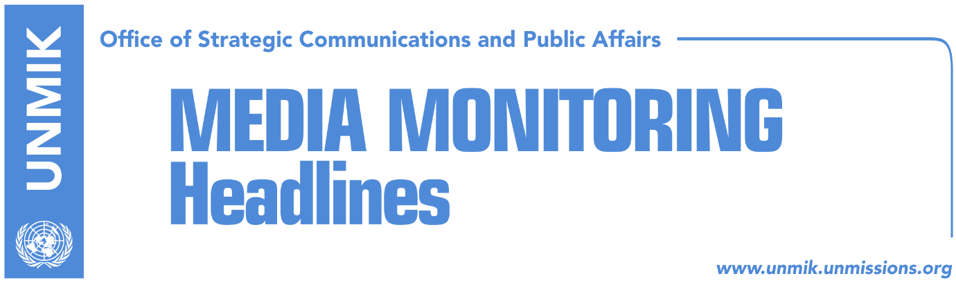

Main Stories 19 February 2018

- U.S. urges Kosovo to fight corruption on path to join EU (Koha)
- Kosovo Assembly postpones session on demarcation (Gazeta Express)
- Serbian List’s absence postpones border demarcation session (Koha)
- Montenegro signals possibility of correction of the border with Kosovo (RTK)
- “Demarcation statement not legally binding for Montenegro” (Koha Ditore)
- LDK supports border demarcation agreement with Montenegro (Kosova Sot)
- Kosovo-Serbia technical dialogue to resume 26 February (media)
- Thaci: No autonomy for north, Serbia aware that Kosovo cannot be divided (RTK)
- Thaci: KSF transformation is imminent (Koha)
- Rama: Kosovo and Albania to have single president (Bota Sot)
- LDK slams Rama’s statement on single Kosovo-Albania president (Koha)
- Vucic: Pristina should be ready for compromise (RTK)
- Lavrov: Pointless to speak about Kosovo seat at UN (Klan Kosova)
- Haradinaj to meet U.S. and French officials today (RTK)

Kosovo Media Highlights

U.S. urges Kosovo to fight corruption on path to join EU (Koha)
The U.S. Assistant Secretary of Defence for International Security Affairs, Robert Karem, said in his remarks during the reception hosted by President of Kosovo Hashim Thaci to mark the tenth year anniversary of independence that Kosovo’s future depends on the difficult choices that will have to be made today. “Citizens and leaders of Kosovo – of all ethnicities – will have to choose: Do you want a future characterized by ethnic tension or one characterized by cooperation and respect for all people? Do you want to live in a frozen conflict, isolated from the Euro-Atlantic family, or will you continue down the path of western democratic principles?,” Karem said. He said the U.S. urged Kosovo institutions to continue fighting corruption and organised crime, strengthen the rule of law, and bring justice to victims. “This means taking great care to refrain from statements that might encourage violence, especially against vulnerable minorities. This means looking for ways to be a good neighbor and to contribute to regional security. This means ratifying the border demarcation agreement with Montenegro, a new member of NATO. It also means continuing to seek a comprehensive agreement on the normalization of relations with Serbia. There is no alternative to dialogue. Kosovo’s future is not as an island, but as an integrated member of the regional and international community,” Karem noted further.

Kosovo Assembly postpones session on demarcation (Gazeta Express)
The Assembly of Kosovo issued on Sunday a press release, announcing officially that the extraordinary session on demarcation of the border with Montenegro has been postponed indefinitely. Earlier on Sunday the Prime Minister, Ramush Haradinaj, said that the session might be postponed for another day.

Serbian List’s absence postpones border demarcation session (Koha)
The paper reports that the absence of the Serbian List MPs has led to the postponement of the Kosovo Assembly session expected to take place on Sunday. The timing of the new session has not been announced yet and Prime Minister of Kosovo, Ramush Haradinaj, said that they have not received any confirmation from the Serbian List that its MPs will vote in favour of the border demarcation agreement with Montenegro. However, “I believe we will secure all necessary votes during the week,” Haradinaj said.

Montenegro signals possibility of correction of the border with Kosovo (RTK)
A statement of the Montenegrin Ministry for Foreign Affairs notes that signing of the joint declaration, respectively annex of the Agreement for demarcation of the border between Montenegro and Kosovo, is yet another a significant step of the improvement of the relations between the two countries. “The signed declaration foresees creation of a joint working group for delineation of the border, which based on Article 7 of the Agreement, represents the final phase of the demarcation phase and leaves possibility for eventual technical corrections, during the demarcation of the border in the field,” informed this Ministry. “With the solution of the demarcation matter with another neighboring country, Montenegro confirmed to be a responsible and reliable NATO member,” notes the communique.

“Demarcation statement not legally binding for Montenegro” (Koha Ditore)
The paper quotes on the front page international law professor and member of the Kosovo government’s commission on border demarcation with Montenegro, Zejnullah Gruda, as saying that attempts to justify the recent joint statement signed by Kosovo and Montenegro presidents as a solution for the ratification of the border agreement is misleading. Gruda said an agreement cannot be ratified along with placing conditions. He said an agreement is either ratified or rejected “but it is impossible to ratify it conditionally or partially.” Gruda also pointed out that joint statements are not legally binding nor do they contain legal tools to ensure their implementation.

LDK supports border demarcation agreement with Montenegro (Kosova Sot)
The Democratic League of Kosovo confirmed its position in support of the border demarcation agreement with Montenegro and said its MPs will fully endorse the draft law when put to vote. The party reaffirmed its position following a meeting of the chairmanship and parliamentary group.

Kosovo-Serbia technical dialogue to resume 26 February (media)
European Union foreign policy spokesperson, Maja Kocijancic, confirmed that the next round of the technical dialogue between Kosovo and Serbia is set to take place 26 February in Brussels. Kocijancic said both parties have agreed to the above time and added that they will be discussing implementation of agreements reached so far in the dialogue process.

Thaci: KSF transformation is imminent (Koha)
President of Kosovo, Hashim Thaci, said that the transformation of the Kosovo Security Force into Kosovo Armed Forces is imminent. “The moment of formalizing Kosovo army is knocking on an open door,” Thaci said at the parade of the KSF troops organised to mark the tenth anniversary of Kosovo’s declaration of independence. He said KSF transformation is fully supported by Kosovo’s strategic partners and NATO. Meanwhile, in a meeting with the U.S. Assistant Secretary of Defence for International Security Affairs, Robert Karem, Thaci said that KSF is ready to transform into an army and that this process will take place in partnership with the U.S.

Thaci: No autonomy for north, Serbia aware that Kosovo cannot be divided (RTK)
The President of Kosovo, Hashim Thaci, told Top Channel that agreement for demarcation opens way for free movement in Schengen zone. “We will request from Junker as we did earlier, to accelerate the process of integration for Kosovo. The best possibility would have been integration of all Western Balkans countries at the same time,” Thaci said. “There will be no autonomy. There will be no division. There will be no exchange of territories. Kosovo is a united country with territorial integrity, respected and approved internationally. In one way or another, Serbia has recognized Kosovo. I met with Serbian leaders and I know that they are aware that this is a sovereign country and this process is irreversible, but none of them has the courage to say this publicly. Without recognition of Kosovo, Serbia cannot integrate in EU,” Thaci said.

Rama: Kosovo and Albania to have single president (Bota Sot)
In his remarks at the Kosovo Assembly, Prime Minister of Albania Edi Rama argued for the need of Kosovo and Albania to have a single foreign policy as well as one president that would symbolize national unity. Rama said such an idea is currently difficult to be realized but that this could happen “within the next decade.”

LDK slams Rama’s statement on single Kosovo-Albania president (Koha)
Head of the Democratic League of Kosovo (LDK) parliamentary group, Avdullah Hoti, has opposed the idea presented by Prime Minister of Albania, Edi Rama, for Kosovo and Albania to have a single president. Hoti said such an idea shows “lack of respect for aspirations of Kosovars for an independent country, integrated into EU and NATO.”

Vucic: Pristina should be ready for compromise (RTK)
The President of Serbia, Aleksandar Vucic, met on Sunday with the U.S. Senator, Ron Johnson. Baoth parties agreed that patience and flexibility resolve all the matters in the region and improve relations between Pristina and Belgrade. “Discussions with the U.S. Senator were meaningful, comprehensive and honest,” said Vucic. He added that he has requested form the U.S. Senator to help on stabilization of the region, requesting from Kosovo Albanians to be ready for truthful solutions, which means compromise. Vucic said technical discussions between Pristina and Belgrade will resume in February and mentioned the date of 26th, while Presidents Thaci and Vucic respectively, are expected to meet in March. “Each agreement should be in favor of all parties, the future of all should be considered,” said U.S. Senator Johnson.

Lavrov: Pointless to speak about Kosovo seat at UN (Klan Kosova)
Russian Foreign Minister, Sergei Lavrov, told Belgrade news agency Beta that is pointless to speak about Kosovo’s seat at the UN for as long as there is no agreement acceptable to both Pristina and Belgrade. Until that time, “there is Resolution 1244 that recognizes autonomous province of Kosovo as part of Serbia.”

Haradinaj to meet U.S. and French officials today (RTK)
The Prime Minister of Kosovo, Ramush Haradinaj is expected to host today a meeting with Bruno Questel, official representative of the President of France. At 16:45, Haradinaj will be hosting another meeting with the U.S. Senator, Ron Johnson.

Disclaimer
This media summary consists of selected local media articles for the information of UN personnel. The public distribution of this media summary is a courtesy service extended by UNMIK on the understanding that the choice of articles translated is exclusive, and the contents do not represent anything other than a selection of articles likely to be of interest to a United Nations readership. The inclusion of articles in this summary does not imply endorsement by UNMIK.

