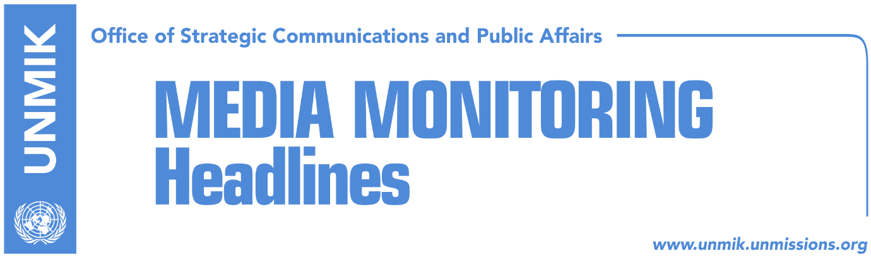

Main Stories 03 March 2018

- Demarcation week (Zeri)
- COMKFOR: Decision on exchange of territories cannot be made only by Pristina and Belgrade (Koha)
- Kosovo prevented participation at OSCE training for Eastern Europe (Koha)
- “We know the name of owner of the vehicle suspected on Ivanovic’s case” (KTV)
- Bajrami: Elections unavoidable (Ekonomia Online)
- Dacic: Kosovo Albanians are not a nation (Russia Today, Lajm)
- “Serbia should recognize Kosovo, Kosovo should offer special status to Serbian Church” (Koha)

Kosovo Media Highlights

Demarcation week (Zeri)
The next week is expected to bring an epilogue to the issue of demarcation of the border with Montenegro, which has been discussed for three years now. During the last week, the agreement failed ratification twice, due to the absence of the Serbian List MPs and objection of the agreement by Vetevendosje Movement. However, a source within the government of Kosovo, reportedly told the paper that the Serbian List will be present at the Assembly next week and that they will vote for the ratification of the agreement.
This was confirmed on Friday also by the Principal Deputy Prime Minister Behgjet Pacolli, who said the Serbian List will vote for ratification of the agreement, after 5 March.
Political analysts claim that decision of the Serbian List is related to the local elections in Serbia, which are to be held this Sunday.

COMKFOR: Decision on exchange of territories cannot be made only by Pristina and Belgrade (Koha)
KFOR Commander Salvatore Cuoci, said KFOR is not involved in discussions for exchange of territories between Kosovo and Serbia, however he did not deny that such idea could exist. “We are not part of this, we are not involved in this process. I do not know if it is more an idea or only speculation, but this could induce other situations in Balkans,” Cuoci said.
“Therefore, when we speak about exchange of territories, this is a major thing and it is not related only to these two countries. But of course this is not under our mandate; This decision is made at higher levels and perhaps, it is not a decision that could be made only in Pristina and in Belgrade,” he said.
“No matter what the solution is, we are here to support peaceful process, because everything that happens, it should happen in a peaceful manner.”
Asked if he sees danger of return of the past in Balkans, Cuoci said “as international community, I do not believe that any country would want return of the past.”

Kosovo prevented participation at OSCE training for Eastern Europe (Koha)
Lack of membership at the Organisation for Security and Co-operation in Europe (OSCE), made Kosovo miss all the trainings organized by this organization. This is the case also with the current one week training that OSCE is organizing in Albania and which focuses on increase of knowledge for professionals on criminal justice in South-Eastern Europe.
The course, which was organized by the OSCE Secretariat’s Transnational Threats Department, with the support of the OSCE Presence in Albania and the Albanian Security Academy, is being attended by 20 members of various criminal justice institutions from Albania, Bosnia and Herzegovina, the former Yugoslav Republic of Macedonia, Montenegro and Serbia.

“We know the name of owner of the vehicle suspected on Ivanovic’s case” (KTV)
Kosovo’s Interior Minister, Flamur Sefaj, told KTV that Kosovo Police is aware of the name of the owner of the vehicle, suspected on the case of Oliver Ivanovic’s murder.
“Unfortunately we saw that two Kosovo Serb police officers were involved in this case and they were arrested. The police came up immediately with initial findings, tracked the vehicle from which it appears that that the murder was committed and we managed to identify the owner of the vehicle. The owner is in Serbia, we have requested from Serbian police to start investigatons on the owner of the vehicle. In this manner we have involved Serbian police on investigations. Their information were quite general and they are still investigating. We expect to receive information from Serbian party. We possess the first and last name of this Serbian citizen,” Sefaj said.

Bajrami: Elections unavoidable (Ekonomia Online)
Kosovo Assembly MP from the Democratic League of Kosovo, Hykmete Bajrami said Kosovo’s government led by Ramush Haradinaj is standing on glass legs and added that opposition will not have to engage to bring it down, because those who are part of the government will do it themselves.
She said decisions made on political basis, lack of quorums at the Assembly and its committees, are some of the reasons to hold national elections as soon as possible.
According to her, there are problems among the coalition partners and all the decisions made so far, are clearly political and in service of the pockets of the political class.
“Enormous number of deputy ministers, decion on salary increase, distribution of funds from state reserves without any criteria, are some of the indications that the sooner this government leaves, and free democratic electons are held, the better for the citizens of the Republic of Kosovo, not mentioning the major issues that await this government,” Bajrami said.

Dacic: Kosovo Albanians are not a nation (Russia Today, Lajm)
Serbia’s Foreign Minister, Ivica Dacic told Russia Today that “we live at a time of anti-Russia hysteria in the world. We’re surely not going to join the sanctions and in that sense we shall continue to develop good relations with the Russian Federation.”
Asked about participation of U.S. representatives in the Pristina-Belgrade discussions in Brussels, Dacic said he never heard from the US that they would like to take part in those negotiations. “That’s what the Albanians from Kosovo are saying. They are actually seeking the involvement of the US in addition to the EU. On the other hand, we have to keep in mind that those proposals are put forward, we have to acknowledge them. In that case we would like to invite the Russian Federation to join as well. In the talks that President Vucic had with President Putin and with Foreign Minister Lavrov and myself, Russia has expressed readiness to join the process. But actually we don’t feel it’s necessary to expand this story right now, Vucic is quoted as saying.
It’s been 10 years after the unilateral declaration of independence of Kosovo, and it’s still an experiment. Regardless of the fact that Kosovo has been recognised by some states Kosovo hasn’t completed its independence run, it hasn’t become a UN member and member of other organisations. There are a lot of countries that do not recognise it like Russia, China, India, Indonesia, Iran, Iraq, Brasil, Argentina, Mexico, Ethiopia, South Africa, Spain. Five EU members haven’t recognised Kosovo. Also over the past few months we’ve managed to have some of the countries revoke their recognition. It means that the process is still alive, it’s not over yet. No one can have a secession without an agreement with the country from which they wish to secede. In that sense we’re for a dialogue. Some European countries say that Serbia has to, that Serbia must recognise Kosovo’s independence. But that’s not a compromise. Serbia will never recognise the unilaterally declared independence of Kosovo. When the countries which advise us to do so, when they do that themselves, there are some other standards.”
“We have our own proposals on how the compromise could look like. But the Albanians in Prishtina don’t consider it necessary to even enter a compromise. They don’t want to discuss, they just want to discuss that Belgrade should recognise their independence. That’s unacceptable for us. We can have discussions on all other issues, we have an internal dialogue on how to arrange the relations. But Albanians obviously think it’s enough to have recognition from some Western countries and that would make it a fait accompli. They’re wrong there. They have a false list of countries that have recognised them. They speak of 116 countries that recognised them. I’m sure it’s in the interest of all to actually find a compromise. But if they don’t want a compromise we shall continue our struggle.
They can create Albania if they want to but on the territory of other states. Surely, not on our territory. We want dialogue, we want dialogue to be successful, we want to reach a solution that is in the interest of all. But imposing a solution that we have to recognise Kosovo, giving ultimatums - that’s something that doesn’t work with the Serbian people.
Kosovo cannot become a member of the EU. Let me point out that you should be reading carefully what the documents of the European Union says. They have an agreement of association with Kosovo but this is, so to speak, a mini-agreement, so they agreed with Kosovo not as a state, but as a territory, with this special way of marking it exactly for the reason that there are five members that haven’t recognised Kosovo yet,” Vucic reportedly said.

https://www.rt.com/shows/sophieco/420251-russia-sanctions-eu-kosovo/

“Serbia should recognize Kosovo, Kosovo should offer special status to Serbian Church” (Koha)
The paper brings a study of Dimitris A. Moschopoulos, published by the Greek foundation “Eliamep” who proposes essence of Kosovo-Serbia agreement.

“Serbia recognizes Kosovo’s statehood and accepts all obligations incumbent on it on account of such recognition, now and in the future. Kosovo recognizes that the Serbian religious and cultural heritage in its territory belongs to the Serbian Orthodox Church, acknowledges and enshrines in its legal framework and constitutional order the exceptionality of such heritage and offers ironclad guarantees that it will live by its obligations in this respect,” stresses this study.

Disclaimer
This media summary consists of selected local media articles for the information of UN personnel. The public distribution of this media summary is a courtesy service extended by UNMIK on the understanding that the choice of articles translated is exclusive, and the contents do not represent anything other than a selection of articles likely to be of interest to a United Nations readership. The inclusion of articles in this summary does not imply endorsement by UNMIK.

