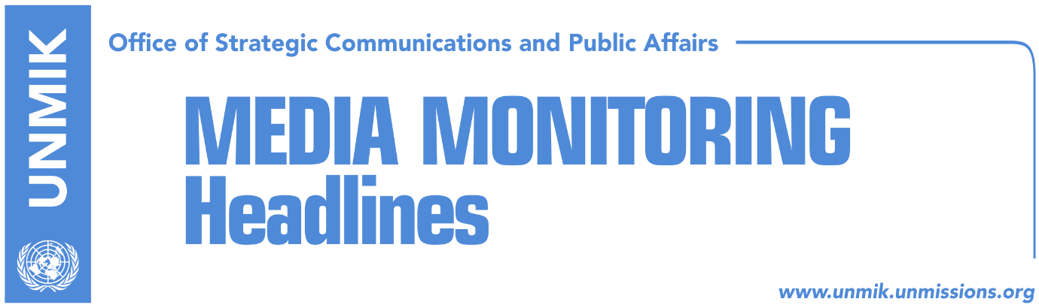

Main Stories 12 March 2018

- Last chance for demarcation to be ratified (Zeri)
- Haradinaj ready to discuss demarcation with Serbian List (Zeri/RTK)
- AAK’s Lekaj announces decisive week for demarcation (Epoka e Re)
- US Assistant Secretary of State to visit Kosovo (media)
- Kosovo may be asked to make “painful compromises” (Koha Ditore)
- Djuric: Serbia also has a four-point plan on Kosovo (Zeri)
- Pacolli urges Mauritius to recognise independence of Kosovo (Epoka e Re)
- Kosovo to renew efforts to join Interpol and UNESCO (RFE)
- Kosovo schools closed today due to teachers’ strike (dailies)

Kosovo Media Highlights

Last chance for demarcation to be ratified (Zeri)
Zeri reports on the front page that this week will be the last opportunity for Kosovo Assembly to ratify the border demarcation agreement with Montenegro and not lose another deadline for visa liberalisation. Deputy Prime Minister and Foreign Minister, Behgjet Pacolli, told the paper that he expects the border demarcation to be put to vote sometime this week, perhaps Wednesday or Thursday. “A solution will be found, absolutely. I believe this week will be crucial, [and] it most certainly the week when demarcation will happen,” Pacolli said.

Haradinaj ready to discuss demarcation with Serbian List (Zeri/RTK)
Kosovo Prime Minister Ramush Haradinaj in an interview for RTK 2 said the Assembly session on the ratification of the border demarcation deal with Montenegro should be held during this week. Haradinaj further said the ruling coalition is ready to discuss with the Serbian List on this matter. “The Serbian List is refusing to speak on this topic for the time being, but they are discussing the possibility to support this process. I respect the Serbian List, they are elected by the people, have their authority and are citizens of Kosovo. I will discuss with them to help us for the free movement of our citizens. I am ready to find a common language with the Serbian List and I believe this is in the interest of Kosovo Serbs as well, because they do not have visa-free passports and cannot travel abroad,” Haradinaj said. He said he was optimistic that the demarcation issue would be finalized this week.

AAK’s Lekaj announces decisive week for demarcation (Epoka e Re)
The deputy leader of the Alliance for the Future of Kosovo, Pal Lekaj, in an interview for the paper said that this week would be decisive regarding the border demarcation issue with Montenegro. Lekaj told the paper that he expects reflection on this matter from the Serbian List, Vetevendosje Movement, as well as from the MPs who have resigned functions in Vetevendosje. He denied claims that the ruling coalition would compromise with the Serbian List on issues that would damage Kosovo in exchange for votes. According to him, after the findings of the Bulliqi commission, and the agreement of the two presidents, there should be no hesitation to vote for the deal.

US Assistant Secretary of State to visit Kosovo (media)
The US Assistant Secretary of State for Europe and Eurasia, Wess Mitchell, will arrive today for a two-day visit to Kosovo where he is scheduled to meet President Hashim Thaci, Prime Minister Ramush Haradinaj as well as other political and civil society representatives. Mitchell is expected to reaffirm close relations between Kosovo and the US and will encourage the government of Kosovo to make progress in the dialogue for normalisation of relations with Serbia, rule of law, economic growth, and to overcome regional challenges, a statement issued by the US Embassy in Pristina noted.

Kosovo may be asked to make “painful compromises” (Koha Ditore)
The paper quotes reports from the Serbian media, namely Belgrade-based paper Novosti, saying that the US has prepared a “special package” on Kosovo will be presented to Serbian President Aleksandar Vucic this week by the US Assistant Secretary of State for Europe and Eurasia, Wess Mitchell. According to Novosti, the package foresees the Association/Community of Serb-majority municipalities taking on broader powers in the field of healthcare, education, and culture. Furthermore, the Association/Community would have close institutional ties with the Kosovo Deputy Prime Minister, appointed from the Serb community. In return, Belgrade would enable Kosovo membership in international organisations. “If the Serbian side accepts this package, it would be allowed membership in the European Union while the US would pledge wide economic and diplomatic support,” the Belgrade paper reported. Meanwhile in Pristina, the government did not specify what will be the focus of Mitchell’s upcoming visit. In a written reply, the government of Kosovo said the visit confirms US commitment to Kosovo and did not want to comment on the reports by the Serb media. At the same time, political analyst Belul Beqaj does not rule out the possibility of Kosovo being asked to make painful compromises during the process of normalisation of relations with Serbia. “Actions of this government so far show that the next compromise could be much more painful than all the previous ones made by Hashim Thaci in the name of Kosovo citizens,” Beqaj said.

Djuric: Serbia also has a four-point plan on Kosovo (Zeri)
Director of the Serbian Government’s Office for Kosovo, Marko Djuric, said in a visit to the village of Prilluzhe, Vushtrri/Vuctirn municipality on Sunday that Serbia also has a four-point plan on Kosovo and that this will be implemented successfully on the ground. Djuric’s comments come as a response to a question on what his views were on the so-called US plan for Kosovo which Serbian media reported will be presented to the Serbian President Aleksandar Vucic by the US Assistant Secretary of State Wess Mitchell this week.

Pacolli urges Mauritius to recognise independence of Kosovo (Epoka e Re)
Kosovo’s Foreign Minister, Behgjet Pacolli, has sent a letter to leadership of Mauritius congratulating them on the fiftieth anniversary of independence and urging them to recognise independence of Kosovo. “Let this 50th anniversary of your independence and the 10th of ours serve as a starting point for building new bridges of cooperation between the two countries and the two peoples,” Pacolli wrote.

Kosovo to renew efforts to join Interpol and UNESCO (RFE)
Halil Matoshi, advisor to Kosovo Prime Minister Ramush Haradinaj, told Radio Free Europe that the government is working on fulfilling all necessary criteria to join Interpol and UNESCO and plans to apply to these two organisations this year. “With regards to technical criteria that needs to be met, that is for Interpol membership, the Government of Kosovo is ready and will most certainly apply this year. With regards to UNESCO, Kosovo is all set. The two laws, on cultural heritage and religions, have already been sent to the Assembly of Kosovo. Relevant departments will at the same time assess whether Kosovo has the required votes to become part of these mechanisms,” Matoshi said.

Kosovo schools closed today due to teachers’ strike (dailies)
Papers report that Kosovo schools, including universities, will be closed today due to teachers’ strike. The teachers are demanding payment for their service during the 1990s when Serbian regime closed down Albanian-language schools but they continued to teach in makeshift facilities. Teachers union said if their demand is not heeded, they will proceed to call a general strike on 13 April.

Disclaimer
This media summary consists of selected local media articles for the information of UN personnel. The public distribution of this media summary is a courtesy service extended by UNMIK on the understanding that the choice of articles translated is exclusive, and the contents do not represent anything other than a selection of articles likely to be of interest to a United Nations readership. The inclusion of articles in this summary does not imply endorsement by UNMIK.

