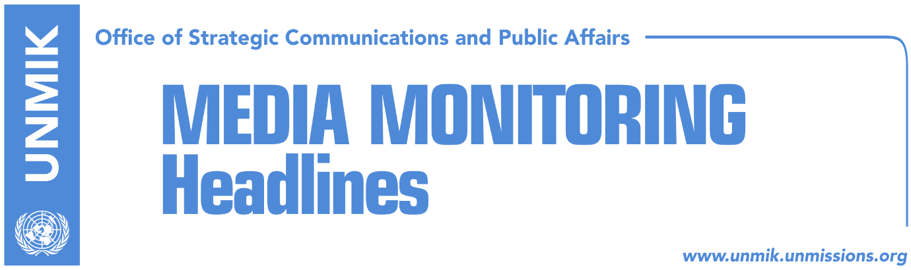

Main Stories 14 March 2018

- Government uncertain when to put to vote demarcation bill (Koha Ditore)
- Simic: We have not changed position, we will not vote demarcation (RTK)
- Serbian List demands new municipalities in exchange for border vote (Bota Sot)
- Opposition parties demand fresh elections (Zeri)
- Juncker: Balkans has more faith in EU than its members (Zeri/Lajmi)
- President Thaci meets British Foreign Secretary, Boris Johnson (RTK)
- Haradinaj meets NATO officials, discusses KSF transformation (Zeri)
- Croatian foreign minister to visit Kosovo today (Koha)
- Slovenia to support Kosovo on INTERPOL and UNESCO membership (Epoka)
- Former German Minister mediates Serbia’s energy blockade (Kosova Sot)
- Serbia hurt by U.S. diplomat’s statement on Kosovo’s army (RTK)
- “Albanians from the Valley should be involved in the new dialogue phase” (Epoka)
- Corruption remains one of main problems for Kosovo businesses (Zeri)

Kosovo Media Highlights

Government uncertain when to put to vote demarcation bill (Koha Ditore)
Although making optimistic statements, the coalition partners are not certain on when to call the Assembly session on border demarcation agreement with Kosovo, the paper reports on the front page. This, according to the paper, is largely because of Serbian List which is still not on board to support the deal. And while politicians emphasize that demarcation will be concluded this week, the Assembly of Kosovo has entered a decision-making deadlock as it is struggling to secure majority not only with regards to demarcation but also with other bills, the paper continues.

Simic: We have not changed position, we will not vote demarcation (RTK)
Kosovo Assembly MP from the Serbian List, Igor Simic, told Serbian news agency “SRNA” that his party has made its position clear last week with regards to the agreement for demarcation of the border with Montenegro, and added that their position has not changed. A few days ago, the Serbian List issued a communique which stressed that they will continue to fight for interests of Serb population in Kosovo, and not for those of some local and foreign centers of power. Simic reiterated that Serbian List will not vote demarcation despite some false news released by media in Albanian language and picked up by those in Serbia.

Serbian List demands new municipalities in exchange for border vote (Bota Sot)
The paper quotes sources saying that the Serbian List is demanding creation of two new Kosovo municipalities, that of Prilluzhe and Gora, in exchange for supporting the border demarcation agreement with Montenegro. Driton Selmanaj, MP from the Democratic League of Kosovo (LDK), said they have no information as to what the government is discussing with the Serbian List. He added however that LDK considers “political dealings like the one with the coalition with Milan Radojicic in Pristina’s bars” to be unacceptable.

Opposition parties demand fresh elections (Zeri)
Two opposition parties, Vetevendosje and the Democratic League of Kosovo (LDK), are demanding fresh elections. MPs from both parties yesterday walked out of the Assembly session as a sign of protest that their recommendations against the decision to increase government cabinet’s salaries were not put to vote. As a result, the coalition parties were forced to reschedule the session due to lack of quorum. Head of LDK parliamentary group, Avdullah Hoti, said the coalition has no majority in the Assembly and that this situation is unsustainable. He said the Assembly should be dissolved as soon as the border demarcation agreement with Montenegro is ratified. At the same time, Vetevendosje issued a statement following the Assembly’s session postponement demanding resignation of the Ramush Haradinaj-led government. “The government has fallen morally, numerically, and should now fall formally,” Vetevendosje said.

Juncker: Balkans has more faith in EU than its members (Zeri/Lajmi)
President of European Commission, Jean-Claude Juncker, said at the European Parliament in Strasbourg that Western Balkans countries seem to have more faith in European Union than its members. Speaking about his recent visit to the region, Juncker underlined how impressed he was with the passion and faith the people in the Western Balkans have towards EU. He said a great deal of work needs to be done in the Balkans, namely resolving of bilateral disputes and strengthening the rule of law. And although he said he made it clear to the region’s leaders that their EU integration depends on their own progress, “I came back convinced more than ever on a joint future.”

President Thaci meets British Foreign Secretary, Boris Johnson (RTK)
The President of Kosovo, Hashim Thaci, met on Tuesday, during his visit to London with Great Britain’s Foreign Secretary, Boris Johnson. Thaci took to Facebook to write that they discussed current developments in Kosovo and the region, especially about the dialogue for normalization of the relations between Kosovo and Serbia. “It is a joint opinion that dialogue is the only way to resolve problems, as a condition for European perspective of the two countries. Kosovo thanks the United Kingdom for the permanent support during all the periods of state building,” Thaci wrote.

Haradinaj meets NATO officials, discusses KSF transformation (Zeri)
Prime Minister of Kosovo, Ramush Haradinaj, met yesterday representatives of the NATO Advisory and Liaison Team (NALT) headed by director, General Ralf Hoffmann. Haradinaj thanked Gen Hoffmann and his team for support to the Kosovo Security Force (KSF) and expressed commitment for furthering cooperation. Haradinaj said KSF remains a professional, inclusive force determined in serving all citizens of Kosovo.

Croatian foreign minister to visit Kosovo today (Koha)
Foreign Minister of Croatia, Marija Pejcinovic Buric, is set to visit Kosovo today and meet Kosovo counterpart, Behgjet Pacolli, and Prime Minister, Ramush Haradinaj.

Slovenia to support Kosovo on INTERPOL and UNESCO membership (Epoka)
Slovenia’s Deputy Prime Minister and Minister for Foreign Affairs, Karl Erjavec, said on Tuesday in Pristina that his country will support Kosovo in the process of membership at international organisations, especially in INTERPOL and UNESCO where Slovenia is member of the executive board. Erjavec made this statement after his meeting with Kosovo’s Foreign Minister, Behgjet Pacolli.

Former German Minister mediates Serbia’s energy blockade (Kosova Sot)
The Prime Minister of Kosovo, Ramush Haradinaj, hosted on Tuesday a meeting with a German delegation, led by former Environment Minister of Germany, Klaus Topfer, who was nominated by German Government as mediator of the problem with energy between Kosovo and Serbia. A press release issued by the government of Kosovo informs that Haradinaj said his government is engaged on resolving the energy problem and requested from the international party and the government of Serbia implementation of the energy agreement reached in Brussels.

Serbia hurt by U.S. diplomat’s statement on Kosovo’s army (RTK)
Serbia’s Minister of Defense, Aleksandar Vulin, said that Kosovo can have only one armed force, and that is KFOR. According to the Serbian news agency Tanjug, Vulin made these comments after the statement of the U.S. Assistant Secretary of State, Wess Mitchell, that the U.S. support creation of the army of Kosovo. “Kosovo can have only one armed force, and that is KFOR. Until the UN Security Council does not change its decision, this is how it will remain, and to Serbia, only this is acceptable,” Vulin reportedly said. He added that “creation of such illegal armed formations represents threat for peace and stability in the entire Balkans.”

“Albanians from the Valley should be involved in the new dialogue phase” (Epoka)
Ragmi Mustafa, leader of the Albanian Democratic Party in Presevo Valley, called on Kosovo institutions to not exclude Albanians from this part during the final phase of the dialogue with Serbia. He told the paper that this is the prime time for Kosovo to raise its voice for the solution of the problem of Albanians in the Valley. According to him, this problem should be resolved at the same time as the one between Kosovo and Serbia. “We only request implementation of standards that Kosovo implements for minorities on the other side of the border. Everything that is valid for Serbs there, should be valid for Albanians here,” Mustafa said.

Corruption remains one of main problems for Kosovo businesses (Zeri)
American Chamber of Commerce in Kosovo presented yesterday the findings of a report on corruption perception by businesses and concluded that 98 percent consider corruption to be a problem for their activity but at the same time 85 percent of them admitted to never reporting it to relevant authorities. However, corruption is not the only concern Kosovo businesses have, the report found. 72 percent of businesses said they have no faith on the judicial system and 58 percent said the reason why they do not report corruption cases is because of the lack of positive results.

Disclaimer
This media summary consists of selected local media articles for the information of UN personnel. The public distribution of this media summary is a courtesy service extended by UNMIK on the understanding that the choice of articles translated is exclusive, and the contents do not represent anything other than a selection of articles likely to be of interest to a United Nations readership. The inclusion of articles in this summary does not imply endorsement by UNMIK.

