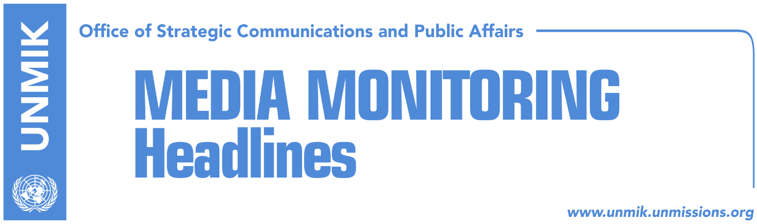

Main Stories 20 March 2018

- Kosovo Assembly with fourth attempt to ratify demarcation deal today (media)
- Haradinaj, Thaci meet to discuss border demarcation with Montenegro (media)
- Maksymiuk: Ratify the demarcation deal (Zeri)
- Dialogue resumes, implementation of agreements is discussed (Zeri)
- Der Standard: Germany prevented Thaci-Vucic agreement on partition (media)
- Hoxhaj: Kosovo should apply for CoE membership as soon as possible (media)
- KDI: Kurti, a model politician for the youth (media)

Kosovo Media Highlights

Kosovo Assembly with fourth attempt to ratify demarcation deal today (media)
Koha Ditore reports on its front page that despite an agreement with the Democratic League of Kosovo (LDK) and some individual MPs, the ruling coalition is not certain yet if it has the required number of votes to ratify the border demarcation deal with Montenegro. Unnamed sources told the paper that the coalition is still counting on the votes of Serbian List MPs and that “it will try to reach an agreement with them on Tuesday”. Meanwhile, the Vetevendosje Movement and the Group of Independent MPs have said they will vote against the border deal. Under the front-page headline Demarcation, an uncertain 80, Zeri reports that while government officials are saying they have secured the required 80 votes to ratify the border deal, PDK MPs have not confirmed this. Epoka e Re quotes European Integration Minister and PDK member, Dhurata Hoxha, as saying that they have the understanding of the Serbian List to support the demarcation deal. “Today, politicians must end the isolation of the country and vote in favor of the demarcation agreement,” Hoxha said.

Haradinaj, Thaci meet to discuss border demarcation with Montenegro (media)
Most media report that Prime Minister, Ramush Haradinaj, visited on Monday President Hashim Thaci to discuss border demarcation with Montenegro. Halil Matoshi, from the Office of the Prime Minister, confirmed the meeting. “Yes, the meeting is a regular one, as part of inter-institutional cooperation. They discussed all the priority matters of Kosovo, therefore tomorrow’s voting of the Assembly for ratification of the international agreement for demarcation of the border with the Republic of Montenegro, as well,” Matoshi said.

Maksymiuk: Ratify the demarcation deal (Zeri)
In a front-page interview to the paper, Daniel Maksymiuk, Canada’s Ambassador to Croatia and Kosovo, called on members of the Kosovo Assembly to ratify the border demarcation agreement with Montenegro. Maksymiuk said better cooperation and the economic development of both countries is among the reasons to ratify the deal. He also said the EU’s condition for Kosovo authorities to fight organized crime and corruption is aimed at building a better and more prosperous Kosovo. “In the case of Kosovo and Montenegro, there is a bilateral solution that reflects the interests of both parties. I would like to see the elected representatives in Parliament assuming their responsibilities to ratify the important deal and I am optimistic that this is what they are going to do,” Maksymiuk was quoted as saying.

Dialogue resumes, implementation of agreements is discussed (Zeri)
The Kosovo and Serbia delegations met in Brussels on Monday and will continue to discuss today and tomorrow the implementation of agreements reached so far in the EU-brokered talks. Discussions will focus on the agreement on the Association/Community of Serb-majority municipalities, the energy, the main bridge over Ibar, the freedom of movement and the integrated border management. Maja Kocijancic, spokeswoman for the European Commission, said the EU expects the full implementation of all agreements, including the agreement on the Association/Community of Serb-majority municipalities.

Der Standard: Germany prevented Thaci-Vucic agreement on partition (media)
Most media cover an article that was originally published in the Vienna-based Der Standard according to which Germany prevented an agreement on Kosovo’s partition. A senior official, who preferred to remain anonymous, told the paper that Kosovo and Serbia presidents, Thaci and Vucic, could use different channels to discuss the idea of Kosovo’s partition.

Hoxhaj: Kosovo should apply for CoE membership as soon as possible (media)
Deputy Prime Minister Enver Hoxhaj said that after the European Union, Council of Europe (CoE) is the most important organization in Europe. According to him, Kosovo should apply for COE membership as soon as possible. “Application for CoE should happen as soon as possible, as Kosovo has never had a more suitable context within the Council of Europe. During the next two years, COE will be presided by member countries which have recognized Kosovo and if we apply now, we can both enter the agenda and start fulfilling conditions to become full CoE members,” Hoxhaj said. He said time for application is now, while membership process lasts from one to three years.

KDI: Kurti, a model politician for the youth (media)
Several media report that a poll conducted by the Pristina-based Kosovo Democratic Institute (KDI) showed that Vetevendosje leader Albin Kurti and Alliance for the Future of Kosovo and Prime Minister Ramush Haradinaj lead the list of politicians preferred by youth in Kosovo. The poll also showed that young voters do not have trust in the government and political parties. “25.2 percent of youths don’t have a model politician. An even higher percentage of youths that don’t have a model politician is seen among Serb youths with 81 percent,” the poll revealed.

Disclaimer
This media summary consists of selected local media articles for the information of UN personnel. The public distribution of this media summary is a courtesy service extended by UNMIK on the understanding that the choice of articles translated is exclusive, and the contents do not represent anything other than a selection of articles likely to be of interest to a United Nations readership. The inclusion of articles in this summary does not imply endorsement by UNMIK.

