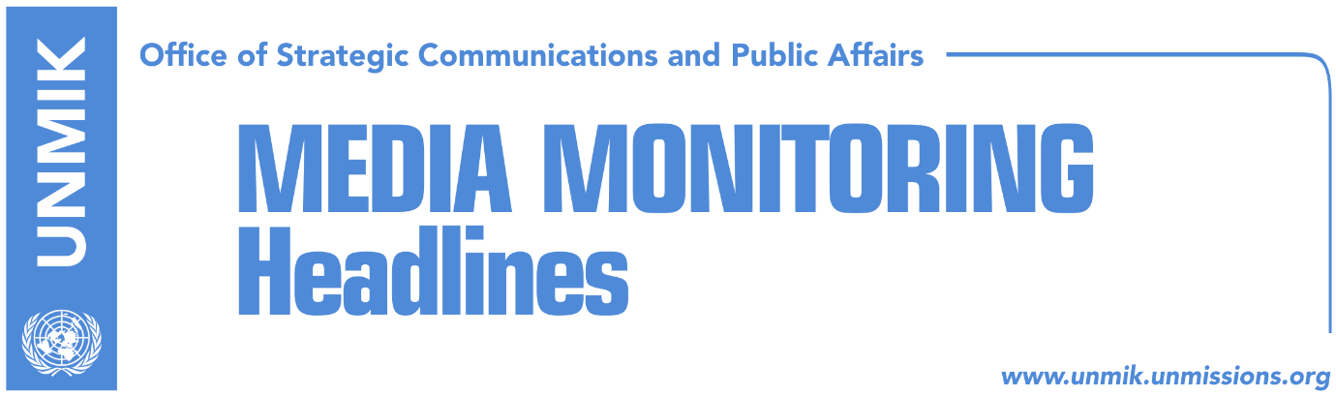

Main Stories 24 March 2018

- Federica Mogherini met with Presidents Vučić and Thaçi (media)
- Thaci: I will establish managing team for Association (Koha)
- Vucic: 1799 days have passed since signing of Brussels Agreement (Koha)
- Haradianaj: Visa liberalisaton within nine months (media)
- Opponent of Kosovo’s independence, nominated Trump’s security adviser (Koha)
- Serbia-Kosovo Handball Match cancelled due to security concerns (media)

Kosovo Media Highlights

Federica Mogherini held a meeting with Presidents Vučić and Thaçi (media)
Federica Mogherini, High Representative for Foreign Affairs and Security Policy/Vice-President of the European Commission, met on Friday 23 March with Presidents Aleksandar Vučić of Serbia and HashimThaçi of Kosovo.

They discussed further, within the framework of the new phase of the EU-facilitated Dialogue between Belgrade and Pristina, the preparations of a comprehensive agreement on normalisation of relations. They reviewed progress made in the implementation of the past agreements, in light of recent working sessions held in Brussels.

The High Representative underlined the importance the EU attaches to the full implementation of all existing agreements and stressed in particular the urgent need to start with the establishment of the Association/Community of Serb majority municipalities, the Energy Agreement and proceed with the completion of the Mitrovica Bridge.

The High Representative welcomed the continued commitment by both Presidents to the normalisation of relations between Kosovo and Serbia and recalled that progress by both on their EU integration agendas is firmly linked to progress in the Dialogue.

Thaci: I will establish a managing team for Association (Koha)
The President of Kosovo Hashim Thaci, said on Friday that Kosovo will fulfill its part of the obligation for establishment of the Association of Serb-majority Municipalities. He said he will very soon establish a Managing Team which will be dealing with drafting of the statute of this Association.

After his meeting with Serbia’s President, Aleksandar Vucic, in Brussels, Thaci said he expects a final agreement with Serbia to happen within this year.

Vucic: 1799 days have passed since signing of Brussels Agreement (Koha Ditore)
The President of Serbia, Aleksandar Vucic, said after his discussions on Friday with the EU High Representative Frederica Mogherini and President of Kosovo, Hashim Thaci, that Association of Serb-majority Municipalities was not even mentioned during the discussions.

Vucic reportedly said that 1799 days have passed since the signing of the Brussels Agreement on the Association, however, its essence was not implemented.
“We analyzed everything else, the six first points were not even touched. This cannot be only Albanians’ fault,” Vucic said. He added that Albanians will certainly say that they will do this next week.
“But this cannot go on in this manner; We have in total 23 principals and Kosovo’s Constitutional Court claims that 22 are in contradiction with the Constitution of Kosovo.” According to Vucic, the statement of the Prime Minister of Kosovo Ramush Haradianj that he did not have time to analyze this Agreement, is an insult for Serbs and Serbia

Haradianaj: Visa liberalisaton within nine months (media)
The Prime Minister of Kosovo, Ramush Haradinaj, says visa liberalization for Kosovo occurred with ratification of the Agreement for border demarcation with Montenegro. According to him, the latest date for final visa liberalization could be after nine months. “Liberalisation happened day before yesterday…the remain part of works will be completed, but it happened day before yesterday. I regret for the manner in which things happened, liberalization has happened, I know why I am saying this. There is a process of rule of law, combating of crime and corruption, ahead of us, it is a working process, but liberalization has happened,” Haradinaj said.

Opponent of Kosovo’s independence, nominated as Trump’s security adviser (Koha)
Republican nominee John Bolton, in the position of the new National Security Advisor to U.S. President Donald Trump, spurred on Friday harsh reactions around the world.

Bolton, who will replace General H.R. McMaster, is known as the strong opponent of the European agreement with Iran for stopping the Islamic Republic's nuclear program, writes Koha Ditore today.

Moreover, he has been a powerful opponent of Kosovo's declaration of independence in 2008, displaying diametrically opposite attitudes to those of the U.S. administration.

"It is best to continue the negotiations on the status of Kosovo, because this is the best way to preserve peace and stability in the region," Bolton said during a 2008 interview shortly after Kosovo's declaration of independence. Unlike Washington's official position, Bolton moreover then said, that he does not recommend recognition of Kosovo to the states of the region.

Serbia-Kosovo Handball Match cancelled due to security concerns (media)
Gazeta Express reports that the government of Serbia has decided to cancel Friday’s match of the women's junior handball game between Kosovo and Serbia due to security concerns.

Preparations for a historic handball match between political adversaries Serbia and Kosovo ended in chaos on Friday with the expulsion of the host nation after it canceled the fixture over security concerns, Reuters reports.
A press release issued by the government of Kosovo says “we condemn the acts of bad nationalism that prevent the organization of international matches, just when efforts are being made for relaxing the relations between our countries and for the Euro-Atlantic integration processes.

Fearsome and hostile situations, just when the young women willing to show a good game and spectacle were about to enter the handball court, were created as a result of the irresponsibility of the Serbian state and of Serbia's security institutions” reads the press release.

Disclaimer
This media summary consists of selected local media articles for the information of UN personnel. The public distribution of this media summary is a courtesy service extended by UNMIK on the understanding that the choice of articles translated is exclusive, and the contents do not represent anything other than a selection of articles likely to be of interest to a United Nations readership. The inclusion of articles in this summary does not imply endorsement by UNMIK.

