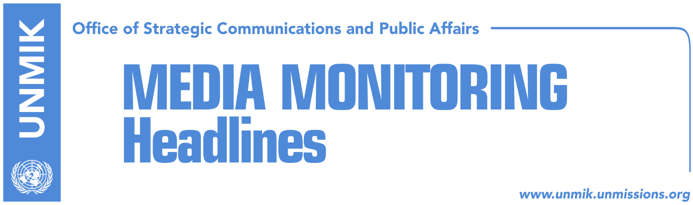

Main Stories 09 April 2018

- Pacolli: Kosovo will never discuss exchange of territories with Serbia (RTK)
- Dacic: Belgrade will try to stop Kosovo’s membership at UN (RTK)
- Pacolli: Kosovo’s participation in Sofia cannot be impeded (RTK)
- Turkish FM with a harsh message for Kosovo (RTK)
- Isa Mustafa returns to Kosovo (Lajmi.net)
- Kosovo does not accept discussion of privatization fund with Serbia (Koha)

Kosovo Media Highlights

Pacolli: Kosovo will never discuss exchange of territories with Serbia (RTK)
Kosovo’s Principal Deputy Prime Minister and Minister for Foreign Affairs, Behgjet Pacolli, took to Twitter to write that Kosovo has never and will never talk with Serbia about exchange of territories.
“Kosovo has never and will never talk with Serbia any territorial swap or partition idea which in Belgrade remains in the minds of politicians since the 90’s. Get to the table and talk on the legally binding agreement for normalization of relations and mutual recognition,” Pacolli wrote.

Dacic: Belgrade will try to stop Kosovo’s membership at UN (RTK)
Serbia’s Foreign Minister, told Serbian news agency Blic that there will be no changes in the Agreement for the Association of Serb-majority Municipalities. He added that Serbia has completed its own part and now the agreements and deadlines should be respected. “Establishment of Association is a major test for the EU, their authority will be understood at this point,” Dacic said.
Asked about partition of Kosovo, Dacic said that Pristina would accept a proposal to partition of Kosovo if it was talked to without its mentors.
"Great powers, when delineation and partition are mentioned, count on a massive displacement of the population - because they do not take into account that the ethnic situation in the field is already in line with the proposal of partition itself." He also said that great powers did not want to consider a partition of Kosovo because they think the issue of Kosovo was closed in 2008 by them recognizing its independence.
“I am sending a clear message to the international community. There will be signing of some agreement…EU should set deadlines and respect them. We have done our part of work,” Dacic said.
He further added that Serbia would not allow Kosovo’s membership at United Nations. "The fact that we will not allow Kosovo's membership in international organizations is not a matter of quarrels or tears. We want a permanent solution that would include a solution for this segment as well.”
“And if we are asked, it means that we have to ask Russia and China and give in after we asked them not to support Kosovo. Also, if we did this, it would be as if we called on all states that revoked recognition of Kosovo to recognize it again. This is not serious. Such an idea can happen, but it is difficult to be reached," he said.

Pacolli: Kosovo’s participation in Sofia cannot be impeded (RTK)
Kosovo’s Principal Deputy Prime Minister and Minister for Foreign Affairs, Behgjet Pacolli, wrote on his Facebook page that no one can impede Kosovo’s participation at Sofia Summit. "It is already official in the Council of Europe agenda. This meeting should be viewed as an opportunity to give new energies to relations between the EU and the six Western Balkan countries: from strengthening infrastructure, digital, inter-human links to the closest co-operation in fighting of common challenges such as security, migration, geopolitical developments and good neighborly relations, "Pacolli wrote on Facebook.

"History has proven that cooperation and integration into Europe has preserved peace, increased security, developed economies, and established citizens' well-being. This model remains irreplaceable," Pacolli added.

Turkish FM with a harsh message for Kosovo (RTK)
Turkey’s Foreign Minister, Mevlut Cavusoglu, said during a speech at Trade and Industry Chamber in Alanya, that Turkey was the second state after the U.S. to recognize independence of Kosovo. He added that Turkish President lobbies for recognition of Kosovo at each country that has not done so by now. Speaking about the recent arrest of six Turkish nationals in Kosovo, he said FETO supporters will be chased everywhere.
"I hope that Kosovo will be cleansed from these traitors. Our Kosovar brothers will find peace, but no matter whether in Kosovo or elsewhere, we will not allow sheltering of our traitors. Kosovo is not supposed to accommodate the traitors who have made a coup in Turkey, and that is what we are expecting from a friend. Hopefully, after this, Kosovo takes responsible steps and does what it is expected from friendship and brotherhood. " said the Turkish foreign minister.

Isa Mustafa returns to Kosovo (Lajmi.net)
The leader of the Democratic League of Kosovo (LDK) Isa Mustafa, has returned to Kosovo, after spending several months in Germany, where he went to hospital after being diagnosed with a serious illness.
Mustafa arrived at Pristina Airport on Saturday at 19:00 hours. It remains to be seen if Mustafa will conclude his mandate which ends in 2019.

Kosovo does not accept discussion of privatization fund with Serbia (Koha)
Kosovo considers Serbia’s request for inclusion of the privatization fund in the agenda of the Pristina-Belgrade talks in Brussels, to be unacceptable. Kosovo’s representative at Brussels discussions, Avni Arifi, called such request “Serbia’s joke with its own citizens.” He added that this matter would never become part of discussions. “This is a joke to make Serbs believe that they will gain money from Kosovo,” Arifi said and added that “they will be giving money to Kosovo.”
He said that war or other damages caused to Kosovo can be part of the dialogue, but never the privatization fund.

Disclaimer
This media summary consists of selected local media articles for the information of UN personnel. The public distribution of this media summary is a courtesy service extended by UNMIK on the understanding that the choice of articles translated is exclusive, and the contents do not represent anything other than a selection of articles likely to be of interest to a United Nations readership. The inclusion of articles in this summary does not imply endorsement by UNMIK.

