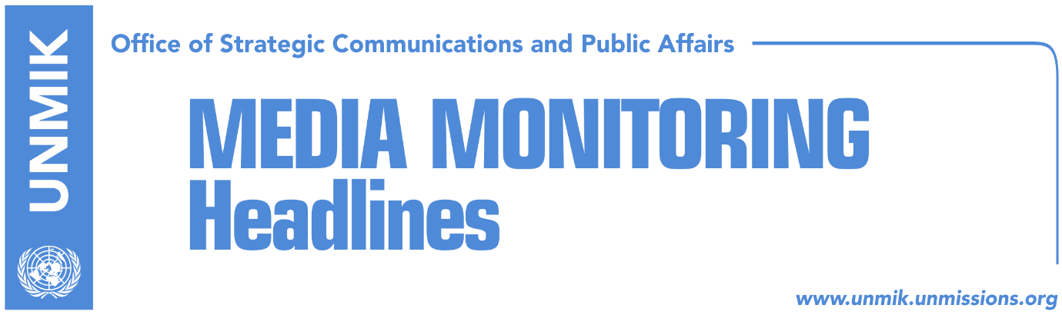

Main Stories 12 April 2018

- Haradinaj: Association/Community only in line with Kosovo constitution (Zeri)
- “Association/Community statute to be drafted in Pristina not Brussels” (Bota Sot)
- EU expects implementation of agreement on Mitrovica bridge reopening (Telegrafi)
- “Government providing shelter to indicted people” (Koha Ditore)
- FH highlights Kosovo’s problems with corruption, rule of law (Koha Ditore)
- “Greece will not be recognising independence of Kosovo” (Zeri)
- Hoxha hopes for visa liberalisation by end of year (VOA/Telegrafi)
- Vetevendosje accuses former MPs of “hijacking” referendum bill (Koha)

Kosovo Media Highlights

Haradinaj: Association/Community only in line with Kosovo constitution (Zeri)
Prime Minister of Kosovo, Ramush Haradinaj, said yesterday at the meeting of his cabinet that the draft statute for the Association/Community of Serb-majority municipalities will be in line with the Constitution of Kosovo and that once completed, it will be submitted for legal review. “The government will sent this statute to the Constitutional Court to verify its conformity to the Constitution,” Haradinaj said. He informed his ministers that the drafting of the statute for the Association/Community is underway and that three teams working on this will be also supported by OSCE experts.

“Association/Community statute to be drafted in Pristina not Brussels” (Bota Sot)
Head of the Democratic League of Kosovo (LDK) parliamentary group, Avdullah Hoti, said that it is very likely that the issue of the Association/Community of Serb-majority municipalities will be discussed in the Pristina-Belgrade dialogue in Brussels. Hoti said the work on the draft statute for the Association/Community needs to be based in Pristina not elsewhere. “Moving the issue to Brussels risks leading to additional concessions,” he warned. In a Facebook post, Hoti also spoke about the dialogue for normalization of relations between Kosovo and Serbia and that confusion regarding it is only deepening further. He said that in the absence of a new Kosovo Assembly resolution on who should lead the process, the applicable rules remain those outlined in the most recent resolution from 2011 and 2012. According to these, government of Kosovo is authorized to be in charge of the dialogue. “Any other dialogue format is in conflict to these resolutions and, as a result, any agreement reached is unacceptable. In this light, involvement of the President in the process of dialogue is in violation to the decision of country’s highest institution,” Hoti wrote.

EU expects implementation of agreement on Mitrovica bridge reopening (Telegrafi)
Maja Kocijancic, spokesperson for the EU foreign policy chief Federica Mogherini, said that the EU is expecting the agreement for the reopening of the main bridge in Mitrovica to be implemented without further delays. She said the opening of the bridge would contribute to free movement and reconciliation.

“Government providing shelter to indicted people” (Koha Ditore)
The paper reports on the front page that Ramush Haradinaj-led government has become a safe haven for many officials who have active indictments. One such example is the Minister for Economic Development, Valdrin Lluka, who is indicted on a conflict of interest charge before and most recently, Besim Beqaj, Minister of Innovation and Entrepreneurship, accused by the prosecution for criminal activity relating to hiring based on party affiliation and connections. Despite Prime Minister Ramush Haradinaj having publicly pledged to ensure his government will not consist of people who face criminal charges, he has not taken any punitive measures towards the two ministers, the paper reports. Meanwhile, civil society representatives state that Haradinaj’s passive stance only helps to promote corruption. Ehat Miftaraj from the Kosovo Democratic Institute think tank said although the ministers are presumed innocent until proven otherwise, it is unacceptable for them to be part of the government for as long as they have active indictments.

FH highlights Kosovo’s problems with corruption, rule of law (Koha Ditore)
Freedom House has published its Nations in Transit report for 2018 with Kosovo scoring 4.93 on a scale from 1 to 7 (with 1 being the most democratic and 7 the least democratic). Last year Kosovo scored 4.96. The report highlights Kosovo facing problems with the high level of corruption, rule of law, media freedom and democratic governance. The areas that scored best in the report include the scope for civil society’s activity which notes the increased number of NGOs, their organizational capacities and financial stability as well as the legal and political environment in which they operate.

“Greece will not be recognising independence of Kosovo” (Zeri)
Greek Foreign Minister, Nikos Kotzias, said his country has no plans to recognise independence of Kosovo and that Kosovo’s representation in Athens will not be of diplomatic but rather trade character. Kotzias made the remarks in Belgrade after meeting Serbian Foreign Minister, Ivica Dacic.

Hoxha hopes for visa liberalisation by end of year (VOA/Telegrafi)
Kosovo’s Minister for European Integration, Dhurata Hoxha, told Voice of America that she hoped the people of Kosovo would be able to travel freely to Europe by the end of the year. She said the government of Kosovo is now waiting for the EU assessment on implementation of visa liberalisation criteria.

Vetevendosje accuses former MPs of “hijacking” referendum bill (Koha)
Vetevendosje has accused its former MPs, now part of the Independent Group of MPs, of “hijacking” the referendum bill after the latter submitted a draft to the Assembly. Vetevendosje’s Albulena Haxhiu said they were the ones that originally planned to undertake the move and not the independent MPs. She said the bill was prepared by Vetevendosje and that earlier in the week she announced they would be submitting it this week. Meanwhile, head of the independent MPs parliamentary group, Dardan Sejdiu, said the most important thing was to have a law on referendum and it is of little relevance who submits it.

Disclaimer
This media summary consists of selected local media articles for the information of UN personnel. The public distribution of this media summary is a courtesy service extended by UNMIK on the understanding that the choice of articles translated is exclusive, and the contents do not represent anything other than a selection of articles likely to be of interest to a United Nations readership. The inclusion of articles in this summary does not imply endorsement by UNMIK.

