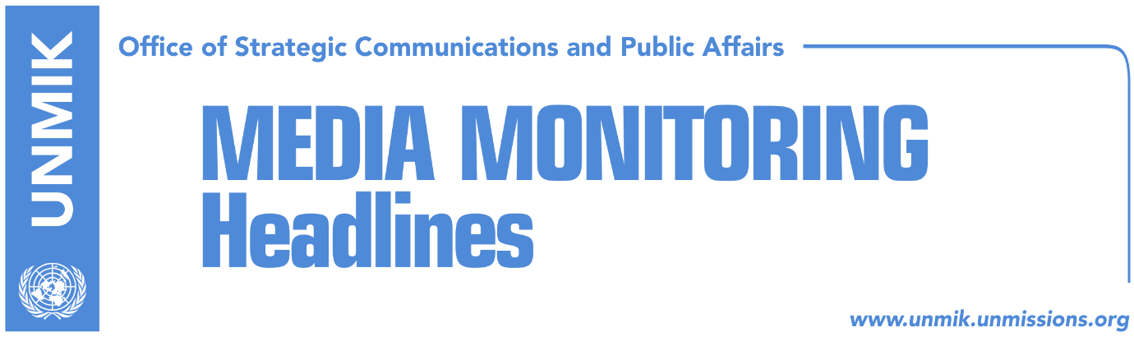

Main Stories 16 April 2018

- Kosovo Progress Report: Reforms have slowed down (Koha Ditore)
- Government to submit draft law on Kosovo army by late April (Koha)
- LDK seeks agreement on extraordinary elections (Epoka)
- Pacolli urges Israel to reconsider decision on Kosovo’s independence (Bota Sot)
- Djuric’s arrest clashes Veseli with his Serbian counterpart (Epoka)
- “NATO commends Kosovo Police on Djuric’s arrest” (Bota Sot)
- Dacic: Kosovo at UN only with Serbia’s acceptance (Zeri)
- Lunacek: Association should not have an executive mandate (Zeri)
- WB: Stability and decrease of corruption, key for tackling unemployment (Koha)

Kosovo Media Highlights

Kosovo Progress Report: Reforms have slowed down (Koha Ditore)
European Commission’s newest Progress Report on Kosovo, according to the paper, is expected to call on political leaders to be engaged in a constructive dialogue with the Assembly as the main forum for political debate as well as remain committed to the dialogue with Serbia which the EU notes needs to reach urgent progress. “Kosovo needs to continue and intensify its engagement in the dialogue with Serbia, including implementation of all agreements, particularly agreement on Association/Community of Serb-majority municipalities,” the report says. It also makes note of Kosovo’s elections process and the delays in constituting new institutions. These delays are also considered to have slowed down the reforms relating to EU integration process. “The new Government and the Assembly need to push forward EU reforms as a priority and build consensus on key strategic issues for Kosovo,” the report is quoted to say. At the same time, ratification of the border demarcation agreement with Montenegro and the increase of track record of corruption fight have received positive assessment from the European Commission. European Commission’s progress report will be published tomorrow, 17 April.

Government to submit draft law on Kosovo army by late April (Koha)
The government of Kosovo has planned to submit draft law on transformation of the Kosovo Security Force (KSF) into Kosovo Armed Forces (KAF) by the end of this month despite calls by international partners to go through constitutional changes, the paper reports. Deputy Minister of the Kosovo Security Force, Burim Ramadani, said the government is committed to implementing its legislative agenda according to plan but at the same time intensify cooperation with international partners. Ramadani did not say however whether the government has decided to give up efforts for changing the mandate of KSF through constitutional amendments because of Serbian List’s refusal to support the initiative.

LDK seeks agreement on extraordinary elections (Epoka)
The Democratic League of Kosovo (LDK) has requested reach of an agreement among the political parties for the works that should commence prior to holding extraordinary elections. LKD’s caucus, Avdullah Hoti, said on Sunday that each lost day without such agreement is a danger and loss for Kosovo. He stressed that the governing coalition has lost majority at the Assembly. “We expect from other political parties to join our initiative for a roundtable in order to agree on overcoming the current situation,” Hoti said.

Pacolli urges Israel to reconsider decision on Kosovo’s independence (Bota Sot)
Kosovo’s Foreign Minister, Behgjet Pacolli, has congratulated the people of Israel on celebrating 70th anniversary of independence and has urged the country to recognise Kosovo as an independent country. “This could be an important momentum to reflect on reviewing de jure recognition of Kosovo,” Pacolli said.

Djuric’s arrest clashes Veseli with his Serbian counterpart (Epoka)
Serbia’s President of the Assembly, Maja Gojkovic, used her speech at the fifth plenary session of the Parliamentarian Assembly of the Process of Cooperation for South Eastern Europe, to complain on the arrest of Serbia’s senior official Marko Djuric, by Kosovo Police. “Dialogue with Pristina is going on for five years now, but I have to stress a serious incident, where one of the participants of the dialogue, Marko Djuric, was arrested,” Gojkovic said. Kosovo Assembly President Kadri Veseli, immediately reacted to the statement, stressing that Marko Djuric has often visited Kosovo however he was expelled for entering Kosovo illegally. “On Djuric’s case, mentioned by colleagues from Serbia, we feel sorry, we hope that it will not be repeated in the future, but Kosovo is an independent state, therefore laws and institutions of the Republic of Kosovo have to be respected,” Veseli said. “So in the mentioned case, he came to Kosovo in an illegal manner, did not respect state authorities, made an effort to create unnecessary crisis, therefore he was not arrested, but expelled from Kosovo state,” he said.

“NATO commends Kosovo Police on Djuric’s arrest” (Bota Sot)
The paper carries a story citing Belgrade news agency Beta which in turn quoted NATO sources as saying that the head of the Serbian Government’s Office for Kosovo, Marko Djuric, entered Kosovo illegally and was rightfully detained by the Kosovo Police. The NATO source is also quoted to have said that Djuric’s visit to Kosovo was a provocation and the fact that the situation got resolved without EULEX and NATO having had to intervene, “means Kosovars know how to resolve [such] situations.”

Dacic: Kosovo at UN only with Serbia’s acceptance (Zeri)
Serbia’s Foreign Minister, Ivica Dacic, said that Kosovo can become a member of the United Nations only if this was accepted by Serbia. He added that Kosovo’s acceptance cannot happen without Serbia’s permission. He added that this is not imaginable to happen. He added that it cannot be accepted from Serbia to tell Russia and China not to impede Kosovo’s membership at UN. “Can you imagine me doing that? Tell Lavrov and my Chinese counterpart that I was joking in the past about this?” Dacic asked. He also said that no one knows what the final agreement between Serbia and Kosovo would contain. Dacic also accused Brussels for supporting Kosovo when establishment of the Association of Serb-majority Municipalities was concerned.

Lunacek: Association should not have an executive mandate (Zeri)
Former EU Rapporteur for Kosovo, Ulrike Lunacek, told the paper that the government of Kosovo should present a proposal for the Association of Serb-majority Municipalities, however this association should in no case have executive mandate. She added that local governing and cooperation among municipalities should be independent from ethnic belonging of the population. Speaking about integration path of Kosovo and Serbia, Lunacek said that after Cyprus case, no EU member state is ready to accept another country with unclear borderline for a member, therefore, there should be a recognition of Kosovo by Serbia. She said she would like for all six South-European states to be accepted at the same time, because this would eliminate the danger of mutual blockades in the membership process.

WB: Stability and decrease of corruption, key for tackling unemployment (Koha)
World Bank’s manager for Kosovo, Marco Mantovanelli, said in an interview to the paper that Kosovo needs to make efforts to decrease corruption and ensure political stability in order to effectively address unemployment. He said over 60,000 jobs were created in Kosovo over the last two years but at the same time, the number of people entering the job market during this period is higher. Mantovanelli remarked that in order to maintain the momentum of new jobs it is important for public institutions to uphold the rule of law, run an effective inspection regime and also invest in human capital. “It is also important to lower levels of corruption, real or perceived, and preserve political stability to support growth in medium term period,” the World Bank official noted.

Disclaimer
This media summary consists of selected local media articles for the information of UN personnel. The public distribution of this media summary is a courtesy service extended by UNMIK on the understanding that the choice of articles translated is exclusive, and the contents do not represent anything other than a selection of articles likely to be of interest to a United Nations readership. The inclusion of articles in this summary does not imply endorsement by UNMIK.

