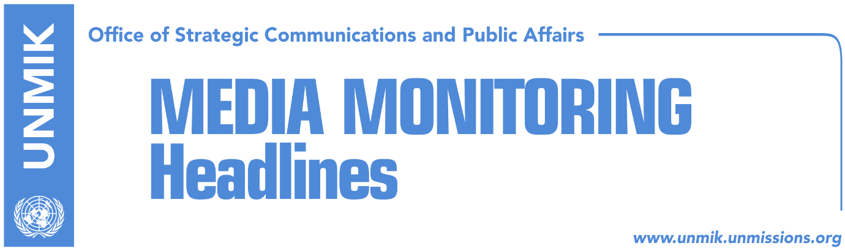

Main Stories 28 April 2018

- Tusk: Reconciliation efforts in Balkans, important for Europe (RFE, RTK)
- Thaci: EU membership provides long-term peace in the region (media)
- Thaci and Vucic do not shake hands at Brdo-Brijuni Summit (media)
- Thaci: Serbia cannot join EU if it doesn’t recognize Kosovo (media)
- Stefanovic: Haradinaj will be arrested if he enters Serbia (RTK)
- Matoshi: Kosovo is facing classic discrimination by the EU (KosovaPress)

Kosovo Media Highlights

Tusk says reconciliation efforts in Balkans 'important' for Europe (RFE, RTK)
European Council President Donald Tusk has praised Macedonia's efforts to reconcile with its neighbors as it accelerates its bid to join the European Union, saying such efforts are needed across the Western Balkans and are "important" for Europe.

Speaking at a regional summit in Skopje on April 27, Tusk singled out the festering dispute between Serbia and Kosovo over Pristina's declaration of independence 10 years ago, which Belgrade has never recognized.

Tusk compared that disagreement with a dispute over the name Macedonia between Macedonia and EU member Greece, which he said showed signs of progress toward settlement.

He said Macedonian leaders had shown "real political will" to resolve their dispute, while other regional leaders have as yet to make the "extra efforts" needed to overcome their disagreements.

"Reconciliation in this part of Europe is important for the whole continent, for our stability, peace, and prosperity," Tusk said.

"It is possible that the history of the Balkans, a kind of a never-ending horror movie, can turn into an Oscar-winning production with a happy end," he said.

This week, Tusk visited Albania, Bosnia-Herzegovina, Kosovo, Montenegro, Serbia, and Macedonia -- all former communist states and EU hopefuls.

Heads of state from all five countries, along with EU members Croatia, Slovenia, and Bulgaria, attended the summit meetings in Skopje.

Slovenian President Borut Pahor urged Balkan leaders to work harder to build good relations with their neighbors, noting that it was a precondition for EU membership.

"Brussels cannot do everything. Part of the job has to be done by Western Balkan leaders," Pahor said.

The EU has set the goal of admitting Serbia and Montenegro into the bloc as soon as 2025. The European Commission also recently recommended that Albania and Macedonia start accession talks.

Thaci: EU membership provides long-term peace in the region (media)
The President of Kosovo, Hashim Thaçi, participated on Friday at the meeting of regional leaders, which was held in Skopje, in the framework of the “Brdo-Brijuni” process. The Summit was also attended by the President of the European Council, Donald Tusk, and Bulgarian Prime Minister, Boyko Borissov, whose country is chairing the EU presidency.
In his speech, President Thaçi has said that this Summit sends a message to all that the region has changed and is an example of positive developments, mentioning the organization of many regional meetings in these recent months.

“All these meetings have made it clear to all that today, the Balkan countries, communicate, talk, dialogue with each other as a tool to solve the open issues we have. But also as a means to clearly articulate our aspirations for our future”, he emphasized.

Thaci also said that “Brdo-Brijuni” has served as an incubator from which many ideas and initiatives have emerged which afterwards have taken forms of regional cooperation and beyond.

“Above all, here, it is confirmed by all that our common aspiration is the membership of our countries in the European Union. This membership means a determination for sustainable peace, stability, development, prosperity for all of our citizens”, said President Thaci.

According to him, all have welcomed the European Commission’s Strategy, which 15 years after the Thessaloniki Summit again clearly reaffirms that the door is open for all Western Balkan countries to join the EU.
“The Sofia Summit, of the EU and the Western Balkans, has a historical character and is a tremendous opportunity for us all”, he emphasized.

http://www.president-ksgov.net/en/news/president-thaci-eu-membership-provides-long-term-peace-in-the-region

Thaci and Vucic do not shake hands at Brdo-Brijuni Summit (media)
Media report that during the “Brdo Brijuni Summit” which was held behind the closed doors, the President of Serbia, Aleksandar Vucic, had some verbal clashes with the President of Kosovo, Hashim Thaci and cold relations with the Croatian President, Kolinda Kitarovic
After the meeting, Vucic told media that leaders of the region are lying themselves that good things are happening. Speaking about the disagreements between Zagreb and Belgrade, Vucic said “we have become ridiculous in front of the entire international community.”
Speaking about EU membership, Vucic said “they all appear with nice speeches but no one helps membership.” According to him, if it wasn’t for the German Chancellor, Angela Merkel, no one could predict what could happen with the region.
Vucic addressed a range of criticisms toward the President of Kosovo, Hashim Thaci with regard to the arrest of the director of the Office for Kosovo at Serbian government, Marko Djuric and about the Association of the Serb-majority Municipalities. He said he did not shake hands with Thaci because he does not trust him on anything.

Thaci: Serbia cannot join EU if it doesn’t recognize Kosovo (media)
The President of Kosovo, Hashim Thaci, told the Croatian daily Vecernje Novosti that Kosovo is determined to create its own army. He also promised that Croatians will soon have a seat at the Assembly of Kosovo.
Speaking about the Association of Serb-majority Municipalities, Thaci said it is not true that leadership in Kosovo is rejecting its establishment. “Kosovo is faithful to all international obligations, including the first Agreement signed between Kosovo and Serbia on 19 April 2013. A few days ago we agreed for the managing team to make preparations for the draft-statute of the Association, of course in close cooperation with the government of Kosovo and with the help of the OSCE in Kosovo. The Association of Serb-majority Municipalities will be established in complete accordance with the Constitution of Kosovo and Kosovo laws,” Thaci said.
He further added that normalization of relations between Kosovo and Serbia is the duty of this generation. “This is the basic condition for Kosovo and Serbia to join the EU,” he said.
Asked about recent claims of the President of Serbia, Aleksandar Vucic, that the Russian President has promised military support to defend Serbs in Kosovo, Thaci said that the best defense of Kosovo Serbs was ensured with the Constitution of Kosovo, Kosovo laws and cooperation between Albanian and Serb politicians, be it at the Assembly and the government of Kosovo, or at the local level, among municipal authorities. “As far as military defense is concerned, we all know what consequences left the war in Kosovo during 1998-1999,” Thaci said.
Stefanovic: Haradinaj will be arrested if he enters Serbia (RTK)
Serbia’s Interior Minister Nebojsa Stefanovic, said Kosovo’s PM Ramush Haradinaj will be arrested if he enters Serbia, because the domestic court's warrant is still valid.
"Our court's warrant for him is in force and he will certainly be arrested if he is accessible to the police," Stefanovic told Serbian media on Friday.

Stefanovic’s statement came after the reporting of the media that Haradinaj said he was ready to visit the three municipalities with Albanian majority in Serbia, Presevo Medvedja and Bujanovac.

Matoshi: Kosovo is facing classical discrimination by the EU (KosovaPress)
Halil Matoshi, adviser to the Prime Minister Ramush Haradinaj, has addressed criticism to the European Union for the approach towards Kosovo, saying that the manner in which Brussels is treating official Belgrade, represents classical discrimination of Kosovo.

"I am not a fan of reciprocity in aggression, but if the threat of an independent country's prime minister, from a country like Serbia which does not guarantee the fundamental right for life, does not cause indignation in the EU, towards those who release from charges criminals who executed civilians in Kosovo, as if it were for exceeding speed on the highway, and if there is no reaction from Brussels to a degree of shock, it can be concluded that Kosovo is facing classic discrimination by the EU," Matoshi wrote.

Disclaimer
This media summary consists of selected local media articles for the information of UN personnel. The public distribution of this media summary is a courtesy service extended by UNMIK on the understanding that the choice of articles translated is exclusive, and the contents do not represent anything other than a selection of articles likely to be of interest to a United Nations readership. The inclusion of articles in this summary does not imply endorsement by UNMIK.

