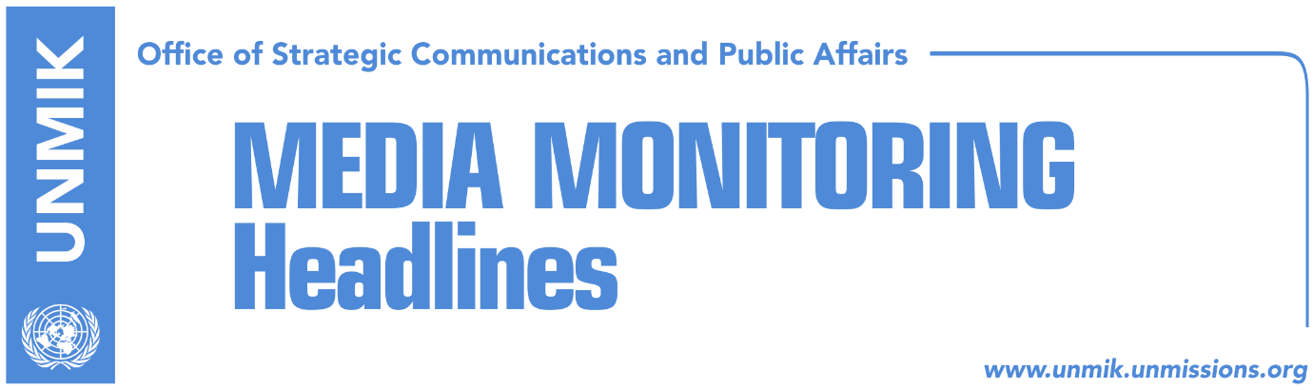

Main Stories 7 May 2018

- Assembly unlikely to adopt platform on dialogue (Koha)
- KFOR ready to assist in specialist chamber’s arrests (Zeri)
- Kurti warns against attempts to create ACSMM during Assembly’s break (Zeri)
- Report: “Time for action in the Western Balkans” (media)
- EULEX not needed in Kosovo after June 14 (Epoka)
- Kosovo applies for OIC observer status (Zeri)
- Chabert: Border demarcation not enough for visa liberalisation (Kosova Sot)

Kosovo Media Highlights

Assembly unlikely to adopt platform on dialogue (Koha)
The paper reports on its front page that regardless of the readiness of political parties to reach consensus for the final phase of talks with Serbia, the key issue that divides them is President Hashim Thaci’s role in the process. There are different positions even among partners of the ruling coalition, making it unlikely for the Assembly to adopt the platform on dialogue. Representatives of Prime Minister Haradinaj’s office did not say how they will address differences in the ruling coalition on Thaci’s role. They said the platform will be discussed in the Assembly, “and then it will be up to the Assembly to decide what will happen next”. Memli Krasniqi, head of the Democratic Party of Kosovo (PDK) parliamentary group, told the paper on Sunday: “we have yet to discuss the platform, but our position in principle is that a broad-based consensus is required on dialogue”. Jeta Krasniqi from the Kosovo Democratic Institute is quoted as saying that a genuine platform on dialogue should have been adopted following a comprehensive inter-political and inter-social dialogue.

KFOR ready to assist in specialist chamber’s arrests (Zeri)
KFOR Commander, Major General Salvatore Cuoci, said in a front-page interview with the paper that if necessary, they are ready to assist Kosovo authorities in undertaking arrests of possible indictees of the specialist chambers. “We will ensure freedom of movement and safe environment by trying to avoid any deterioration as a result of arrests and, in essence, we will continue to provide security for all the people of Kosovo,” Cuoci said. COMKFOR Cuoci said that while the security situation in Kosovo has improved, it remains fragile. He however made it clear that KFOR is the third responding force for security in Kosovo, following the Kosovo Police and EULEX, and will only intervene “in managing military problems.” Asked about whether the arrest of Serbian government’s official Marko Djuric by Kosovo Police could have had repercussions on the security situation, Cuoci said KFOR had close cooperation during the operation with Kosovo authorities in order to avoid any deterioration. “I think it was a success story although the arrest was something on which we can discuss and conclude that perhaps the brutal force of the Kosovo Police could have been avoided.” As for the transformation of the Kosovo Security Force (KSF), Major General Cuoci reaffirmed the position of NATO that the process should take place through constitutional changes.

Kurti warns against attempts to create ACSMM during Assembly’s break (Zeri)
Vetevendosje leader, Albin Kurti, has warned against what he called attempts by the government to establish the Association/Community of Serb-majority municipalities during the Assembly’s summer break. He said this should be prevented by all means adding that the Association/Community will not have the character of a non-governmental organisation but would lead to “Bosnianisation” of Kosovo. In his remarks at the Vetevendosje general council, Kurti also said that President of Kosovo, Hashim Thaci, should not be leading the dialogue with Serbia. “On the one hand he is very afraid of the specialist court which he imposed with the immense pressure on PDK MPs and on the other hand he wants the dialogue to be his legacy and to legitimize it,” Kurti said of Thaci.

Report: “Time for action in the Western Balkans” (media)
The EastWest Institute, together with the National Committee on American Foreign Policy issued a report examining the need for immediate, decisive action by the United States and the European Union to address pressing issues and prevent potential conflict in the Western Balkans. The Western Balkans—Bosnia-Herzegovina, Macedonia, Kosovo, Montenegro, Albania, and Serbia—are once again an area of concern owing to deficient internal governance, economic challenges, intraregional ethnic frictions and external influences. In the face of early warning signs, the report presents a fresh look and advocates for a coordinated response, introducing achievable policy steps that are practical under the current socio-economic conditions. Bota Sot and Epoka e Re cover the report under the headline Serbia to recognize Kosovo and not obstruct formation of army. Link to the full report: https://www.ncafp.org/2016/wp-content/uploads/2018/05/Time-for-Action-in-the-Western-Balkans.pdf

EULEX not needed in Kosovo after June 14 (Epoka)
Representatives of the ruling coalition and the opposition believe that the EU Rule of Law Mission (EULEX) will no longer be needed in Kosovo after June 14. Justice Minister Abelard Tahiri told the paper on Sunday that Kosovo’s judiciary has the required capacities and that EULEX should no longer have an executive mission. Democratic League of Kosovo (LDK) MP Naser Rugova said EULEX should conclude its mandate in line with the existing agreement.

Kosovo applies for OIC observer status (Zeri)
The government of Kosovo has applied for an observer status with the Organisation of Islamic Cooperation (OIC), announced advisor to Foreign Minister Behgjet Pacolli, Jetlir Zyberaj. He said the objective of the application bid is for Kosovo to deepen cooperation with OIC member states and gain access to development funds.

Chabert: Border demarcation not enough for visa liberalisation (Kosova Sot)
The French Ambassador to Kosovo, Didier Chabert, said in an interview with the paper that Kosovo’s determined efforts to fight corruption and organised crime is the final remaining criteria for the visa liberalisation. He said the government of Kosovo is fully aware of what the EU expects it to do and a report will be drafted on how well Kosovo institutions have performed.

Disclaimer
This media summary consists of selected local media articles for the information of UN personnel. The public distribution of this media summary is a courtesy service extended by UNMIK on the understanding that the choice of articles translated is exclusive, and the contents do not represent anything other than a selection of articles likely to be of interest to a United Nations readership. The inclusion of articles in this summary does not imply endorsement by UNMIK.

