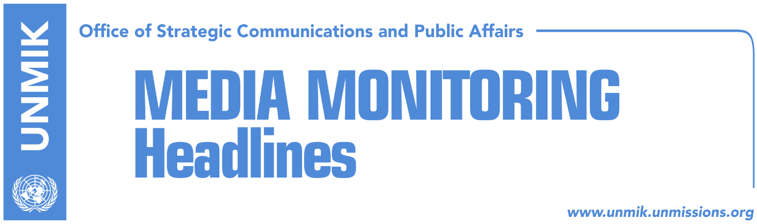

Main Stories 14 May 2018

- Sofia summit statement provides no concrete enlargement perspective (Koha)
- Kosovo leaders set to take part in EU-Balkans summit in Sofia (Zeri)
- UN Security Council to discuss Kosovo today (media)
- Final agreement to lead to constitutional changes in Kosovo and Serbia (Koha)
- LDK: Kosovo to head to elections as soon as possible (Zeri/RFE)
- AAK rejects idea of early elections (Koha/RFE)
- Vetevendosje to host third gathering of political parties (Zeri)
- Hoxhaj reacts to Vucic’s statement on independence of Kosovo (RTK)
- Bondsteel commander: Political issues to be resolved through dialogue (Zeri)
- Pacolli supports idea of creation of U.S. economic zone (Epoka)

Kosovo Media Highlights

Sofia summit statement provides no concrete enlargement perspective (Koha)
The paper on the front page carries what it says is the draft statement of the EU-Western Balkans summit in Sofia which has been agreed in a meeting of permanent representatives of EU member states without the presence of Western Balkans officials. According to Koha Ditore, in terms of enlargement perspective for the region, the statement offers less than what was provided by the Thessaloniki summit 15 years ago. However, the current document does offer more concrete initiative for the connectivity of the region aimed at getting the Western Balkans closer to EU standards. “This summit could be interpreted as an encouragement by those interested in the development of the region but also as a disappointment by those who have been waiting for a clear signal that regional countries will be soon welcomed to EU,” the paper writes. The statement does nevertheless express commitment to the Western Balkans European perspective and hails the efforts towards European principles and the vision for a strong, stable and united Europe.

Kosovo leaders set to take part in EU-Balkans summit in Sofia (Zeri)
Kosovo delegation scheduled to take part in the EU-Western Balkans summit in the Bulgarian capital Sofia will consist of President Hashim Thaci, Prime Minister Ramush Haradinaj, and Foreign Minister Behgjet Pacolli. President Thaci’s advisor, Ardian Arifaj, said Kosovo will be represented at the summit equally to all other participants and ruled out the possibility of non-recognising countries presenting any problems in this regard. “There were some reservations at the beginning but Kosovo is very appreciative to Bulgaria as an organizer and host and to other countries that insisted summit only makes sense with all Western Balkans countries,” Arifaj said. He noted further that the Kosovo delegation will be led by President Thaci.

UN Security Council to discuss Kosovo today (media)
The United Nations Security Council will be discussing today the quarterly report of the UN Secretary-General, Antonio Guterres on UNMIK’s work in Kosovo. In his report for the work of UNMIK in the period from 17 January to 15 April, Guterres calls on the leaders in Belgrade and Pristina to continue to treat contested matters through dialogue and demonstration of political will, required for complete normalization of the relations.
“The conduct of Kosovo police during a high-profile operation such as the arrest of Mr. Djuric, which resulted in a number of injuries, is cause for concern. A thorough inquiry is needed into the 26 March events, with corrective action in case of failures to uphold human rights,” Guterres said. He also expressed concern, about the slow pace of progress of the investigation into the 16 January murder of Kosovo Serb politician Oliver Ivanovic. The report hails ratification of the agreement for demarcation of the border with Montenegro at the Assembly of Kosovo, which shows Kosovo’s commitment for European perspective.

Final agreement to lead to constitutional changes in Kosovo and Serbia (Koha)
The paper quotes sources saying that one of the options being discussed by the international community and local officials foresees both Kosovo and Serbia changing their constitutions to accommodate the provisions of the final legally-binding settlement. Sources said that Pristina may be asked to give the local governments more powers and increase the competencies of the Association/Community of Serb-majority municipalities while at the central level minority communities would be stripped of the right to double vote with regards to constitutional changes. This would in turn pave way for the transformation of the Kosovo Security Force into a Kosovo army. Kosovo’s UN membership has also been discussed as part of the settlement which would happen without Serbia’s formal recognition of Kosovo and an indirect pledge from Russia that it would not impede Kosovo’s membership. Sources further said that intensive meetings at the senior level are expected to begin in June in an effort to reach a final agreement between Kosovo and Serbia.

LDK: Kosovo to head to elections as soon as possible (Zeri/RFE)
The Democratic League of Kosovo (LDK) reiterated calls for early elections in Kosovo saying the current government has lost parliamentary majority. Head of the party’s parliamentary group, Avdullah Hoti told Radio Free Europe that regardless of whether joint political groups will be formed on key issues like the dialogue with Serbia, Association/Community of Serb-majority municipalities, transformation of the Kosovo Security Force, or election reform, the fact of the matter remains that there is no parliamentary majority at the Assembly and this prevents the normal functioning of institutions. “We need to agree on the country heading to fresh elections as soon as possible,” Hoti said.

AAK rejects idea of early elections (Koha/RFE)
The Alliance for the Future of Kosovo (AAK) has rejected the prospect of Kosovo heading to early elections. The head of AAK parliamentary group, Ahmet Isufi, said there are more important issues Kosovo needs to focus right now than think about elections such as the dialogue with Serbia and transformation of the Kosovo Security Force.

Vetevendosje to host third gathering of political parties (Zeri)
Vetevendosje will organise this week the third roundtable with representatives of parliamentary parties but it does not expect any breakthrough on issues considered of national interest. Tinka Kurti, member of Vetevendosje chairmanship, told the paper: “Vetevendosje Movement will organise this roundtable but we don’t expect the change of approaches.”

Hoxhaj reacts to Vucic’s statement on independence of Kosovo (RTK)
Deputy Prime Minister of Kosovo, Enver Hoxhaj, reacted to the statements of the President of Serbia, Aleksandar Vucic, who said that Serbs stamped Kosovo’s independence. “Kosovo’s independence has been sealed by people’s will, sacrifice and determination, and not from Serbia’s wrong politics! Our independence is not a triumph over Serbia, but a legitimate right to exists, both as citizens and as a state,” Hoxhaj wrote on his Twitter account.

Bondsteel commander: Political issues to be resolved through dialogue (Zeri)
The commander of the US army base Bondsteel, Colonel Nick Ducich told Serbian media that the security situation in Kosovo is calm and that KFOR troops are doing everything to ensure a safe and secure environment for all the people of Kosovo. “Security situation in my area is calm and stable. In my view, biggest problems Kosovo faces, as pointed out by the European Commission as well, are corruption and organised crime,” Ducich said adding that political issues in Kosovo need to be resolved through dialogue.

Pacolli supports idea of creation of U.S. economic zone (Epoka)
Kosovo’s Foreign Minister Behgjet Pacolli, pledged that he would move forward the idea for creation of a special U.S. economic zone. He wrote on his Facebook account that there are many U.S. companies which are interested to invest in Kosovo. “I strongly support the launched idea for creation of economic zones, especially a zone for U.S. investors, which would be an additional pillar of the strategic relations between Kosovo and the U.S. and it will attract companies to come to Kosovo,” Pacolli wrote.

Disclaimer
This media summary consists of selected local media articles for the information of UN personnel. The public distribution of this media summary is a courtesy service extended by UNMIK on the understanding that the choice of articles translated is exclusive, and the contents do not represent anything other than a selection of articles likely to be of interest to a United Nations readership. The inclusion of articles in this summary does not imply endorsement by UNMIK.

