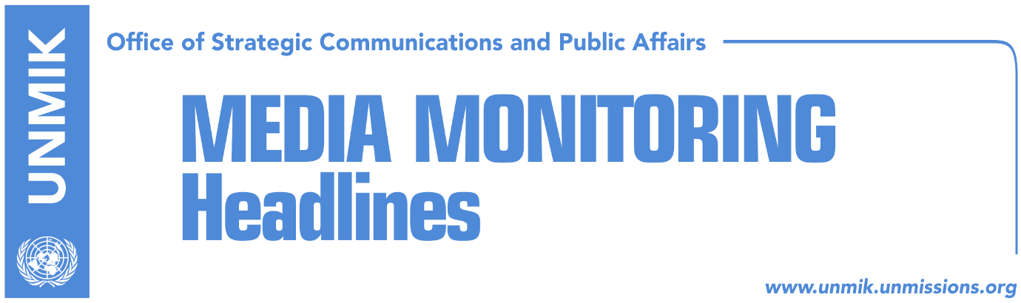

Main Stories 16 May 2018

- 28 EU states approve declaration on Western Balkans (Koha Ditore)
- Fajon: EU Commission to deliver assessment on progress as soon as possible (media)
- EC appeals to government to set a limit on deputy ministers (Koha)
- “QUINT met in Washington onto discuss final phase of dialogue”(Gazeta Express)
- Clark: Mission in Kosovo is not completed (Koha)

Kosovo Media Highlights

28 EU states approve declaration on Western Balkans (Koha)
Officials of the European Council confirmed that representatives of the 28 EU countries agreed on the text of the joint declaration to be endorsed at the EU-Western Balkans Summit, which will be held in Sofia, on 17 May. A senior EU official told the paper that it was difficult to reach a consensus at EU on this text, due to the five countries which have not recognized Kosovo. He called this agreement a big achievement, as 28 countries agreed at least on the content of the declaration. He said protocol experts found a solution on how to ensure participation of all at Sofia Summit. “There was no request of Spain which we did not fulfill,” said this source adding that they did not even hope that the Prime Minister of Spain would participate. However, this country will be represented by a lower level. As a compromise, it was decided to refer to the Western Balkans countries as “partners”, while the Summit will not be on enlargement, but only on practical matters, such as connectivity, coordination of actions on migration, justice reforms and some other issues, reports this daily.

Fajon: EU Commission to deliver assessment on progress as soon as possible (media)
The European Parliament Rapporteur for Kosovo, Tanja Fajon, met on Tuesday in Brussels with Kosovo’s Deputy Prime Minister Enver Hoxhaj. They discussed developments in Kosovo and process of visa liberalization.
“Just had a productive meeting with Enver Hoxhaj at the European Parliament. Visa liberalization is a top priority for Kosovo. I reconfirmed my strong support to the process and will encourage EU Commission to deliver its assessment on the progress as soon as possible.
I will do everything in my power at the European Parliament to build and pursue progress,” Fajon wrote on her Twitter account.
Hoxhaj met also with European Commissioner for European Neighbourhood Policy and Enlargement Negotiations, Johannes Hahn and with the
European Commissioner for migration and home affairs, Dimitris Avramopulos.

EC appeals to government to set a limit on deputy ministers (Koha)
The European Commission has appealed to the government of Kosovo to set a limit on the number of the deputy ministers, be it through the draft law for functioning of the state administration and independent agencies or the one on the government. This appeal came as part of the joint conclusions of the Special Group for Public Administration, published on Tuesday. After the meeting which took place at the end of April.

“QUINT met in Washington onto discuss final phase of dialogue”(Gazeta Express)
Kosovo President’s political adviser, Blerim Shala, told T7 broadcaster that the QUINT representatives held a meeting in Washington last week to discuss final phase of Kosovo-Serbia dialogue and coordination on Kosovo’s membership into international organisations.

“As far as we know the QUINT representatives held two meetings for two specific issues. The first topic was coordination of the QUINT members with regard to Kosovo’s membership into international organisations, including INTERPOL hopefully this year, and potential membership at UNESCO next year. In general the meeting was about Kosovo’s international representation,” Shala said.
“The second meeting was dedicated exclusively to the Kosovo-Serbia dialogue, namely the final phase of the dialogue,” Shala added.
Gazeta Express reported that the European countries were represented in this meeting by political directors for Balkans whereas the U.S. by its State Department official dealing with Balkans.

Clark: Mission in Kosovo is not completed (Koha)
Former NATO’s Supreme Allied Commander Wesley Clark, who arrived in Kosovo on Tuesday, told Kohavision that the mission started in Kosovo in 1998, has not ended yet. He insisted that it is time to conclude Kosovo’s state building and that time has come for Serbia and Kosovo to normalize their relations. According to him, Kosovo should become a UN member, while Serbia and eventually Kosovo, should become EU members. Clark considers that Kosovo’s recognition by Serbia is possible. He warned that the danger for the region comes from Russia and Turkey as well as practices of autocratic local leaders, who do not understand that in democracy, wealth comes from business and not from being in power. “The best way to ensure a democratic, independent future of Kosovo is through economic development. If I were in Kosovo, under KFOR and NATO protection, I would rather want government resources to be spent on economic development than on army,” Clark said.

Disclaimer
This media summary consists of selected local media articles for the information of UN personnel. The public distribution of this media summary is a courtesy service extended by UNMIK on the understanding that the choice of articles translated is exclusive, and the contents do not represent anything other than a selection of articles likely to be of interest to a United Nations readership. The inclusion of articles in this summary does not imply endorsement by UNMIK.

