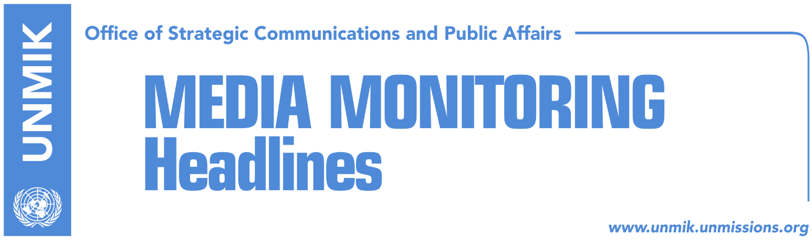

Main Stories 18 May 2018

- Thaci talks about final agreement with Serbia in 6-9 months (Koha)
- “Thaci hints at compromise with Serbia” (Zeri)
- Kosovo represented through footnote at EU-Western Balkans summit (Zeri)
- Haradinaj hails EU-Western Balkans statement as progress (Klan Kosova)
- Hahn: Open perspective for Western Balkans (RTK/DW)
- Pacolli: Political disagreements are impeding economic cooperation (RTK)
- U.S. KSF transition through constitutional amendments (Koha)
- Police directors of the region discuss war against crime and terrorism (Zeri)

Kosovo Media Highlights

Thaci talks about final agreement with Serbia in 6-9 months (Koha)
In its leading front-page story, the paper covers the EU – Western Balkans Summit in Sofia, Bulgaria, highlighting Kosovo President Hashim Thaci’s statement that he has received support from German Chancellor Merkel and French President Macron to start a new phase of dialogue which will result in a comprehensive and legally-binding agreement with Serbia. Thaci said this will not be easy for Kosovo or Serbia and implied that a final agreement could be reached in 6 or 9 months.

“Thaci hints at compromise with Serbia” (Zeri)
The paper quotes on the front page President of Kosovo Hashim Thaci saying at the EU-Western Balkans summit in Sofia that the final agreement between Kosovo and Serbia will offer a more positive affirmation to the Kosovo Serbs which according to analysts the paper has spoken to imply that the Association/Community of Serb-majority municipalities will enjoy executive powers although in conflict to the Constitution of Kosovo. After meeting the EU High Representative for Foreign Affairs and Security Policy, Federica Mogherini, and the Serbian President, Aleksandar Vucic, Thaci stated that no party will come out as a 100% winner from the dialogue for normalisation of relations. Jeta Krasniqi from the Kosovo Democratic Institute told the paper that Thaci’s statement regarding more affirmative actions for the Kosovo Serbs has to do with competencies that the Association/Community will enjoy. “It is clear that these will include executive competencies for the Serb community,” Krasniqi said. At the same time, analyst Imer Mushkolaj said the basis for the Association/Community is going to rest on the Brussels agreements but warned that this will not be possible without changing the Constitution of Kosovo first. “The Association is not an NGO and this being the case it cannot function within the current Kosovo legal framework,” Mushkolaj noted.

Kosovo represented through footnote at EU-Western Balkans summit (Zeri)
The paper reports on the signing of a joint EU-Western Balkans declaration in Sofia and highlights that Kosovo is represented in the document through a footnote which states that the designation is used without prejudice to the status of Kosovo and in line with UN Security Council resolution and the ICJ opinion on Kosovo’s declaration of independence. The 17-point declaration adopted in Sofia yesterday calls for deepening of cooperation in the Western Balkans and increase of stability in the region as a prerequisite for EU integration. “The EU welcomes the shared commitment of the Western Balkans partners to European values and principles, and to the vision of a strong, stable and united Europe, underpinned by our historic, cultural and geographic ties and by our mutual political, security and economic interests,” the first provision of the declaration states. It also notes that EU supports efforts of the Western Balkans partners for strengthening further good neighbourly relations and regional cooperation. It also calls for the need to step up efforts to fight corruption and organised crime as well as terrorism and extremism. See the declaration: http://www.consilium.europa.eu/media/34776/sofia-declaration_en.pdf

Haradinaj hails EU-Western Balkans statement as progress (Klan Kosova)
In an interview to Klan Kosova from the EU-Western Balkans summit in Sofia, Prime Minister of Kosovo, Ramush Haradinaj, hailed the joint declaration as progress for Kosovo. “We are grateful to all EU countries, especially to Chancellor Merkel and President Macron, and I would like to thank President Borissov for his determination and also countries from the former Yugoslavia for their extraordinary understanding to Kosovo and the respectful approach to our requests,” Haradinaj said. He said he assured his interlocutors in Sofia that visa liberalisation for Kosovo will not translate into an emigrant influx. “I was as direct as possible and told them we need your support on this issue. I think the EU institutions will acknowledge implementation of all criteria in a matter of weeks and then the countries need to decide individually, a process that can take several more months,” Haradinaj said. Speaking about the Association/Community of Serb-majority municipalities, Haradinaj said the Brussels agreement stipulates that the Association/Community should be established in line with Kosovo legislation. “The approval for this needs to be given by the Constitutional Court,” he underlined. “The Constitutional Court has immense power in the country and has brought down presidents and this is a very good sign of democracy. This Court needs to determine whether the Association’s statute is in accordance to the country’s Constitution.” He said that even the EU High Representative Federica Mogherini said the Association/Community should be in line with Kosovo laws. As for the dialogue with Serbia for normalisation of relations, Haradinaj said reconciliation is not an easy compromise for Kosovo. “President Thaci reiterated today that Kosovo is ready for [visa] liberalisation, dialogue and compromise, but reconciliation with Serbia is no small compromise for Kosovo,” he said adding: “You know what this means; we have over 200 locations where heinous crimes were committed against women, elderly, children, unarmed citizens were killed for no reason. We think the greatest compromise Kosovo can do is reconcile.”

Hahn: Open perspective for Western Balkans (RTK/DW)
In an interview for Deutsche Welle, European Commissioner for Neighbourhood Policy and Enlargement Negotiations, Johannes Hahn, said that there is a clear European perspective for the Western Balkans and that the EU-Western Balkans summit in Sofia focuses more on the “connectivity” of the region, how to expand infrastructure, energy, and digital connectivity. “We are in continuous exchange and cooperation with the countries. Some have moved faster than others, but all have made progress. A very important aspect is that these countries are also getting ready to join the EU in the infrastructural aspect. We are working for a regional free trade area that would enable the countries to have better trade relations,” Hahn said. He reaffirmed the EU position that “there will be no new members without them first resolving bilateral conflicts.”

Pacolli: Political disagreements are impeding economic cooperation (RTK)
Kosovo’s Deputy Prime Minister Behgjet Pacolli, participated at Global Economic Forum, which is being held in auspices of the EU Summit for Western Balkans, in Sofia, Bulgaria. He said that regional cooperation in Western Balkans is the key for using the economic potential of the region. “Since we are seeing a revitalization of the relations between EU and Western Balkans, we should benefit from this momentum as much as possible. Western Balkans is again among the top priorities of the EU agenda,” Pacolli said. However, he stressed that bilateral disagreements at political level remain an obstacle. “The focus should be on removing barriers and allowing free movement and investments, goods and people,” Pacolli said. “It is important for the EU to take a courageous stance of offering membership for the six Western Balkans countries at the same time,” Pacolli said.

U.S. KSF transition through constitutional amendments (Koha)
The United States Embassy has reacted to the Kosovo government’s plan to initiate the transformation of the Kosovo Security Force into the Kosovo Armed Forces without constitutional amendments. The U.S. Embassy told the paper on Thursday that the government should work methodically on the transition process. “We have encouraged the government to work methodically on the transitioning of the KSF and to continue its campaign in Kosovo, as well as with international partners, to secure maximal support for this transition. The U.S. continue to support the transitioning of the KSF through constitutional amendments,” the U.S. Embassy said in a written reply to the paper.

Police directors of the region discuss war against crime and terrorism (Zeri)
A two-day regional conference of the Police directors of Albania, Croatia, Former Yugoslav Republic of Macedonia and Slovenia, has convened on Thursday in Pristina. The conference is organized by Kosovo Police and supported by EULEX. Acting Director of Kosovo Police, Naim Rexha, said in a video statement for the media that the conference intends increase of cooperation in the region, gathering and exchange of information in order to prevent threats and dangers such as international organized crime and corruption.

Disclaimer
This media summary consists of selected local media articles for the information of UN personnel. The public distribution of this media summary is a courtesy service extended by UNMIK on the understanding that the choice of articles translated is exclusive, and the contents do not represent anything other than a selection of articles likely to be of interest to a United Nations readership. The inclusion of articles in this summary does not imply endorsement by UNMIK.

