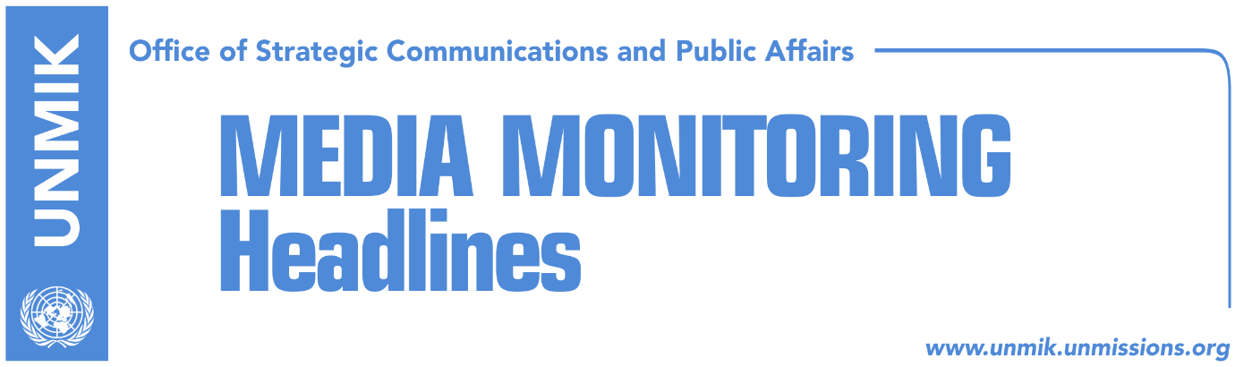

Main Stories 23 May 2018

- Thaci: It is time for the Western Balkans to join EU (dailies)
- Haradinaj urges Vatican to recognise independence of Kosovo (dailies)
- Thaci expects next round of dialogue to take place in June (Zeri)
- Matoshi: US involved in Kosovo-Serbia dialogue (Bota Sot)
- “Autonomy” for ACSMM linked with Trepca and Gazivoda (Koha)
- Serbian List insists on constitutional amendments for Association (RFE)
- “Normalization of relations, according to the two Germanies model” (media)
- Constitutional Court risks remaining without decision-making powers (Zeri)
- Hoti: Haradinaj-led government is scattered (Zeri)
- “Elections in August will result in radical changes in political landscape” (media)
- Zeka: There is mobilisation for Kosovo’s Interpol membership (Epoka)

Kosovo Media Highlights

Thaci: It is time for the Western Balkans to join EU (dailies)
In his address at the security forum taking place in Montenegro, President of Kosovo Hashim Thaci spoke of the need for the Western Balkans to join European Union saying that enlargement fatigue should not be used as a justification not to undertake economic and political reforms in line with the ACQUIS. He said it was unfortunate that there are groups in the Balkans that do not see the EU as a project of peace. He said the EU is not only a peace project but a “supranational governance structure which continuously expands and enlarges cooperation.” “EU enlargement must not be put to doubt. For this reason, my main message is: Increasing right wing extremist populist tendencies should not be used as justification by EU member states in order not to keep open the EU perspective for the countries of the Western Balkans,” Thaci said. The papers also report of a meeting President Hashim Thaci had with President of Montenegro Milo Djukanovic at the sidelines of the forum. In a Facebook post, Thaci said they discussed setting up a joint agenda of bilateral cooperation that would encourage a greater trade exchange and support for the EU integration process. Also in Facebook, Thaci said he met in Montenegro the US State Department Director for South Central European Affairs, Matthew Palmer and that he spoke to him about the strengthening of peace in the region and Kosovo’s Euro-Atlantic process. “Kosovo is ready to continue the final stage of dialogue for normalisation of relations between Kosovo and Serbia under the facilitation of the EU and strong support of the US,” Thaci wrote.

Haradinaj urges Vatican to recognise independence of Kosovo (dailies)
Prime Minister of Kosovo, Ramush Haradinaj, urged Vatican to recognise independence of Kosovo saying it is a necessary step. “The state of Kosovo is an important factor of peace and stability as well as promoter of good neighbourhood,” Haradinaj is quoted to have said in a meeting with Vatican’s Secretary of State, Cardinal Pietro Parolin. According to a press release issued by the government of Kosovo, Haradinaj also said Kosovo is interested in pushing forward the process of reconciliation and permanent peace in the Balkans and is also keen on enjoying strategic relations with the Holy See.

Thaci expects next round of dialogue to take place in June (Zeri)
President of Kosovo, Hashim Thaci, told regional television network N1 that he expects the nest round of dialogue for normalisation of relations between Kosovo and Serbia to take place next month. “I believe we will have a new meeting in Brussels at the second half of June,” Thaci is quoted as saying.

Matoshi: US involved in Kosovo-Serbia dialogue (Bota Sot)
Halil Matoshi, adviser to Prime Minister Ramush Haradinaj, told the paper that the US is already involved in the Kosovo-Serbia dialogue. “The request of Prime Minister Haradinaj in Brussels for the US to be involved in the final stage of dialogue with Serbia has had a strong impact in the EU and beyond. The US is involved in the conclusion of the dialogue between the two countries that will result in a mutual recognition although this is being termed as a legally-binding agreement,” Matoshi said.

“Autonomy” for ACSMM linked with Trepca and Gazivoda (Koha)
The paper reports on its front page that two of Kosovo’s biggest resources have been included in the discussions of the Managing Team that works on the statute of the Association/Community of Serb-majority municipalities. The Trepca mining complex and the Gazivoda Lake were discussed at the latest meeting of the Managing Team, which focused on economic development. Present at the meeting were Gazivoda director Srdjan Vulovic and the director of the part of the mining complex located in the north, Jovan Dimkic. According to local media in the north, participants at the meeting said there should be no obstacles to economic development, “as an important element for the survival of the Serb people in Kosovo”. The paper contacted Prime Minister Ramush Haradinaj’s office to ask if they have any information as to what was discussed at the meeting on Monday, but received no reply. The Ministry for Local Government, which supervises the drafting of the statute of the Association/Community, did not provide any explanation to the paper either.

Serbian List insists on constitutional amendments for Association (RFE)
Serbian List representatives are arguing that the formation of the Association/Community of Serb-majority municipalities requires amendments in the Kosovo Constitution and legal acts. Serbian List MP, Igor Simic, told Radio Free Europe that the Brussels agreement on the Association/Community cannot be implemented without these amendments and that they are part of the implementation plan. “Amendments are absolutely necessary not only in the Constitution but also in other legal acts in order to adjust Pristina’s legal framework to the Brussels agreement. This is the only way to form the Association/Community according to the Brussels agreement. If this first step is not made, we would be facing additional delays and problems with forming the Association/Community,” Simic added. The Kosovo government meanwhile ruled out any possibility of initiating constitutional amendments as requested by Serbian List officials.

“Normalization of relations, according to the two Germanies model” (media)
Aleksandra Joksimovic, head of the Serbian Center for Foreign Policy, said it was “clear we are approaching the final phase of talks between Belgrade and Pristina … and a probable solution will be similar to the two Germanies model”. “Certainly every case has its specifics, therefore, I don’t think this model will be fully copied. The idea of normalization of relations without full recognition isn’t something that should be pursued,” she said. Joksimovic said Belgrade was having important consultations with key world centers on the Kosovo issue and that Serbian President Aleksandar Vucic is engaged in finding a compromise solution that will be acceptable for both parties. “This will allow Serbia to focus on the process of reforms and to make quick steps toward European integration, and achieve its main objective – full EU integration – by 2025,” she said. “The message is that in Belgrade there is political readiness to start talks on the Kosovo issue so that it does not remain a frozen conflict”.

Constitutional Court risks remaining without decision-making powers (Zeri)
The paper reports on the front page that the Constitutional Court of Kosovo risks losing its decision-making powers as it will remain without quorum as a result of the Kosovo Assembly’s failure to elect judges. The Constitutional Court, explains the paper, has a total of nine judges, three of which are set to end their mandate on June 15. After that period, the court will be left with only six judges while seven is the minimum required for quorum. Officials at the Kosovo Assembly said the vacancy announcement for the additional judges has been re-advertised yesterday but members of the Assembly’s legislation committee fear the process may be prolonged until late summer.

Hoti: Haradinaj-led government is scattered (Zeri)
In an interview to the paper, the head of the Democratic League of Kosovo (LDK) parliamentary group, Avdullah Hoti, said political parties need to, as soon as possible, come out with a date for early elections as the Ramush Haradinaj-led government is already “scattered”. Hoti said Haradinaj has no political power to guarantee the implementation of an agreement with Serbia. “The prime minister comes from the fifth largest parliamentary party and no one at the table sees him as a credible partner that can agree to and implement agreements because he has no power to do so,” Hoti said of Haradinaj. He said the dialogue should be led by the government but one which has a parliamentary majority.

“Elections in August will result in radical changes in political landscape” (media)
Democratic League of Kosovo (LDK) MP, Arben Gashi, said the new parliamentary elections, which according to him could be held sometimes in August this year, will bring about radical changes in Kosovo’s political landscape. “Another option is to reach an agreement for early elections in September or October,” he said. Gashi said the LDK with the Serbian List could bring down the government, but not if Serbian List MPs set conditions for this cooperation.

Zeka: There is mobilisation for Kosovo’s Interpol membership (Epoka)
In an interview to the paper, Kosovo’s Deputy Minister of Interior, Izmi Zeka, said Kosovo’s membership in Interpol is one of top priorities for the government of Kosovo and that lobbying efforts have resulted in Kosovo becoming part of the voting agenda in the next Interpol Assembly’s session set to take place late in the year. In addition, Zeka pointed out, there is an “inter-institutional working group in place with a wide mobilisation, in particular on the part of the Ministry of Foreign Affairs and the Ministry of Interior, tasked with coordinating the process and harmonising lobbying strategies.”

Disclaimer
This media summary consists of selected local media articles for the information of UN personnel. The public distribution of this media summary is a courtesy service extended by UNMIK on the understanding that the choice of articles translated is exclusive, and the contents do not represent anything other than a selection of articles likely to be of interest to a United Nations readership. The inclusion of articles in this summary does not imply endorsement by UNMIK.

