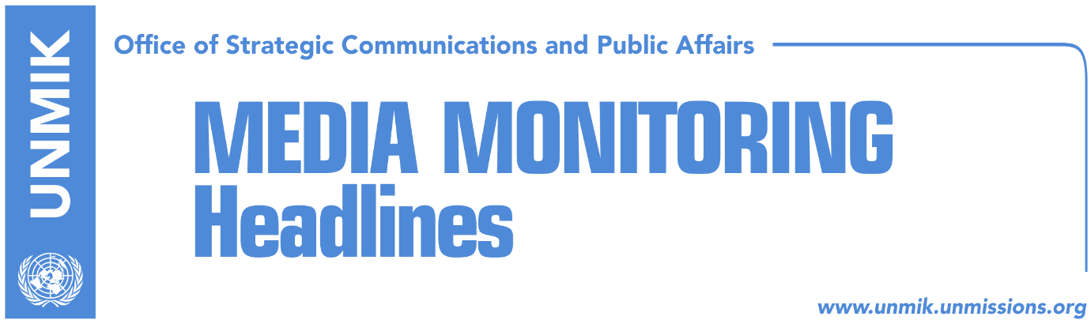

Main Stories 25 May 2018

- Thaci does not wait for mandate from Assembly for dialogue with Serbia (Koha)
- Arifi: Kosovo is losing time with the Association (Koha)
- Haliti implies international pressure for Association/Community (Koha)
- EU: We expect clear proof of progress in fight against corruption (Zeri)
- Thaci and Papadopoulou discuss end of EU mission in Kosovo (dailies)
- Thaci doesn’t decree Serb judge pending additional information (media)
- Simic: Kosovo Constitution to change to accommodate ACSMM (Zeri)
- Tahiri: Leaving Association at final stage of dialogue is dangerous (Epoka)
- Prosecution to launch investigation against Rikalo (Zeri)

Kosovo Media Highlights

Thaci does not wait for mandate from Assembly for dialogue with Serbia (Koha)
The Office of Kosovo President Hashim Thaci told the paper on Thursday that the modalities of a final agreement between Kosovo and Serbia will be discussed at the next meeting. Bekim Collaku, advisor to President Thaci, said in addition to discussions on ideas and proposals for a final agreement, “we will also discuss the implementation of agreements reached so far”. “It is clear that dialogue on normalization of relations between Kosovo and Serbia has entered its final phase. Therefore, it is expected that the next meeting will discuss the modalities of a final agreement, which will mark the full normalization of state relations. For Kosovo this implies nothing less than mutual recognition,” Collaku told the paper on Thursday. The paper meanwhile recalls that there is still no consensus among political parties in Kosovo about the topics and the leading role of President Thaci in the final phase of talks.

Arifi: Kosovo is losing time with the Association (Koha)
Avni Arifi, coordinator of Kosovo’s delegation in the talks with Serbia, told KTV on Thursday that the Association/Community of Serb-majority municipalities should not be the only important topic of the process. Arifi said Kosovo was losing with the Association/Community and that “the Association is only one out of the 10 topics that have not been implemented”. He also added that Pristina will respect the international agreement on the Association and that the statute will be in line with the Constitution of Kosovo. Arifi also said Pristina must be ready for an agreement with Belgrade. “We need unity; the platform proposed by the government is good. Everyone needs to be involved in the process and we can be successful only if we stand united,” he said. Asked if President Thaci should lead the talks with Serbia, Arifi said: “The President’s right to represent derives from the Constitution. I believe we were successful with the Rambouillet Agreement. At the time, there was a split between political parties but success was achieved.”

Haliti implies international pressure for Association/Community (Koha)
Xhavit Haliti, Vice President of the Kosovo Assembly, said in an interview to KTV on Thursday that it is now clear what the West expects from Serbia and Kosovo for a final political settlement. “You saw what happened with efforts to revoke the Special Court and also with delays to vote on the border demarcation agreement [with Montenegro]. You will see what will happen with the Association/Community of Serb-majority municipalities. It is an international agreement signed by the highest state leaders,” Haliti said. “The world, especially the West has problems with Russia, Asia and other countries. I believe we need to act quickly in accepting the version offered by the West,” he said, adding that this version will not threaten Kosovo’s sovereignty.

EU: We expect clear proof of progress in fight against corruption (Zeri)
EU officials told the paper that they expect Kosovo institutions to provide clear proof of progress in the fight against corruption and organised crime as the last condition for visa liberalisation. EU officials explained that once the European Commission estimates that all visa liberalisation criteria have been met, its proposal needs to the approved by European Parliament and subsequently the Council of Ministers. “We hope this process to end soon,” EU representatives said.

Thaci and Papadopoulou discuss end of EU mission in Kosovo (dailies)
President of Kosovo, Hashim Thaci, met yesterday the head of EU Rule of Law Mission (EULEX), Alexandra Papadopoulou. A statement issued by Thaci’s office after the meeting, notes that the two officials discussed the ending of the EU mission. Thaci and Papadopoulou agreed that the letter exchange between Kosovo and EU institutions has been finalized and that it foresees EU concluding its mission this year. Thaci also thanked Papadopoulou for constructive approach and cooperation.

Thaci doesn’t decree Serb judge pending additional information (media)
President of Kosovo, Hashim Thaci, will not decree the newly-elected Constitutional Court judge, Radomir Laban, until a full verification process is carried out by judicial authorities. President Thaci is quoted as saying that Laban’s decreeing will not take place at this time due to raised concerns about his past. Laban’s appointment, put forward by the Serbian List, was approved by the Assembly of Kosovo last week. Soon after, the Pristina-based Council for Human Rights and Freedoms as well as opposition Vetevendosje wrote to Thaci asking him not to decree Laban because of his “criminal past”. Laban was also reported to have been convicted by Serbian authorities on bribery charges. Meanwhile, institutions in Serbia claim Laban has been a fugitive since 2011. A spokesperson for the Basic Court in Kraljevo, Serbia said that once all the paperwork is completed, they will issue an international arrest warrant for Laban through Interpol.

Simic: Kosovo Constitution to change to accommodate ACSMM (Zeri)
Serbian List MP, Igor Simic, called for the amendment of the Kosovo Constitution and all legislative acts necessary to accommodate the establishment of the Association/Community of Serb-majority municipalities in accordance to the Brussels Agreement. Simic said this is the only way through which the Association/Community can be established and “anything other than this would mean further delays.”

Tahiri: Leaving Association at final stage of dialogue is dangerous (Epoka)
In a front-page interview to the paper, former Kosovo chief negotiator in the dialogue with Serbia, Edita Tahiri warned that leaving the issue of the Association/Community of Serb-majority for the final stage of the dialogue could be dangerous for Kosovo. “If the Association is delayed and enters the package of final agreement, Serbia could make additional demands outside the agreement,” Tahiri said. She added that this stage of the dialogue requires broad political consensus in Kosovo. “This for the fact that these are serious decisions and is a process that will have a historic result,” Tahiri noted.

Prosecution to launch investigation against Rikalo (Zeri)
Kosovo prosecution has launched an investigation against the Minister of Agriculture, Forestry and Rural Development, Nenad Rikalo, a day after the paper reported that nine months into his ministerial appointment, Rikalo has not yet given up ownership of a private company active since 2005. Rikalo said he is in the process of leaving the private company which he said is currently inactive.

Disclaimer
This media summary consists of selected local media articles for the information of UN personnel. The public distribution of this media summary is a courtesy service extended by UNMIK on the understanding that the choice of articles translated is exclusive, and the contents do not represent anything other than a selection of articles likely to be of interest to a United Nations readership. The inclusion of articles in this summary does not imply endorsement by UNMIK.

