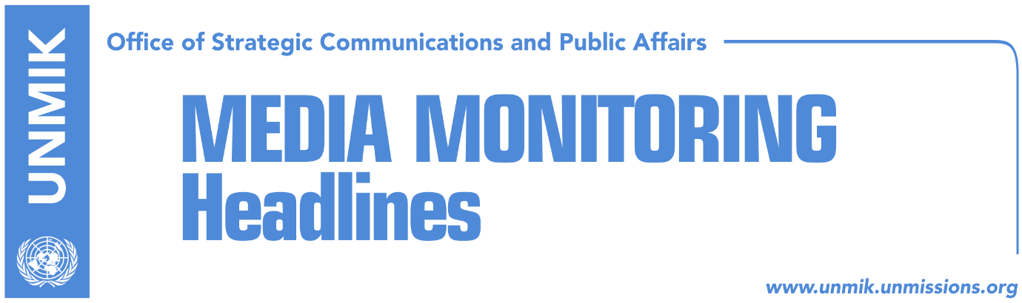

Main Stories 30 May 2018

- Thaci receives support from Kurz on Kosovo’s Interpol bid (Zeri)
- Haradinaj: Visa liberalisation news in June (Zeri)
- Haradinaj: No rescue fund for Kosovo Telecom (Koha Ditore)
- Veseli to youth: Don’t view liberalisation as possibility to leave Kosovo (Koha)
- Haradinaj asks his cabinet to justify official travels (dailies)
- War against crime and corruption, Kosovo’s main challenges (Epoka)
- Government approves Trepca’s statute (Epoka)
- State Department: Religious freedoms face many problems in Kosovo (Zeri)
- US Ambassador condemns incident in Poterq, Klina municipality (Bota Sot)
- Guinea Bissau reconfirms recognition of Kosovo (RTK)
- Hoxhaj: Kosovo does not need UNMIK, this mission should conclude (RTK)
- Veliu: Opposition should take over responsibility for dialogue (Epoka)

Kosovo Media Highlights

Thaci receives support from Kurz on Kosovo’s Interpol bid (Zeri)
President of Kosovo, Hashim Thaci, met in Vienna the Austrian Chancellor, Sebastian Kurz, and discussed the conclusion of the Kosovo-Serbia dialogue for normalisation of relations as well as Kosovo’s Interpol membership bid. “It was an excellent meeting as Austria was one of the strongest supporters of the state of Kosovo and of strengthening of its international subjectivity. We discussed with Kurz Austria’s support for Kosovo’s membership in Interpol… as well as for Kosovo’s European perspective,” Thaci said adding that he received confirmation from his interlocutor that Kosovo has successfully implemented all 95 criteria for visa liberalisation. Thaci also said the Austrian Chancellor is expected to play an important role in the process for normalisation of relations with Serbia as his country is set to take on European presidency on July 1. He said the dialogue will result in a win-win situation for both Kosovo and Serbia “as the two countries will be part of the EU and the process will end in mutual recognition and Kosovo’s membership in all international organisations.” Chancellor Kurz on his part said Austria is a strong supporter of the Western Balkans region, and supports visa liberalisation for Kosovo.

Haradinaj: Visa liberalisation news in June (Zeri)
Prime Minister of Kosovo, Ramush Haradinaj, said at the meeting of the government yesterday that Kosovo will receive important news on visa liberalisation in June. He also said he is expected to meet EU officials in the coming days to discuss implementation of European agenda.

Haradinaj: No rescue fund for Kosovo Telecom (Koha Ditore)
Prime Minister of Kosovo, Ramush Haradinaj, said that he is aware the situation in Kosovo Telecom is not good and that the company needs a serious investor to get in on its feet but added that the government will not allocate money to rescue it. He said in an effort to assist the company, they have asked it to cut “senseless” expenses. “Stop the existing practice of spending. We won’t give any money,” Haradinaj told reporters yesterday after a government meeting.

Veseli to youth: Don’t view liberalisation as possibility to leave Kosovo (Koha)
Kosovo Assembly Speaker, Kadri Veseli, said at a youth event that visa liberalisation should not be seen as a possibility to leave Kosovo but, on the contrary, as perspective for Kosovo’s development. “Visa liberalisation will happen soon but our young people should not at any time see this as a way out of Kosovo. Liberalisation means Europe coming to Kosovo,” Veseli said.

Haradinaj asks his cabinet to justify official travels (dailies)
Prime Minister of Kosovo, Ramush Haradinaj, has requested his cabinet ministers to justify in written form any official travel they plan to undertake or face punitive measures. “We have political and moral responsibility for introducing such a rule,” Haradinaj said. Koha Ditore writes that Haradinaj’s decision came days after the paper reported of a “record” number of government officials that attended the EU-Western Balkans summit in Sofia earlier this month.

War against crime and corruption, Kosovo’s main challenges (Epoka)
Representatives of the joint coordinating board for the rule of law, said on Tuesday that war against corruption and organized crime remain the main challenges of Kosovo. Head of the EU Office in Kosovo, Nataliya Apostolova said that Kosovo has marked progress on many issues related to the rule of law, however, according to her, these two challenges remain. She added that what remains to be done in the legislative field is speedy endorsement of the dispositions related to the suspension and removal of the unprofessional public officials and those who are sentenced for corruption.

Government approves Trepca’s statute (Epoka)
The government of Kosovo approved on Tuesday the proposal of the Trepca Supervising Board for Trepca’s statute, which determines founders, their shares, activity, organizing structure, essential capital, management, license and other specific organizing matters. The statute determines the government of Kosovo as owner of 80 percent of the shares, while based on the Law for Trepca, the employees will be shareholders of the rest 20 percent.

US State Department: Religious freedoms face many problems in Kosovo (Zeri)
The US State Department has published a report on religious freedoms across the world and in Kosovo’s case noted that these freedoms have not always been upheld for religious believers. The report mentions the Kosovo government’s financial support to Islamic education institutions and notes that other religious groups have complained of not receiving the same support. The US State Department speaks about the media reports claiming that the Turkish government put on Kosovo institutions to close schools it believes are linked to the cleric Fethullah Gulen. The report is said to make several references to Vetevendosje and mentions the case when one of its candidates running for election warned about Israel’s extinction.

https://www.state.gov/j/drl/rls/irf/religiousfreedom/index.htm?year=2017&dlid=280922#wrapper

US Ambassador condemns incident in Poterq, Klina municipality (Bota Sot)
The US Ambassador to Kosovo, Greg Delawie, has reacted to the incident in the village of Poterq, Klina where Albanian residents protested against a visit from a group of Serbs. “Kosovo citizens must commit to the future. Returnees should be able to travel safely,” Delawie wrote on Twitter adding that he was clad the Kosovo Police handles the incident which was not necessary. “Violence is not the answer; a serious effort at reconciliation is needed to achieve Kosovo’s goals,” he wrote further in the post.

Guinea Bissau reconfirms recognition of Kosovo (RTK)
Kosovo’s Ministry of Foreign Affairs announced that it has received official confirmation from the Embassy of Guinea Bissau in Brussels that the country has recognised independence of Kosovo. The original decision to recognise Kosovo as an independent country was taken by Guinea Bissau authorities in 2011.

Hoxhaj: Kosovo does not need UNMIK, this mission should conclude (RTK)
Deputy Prime Minister of Kosovo, Enver Hoxhaj, took to Twitter to write on the United Nations Peacekeeping Day. “On the international day of the peacekeepers, grateful to UN troops for contribution on building a multiethnic and democratic Kosovo. Peacekeepers are needed in conflict zones, but UNMIK is unnecessary as Kosovo is a stable country. UNMIK’s mission should be terminated and its budget allocated elsewhere,” Hoxhaj wrote.

Veliu: Opposition should take over responsibility for dialogue (Epoka)
Deputy leader of the Democratic League of Kosovo (LDK) Agim Veliu said that each institution should take part on the final phase of the dialogue. He told the paper that except for the state institutions, opposition should also play an extraordinary role in this process. He added that LDK as an institutionalist party, is not much concerned about who is going to lead the dialogue. He denied claims about divisions in his political party on whether President Hashim Thaci should lead the dialogue process or not.

Disclaimer
This media summary consists of selected local media articles for the information of UN personnel. The public distribution of this media summary is a courtesy service extended by UNMIK on the understanding that the choice of articles translated is exclusive, and the contents do not represent anything other than a selection of articles likely to be of interest to a United Nations readership. The inclusion of articles in this summary does not imply endorsement by UNMIK.

