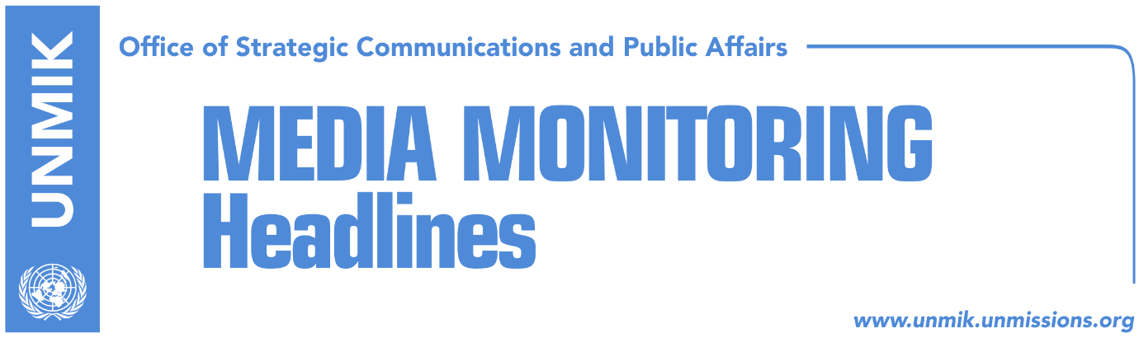

Main Stories 02 June 2018

- Thaci: Euro-Atlantic perspective should open to Kosovo (media)
- Scott: Final decision can be reached if there is courage (media)
- Arifi to EU: You have become Serbia’s right hand (media)
- Bahtiri: River Iber bridge to open soon (media)
- Kosovo and Serbia in a harsh battle over INTERPOL (Zeri, RTK)

Kosovo Media Highlights

Thaci: Euro-Atlantic perspective should open to Kosovo (media)
During his visit to the Great Britain, President of Kosovo Hashim Thaci held a lecture at Oxford University. “I discussed with many students of the Oxford University about Kosovo and its journey toward the independence,” Thaci wrote on his Facebook account.
“I spoke in front of the students and Professors of Oxford University about the current developments in Kosovo, the state-building process and necessity for the continuance of the dialogue with Serbia as well as reach of an agreement.
It is the prime time to open Euro-Atlantic perspective to Kosovo. Students were interested for the economic situation, youth perspective and position of non-majority communities in Kosovo.
Kosovo, with its constitution and laws leads with affirmative rights for the communities. Kosovo is country of opportunities for investments and return of experts who are being educated in Great Britain and other universities in the World. Great Britain, as global power has been and will remain Kosovo’s strategic partner,” Thaci wrote.
Scott: Final decision can be reached if there is courage (media)
The U.S. Ambassador to Serbia, Kyle Scott told Kosovo’s public broadcaster RTK that a broad agreement could be reached this year if Kosovo and Serbian parties have the courage and leadership. He said that “Miredita, Dobar Dan” festival is an event which represents different cultures and it should not be politicized.
Asked if Kosovo and Serbia are entering the final phase of the discussions for normalization of relations, Scott said “I think that we have a wonderful opportunity this year to move toward the broad-based agreement and normalization of the relations between Kosovo and Serbia, if there state leadership in the governments of both countries. Courage and leadership is required,” Scott said.

Arifi to EU: You have become Serbia’s right hand (media)
The government of Kosovo sent a harsh reply to the invitation of the EU official Thomas Busch for another round of technical dialogue with Serbia on 25 May in Brussels.
“I must stress that I am completely disappointed and insulted by your invitation. This invitation proves that your role as European Union team for facilitation of the technical dialogue between Kosovo and Serbia has transformed into Serbian delegation’s right hand by serving Serbian interests on reach of their agenda,” replied Avni Arifi, head of Kosovo’s team for technical dialogue with Serbia.
“You have ignored completely our continuous and frequent requests to focus on the energy matter, which interrupted the entire continent’s market and which literally requires only two or three hours to be resolved,” he added.
Government spokesperson, Donjeta Gashi, said the executive is for continuance of the dialogue where the matters discussed would not be selective.
Avni Arifi on the other hand considers that Brussels is interested only on the Association of Serb-majority Municipalities, for which Serbian party insists to discuss.

Bahtiri: River Iber bridge to open soon (media)
Mayor of Mitrovica South Agim Bahtiri, responded once again to the announcements of his counterpart in Mitrovica North, Goran Rakic, who said the bridge will not open due to security concerns. “We have an agreement with Serbia under the EU facilitation on revitalisation of the bridge, and this will happen soon,” Bahtiri said adding that no one can prevent its opening.
“Mr. Rakic has always wanted to take Suhodoll in the northern part, which is impossible. This will not happen in any manner,” he said. “If Ahtisaari’s Paln changes, then many things will change for the entire Kosovo. We do not want to join Rakic’s plan. AHtisaari’s plan does not change,” stressed Bahtiri.

“Mr Rakic has no power to stop opening of the bridge. Opening of the bridge is regulated through an international agreement and is at the benefit of all citizens of Mitrovica regardless ethnicity. The bridge is a symbol of bringing people together and enabling freedom of movement, and not dividing people,” Bahtiri said. “Rakic as well as other Serbs want every Serbian house be under their control, and this is impossible. There are many Albanian houses in the northern part of the city, and I never make efforts to return them under the administration of Mitrovica South,” Bahtiri said.

Kosovo and Serbia in a harsh battle over INTERPOL (Zeri, RTK)
After failing to become member of INTERPOL last year, Kosovo is aiming to finally become a member this year. Deputy Prime Minister of Kosovo Enver Hoxhaj, told Zeri that Kosovo is determined to become an INTERPOL member during 2018. He added that the government has received confirmation of many member states that they would support Kosovo’s application at INTERPOL.
On the other hand, reports the paper, Serbia has mobilized to prevent Kosovo’s membership at this international organization.
Serbia’s Interior Minister Nebojsa Stefanovic, said a few days ago that Kosovo’s potential membership at INTERPOL would have been unacceptable for Serbian state and its government will do the utmost to prevent this initiative.

Disclaimer
This media summary consists of selected local media articles for the information of UN personnel. The public distribution of this media summary is a courtesy service extended by UNMIK on the understanding that the choice of articles translated is exclusive, and the contents do not represent anything other than a selection of articles likely to be of interest to a United Nations readership. The inclusion of articles in this summary does not imply endorsement by UNMIK.

