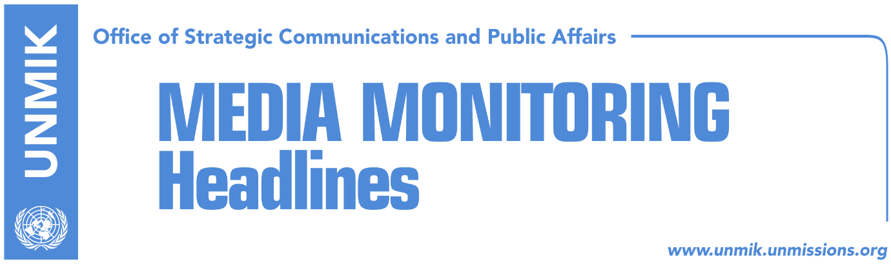

Main Stories 7 June 2018

- Šoltes optimistic for visa liberalization by year’s end (media)
- Pristina – Belgrade technical dialogue, blocked (Koha)
- U.S.: We didn’t make proposal for Kosovo – Serbia agreement (Zeri)
- Delawie concerned with incidents against Serbs (Epoka)
- UNMIK chief: No place for intimidation in a democratic society (media)
- Kurti: Unification of Mitrovica more important than UN seat (Zeri)
- The sabotaging of institutions (Koha)
- Kurti: New statute divides Trepca complex along ethnic lines (media)
- Selimi: Border with Serbia, part of dialogue agreement (media)

Kosovo Media Highlights

Šoltes optimistic for visa liberalization by year’s end (media)
The European Parliament’s Rapporteur on Kosovo, Igor Šoltes, said on Wednesday that Kosovo authorities should not blame the European Union for the lack of visa liberalization. Šoltes said during a visit to Pristina: “the visa liberalization process is running very late, but don’t blame the European Union. Kosovo is late for two years and did not complete the process at the same time as Ukraine and Georgia. Nonetheless, at the European Parliament, we are doing our best for visa liberalization for Kosovo … There are great expectations for the next couple of months. In addition to the European Parliament, there are other actors in the process. The message of the European Commission to give a green light to visa liberalization will be very important and I honestly believe this will happen by the end of this year”. Šoltes also commented on the final phase of dialogue between Kosovo and Serbia, saying that the process should conclude with an agreement that is acceptable for both sides. “It is very important to find an acceptable platform for the government and the opposition,” he added.

Pristina – Belgrade technical dialogue, blocked (Koha)
The technical dialogue between Pristina and Belgrade remains blocked as several agreements have yet to be implemented. Clashes between Kosovo and Serbian government officials ensued after a statement by Avni Arifi, Kosovo government’s coordinator for dialogue, who said that the Association/Community of Serb-majority municipalities would not be formed if the other agreements are not implemented. “Serbia continues to block the agreement on energy and all relevant actors are aware of this, including Berlin … Kosovo remains committed to implement all international obligations, but at the same time we insist that the other side should meet their obligations too. The time when agreements were implemented by one side only has passed,” Arifi said.

U.S.: We didn’t make proposal for Kosovo – Serbia agreement (Zeri)
The United States Embassy in Belgrade issued a reaction on Wednesday following reports in some Serbian media according to which Serbian President Aleksandar Vucic has turned down a U.S. proposal for an agreement between Kosovo and Serbia. The U.S. Embassy said in a statement: “The United States continue to support the EU-led dialogue for normalization of relations between Pristina and Belgrade. We have talked about different ideas with Serb and Kosovo leaders, and with EU representatives, but we did not make any proposal”.

Delawie concerned with incidents against Serbs (Epoka)
The U.S. Ambassador in Kosovo, Greg Delawie, said on Wednesday that the Kosovo government and all other respective authorities must address attacks against members of minority communities. After meeting Prime Minister Haradinaj, Delawie told Radio Free Europe that he expressed his concern to Haradinaj about recent incidents against Serb community members. “I think these incidents are totally unacceptable. I welcome the government’s statement on Tuesday, but I want to see more being done. I think the police are reacting positively and this is good, but this should be further improved by preventing incidents from happening,” Delawie said.

UNMIK chief: No place for intimidation in a democratic society (media)
The Head of the United Nations Mission in Kosovo (UNMIK) Zahir Tanin welcomed on Wednesday the condemnation of Kosovo leaders concerning recent-ethnically motivated incidents. “There is no place for intimidation in a democratic society. The rule of law should apply to all,” Tanin said in a press release.

Kurti: Unification of Mitrovica more important than UN seat (Zeri)
The paper covers in one of its front-page stories Vetevendosje leader Albin Kurti’s meeting on Wednesday with the European Parliament’s Rapporteur on Kosovo, Igor Šoltes. Citing a press release issued by Vetevendosje, the paper quotes Kurti as saying that “for Kosovo’s state-building process and development, the unification of Mitrovica is more important than the UN seat which is being promised without any basis”. Kurti also said that for ten years, the EU Rule of Law Mission (EULEX) failed to resolve war crimes and crimes committed after the war.
The sabotaging of institutions (Koha)
The paper reports on its front page that “the highest state officials are ignoring the institutions they lead”. The paper further comments: “for two days now, the Assembly President is not chairing the assembly sessions. At one point on Wednesday, there were only 32 MPs in the plenary session, although the list that is used as basis for per diems there were 114 MPs listed. The Prime Minister has said he will not attend any assembly session this week, although he has been invited to three interpellations. Some ministers have ignored the latest government meeting due to their own activities around Kosovo. This shows that at a time when neither the ruling coalition nor the opposition have the majority in the Assembly, the highest state officials are ignoring the institutions, without any fear that they could be held accountable for such actions”. In a different article related to the same issue, the paper notes that MPs sign in for per diems but fail to attend assembly sessions.

Kurti: New statute divides Trepca complex along ethnic lines (media)
The Vetevendosje Movement organized a roundtable on Wednesday on the new statute of the Trepca mining complex. Koha Ditore quotes Vetevendosje leader Albin Kurti as saying that the draft statute proposed by the government does not provide for an integrated and unique management structure. Kurti also argued that the mining complex will be divided into business units and that in the current context this means dividing the complex along ethnic lines.

Selimi: Border with Serbia, part of dialogue agreement (media)
Several online media report that Petrit Selimi, former Foreign Minister of Kosovo and current National Coordinator for Millennium Challenge Corporation, said on Wednesday that the final agreement between Kosovo and Serbia will also resolve the border issue between the two countries. Selimi wrote on Twitter: “the border demarcation between Kosovo and Montenegro is now in force. Kosovo has legally delineated the border with Macedonia and Montenegro, it has no border issues with Albania, and the border demarcation with Serbia will certainly be part of a legally-binding agreement between the two”.

sonnel. The public distribution of this media summary is a courtesy service extended by UNMIK on the understanding that the choice of articles translated is exclusive, and the contents do not represent anything other than a selection of articles likely to be of interest to a United Nations readership. The inclusion of articles in this summary does not imply endorsement by UNMIK.

