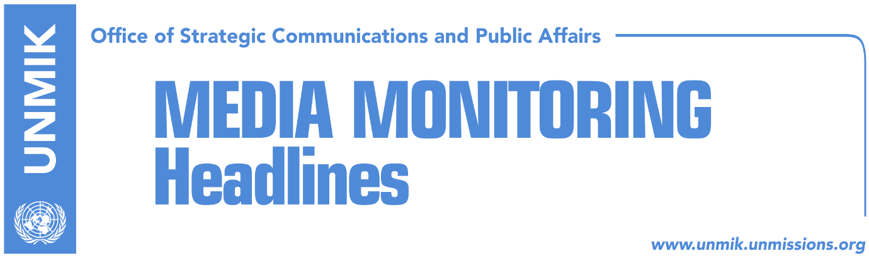

Main Stories 11 June 2018

- Haradinaj: Open issues with Serbia resolved through recognition (Epoka)
- The U.S. and EU deny change of dialogue format (RTK)
- Serwer: Moscow not Belgrade deciding on Kosovo’s UN seat (Zeri)
- Political representatives to meet again this week, dialogue main topic (Zeri)
- New details emerge from planned attack on KFOR troops (Bota Sot/RFE)
- Bahtiri: Mitrovica bridge to open soon (Zeri/EO)
- Thaci, panelist at the International Economic Forum in Montreal (RTK)
- Serbia accusing Kosovo for lack of cooperation on Ivanovic’s case (RTK)
- Serbian List against the Kosovo Army (Telegrafi)
- Kosovo and FYROM to open new border point (RTK)
- Trepca mining complex, under private management (Koha)

Kosovo Media Highlights

Haradinaj: Open issues with Serbia resolved through recognition (Epoka)
Prime Minister of Kosovo, Ramush Haradinaj, said at a session of the Kosovo Assembly held in Prizren to mark the 140th anniversary of Prizren League that Kosovo is in a “sensitive” period as there are attempts to resolve these through new political “bargains”. He assured the people of Kosovo that such moves will not happen and that the only way to resolve open issues is through reconciliation and mutual recognition.

The U.S. and EU deny change of dialogue format (RTK)
Head of the EU Office in Belgrade Sam Fabrici and the U.S. Ambassador to Serbia, Kyle Scott, denied the claims of Serbian media about changes on the format of the Pristina-Belgrade dialogue. Scott stressed that the EU should continue to lead the dialogue and added that final decision belongs to Pristina and Belgrade. “The EU is leading with the dialogue and we are satisfied with the format, I think that it should resume in the same manner,” Scott said. Head of the EU Office said there has been no request so far to change the format of the dialogue. “We will continue to participate in discussions,” he said. Serbian media also reported on Sunday about the possibility on an international conference on solution of Kosovo-Serbia issue. They went further naming this conference “the second Rambouillet” where great powers would help on reaching an agreement.

Serwer: Moscow not Belgrade deciding on Kosovo’s UN seat (Zeri)
Daniel Serwer, Balkans analyst from the Johns Hopkins University’s School of Advanced International Studies, said in a front-page interview to the paper that it is Moscow rather than Belgrade that decides on whether Kosovo will get a seat at the UN and that this goal is difficult to be achieved through negotiations even with Belgrade’s approval. “I can unfortunately imagine a situation whereby Belgrade concludes UN membership is a good idea but Moscow refuses,” Serwer said. Asked about how long before a final agreement with Serbia is achieved, Serwer said this could be a matter of hours or drag on indefinitely. “I hope everything will be resolved but I am not optimistic.” Serwer also said that Kosovo side wants the agreement to pave way for creation of Kosovo armed forces while Serbia wants the establishment of the Association/Community of Serb-majority municipalities whereas when it comes to mutual recognition, “this needs to be between Serbia and the EU which I believe will insist on full and irreversible normalization. This means mutual recognition and exchange of representatives at the ambassadorial level.”

Political representatives to meet again this week, dialogue main topic (Zeri)
The fourth meeting of representatives of main political parties in Kosovo is expected to take place this week, organised by the Social Democratic Party (PSD). The paper reports that the only item on the meeting’s agenda will be dialogue with Serbia. PSD spokesperson, Shkodran Hoti, said the date of the meeting has not been set yet but confirmed that dialogue will be discussed.

New details emerge from planned attack on KFOR troops (Bota Sot/RFE)
Special Prosecution of Kosovo has revealed that the two suspects arrested last week for planning an attack on KFOR troops were a couple that had been living together and that the man was born in Kosovo but had Belgian citizenship. The prosecution did not say however whether the suspects planned an attack against a particular country that has troops deployed to Kosovo. The Kosovo-born man is said to have also planned terrorist attacks in France and Belgium. The two suspects have been issued a one-month detention sentence but it is not clear whether they are alleged to have planned the attacks alone or were part of a larger group. Kosovo Police officials told Radio Free Europe that intensive investigations are underway and did not rule out more arrests.

Bahtiri: Mitrovica bridge to open soon (Zeri/EO)
Mitrovica Mayor, Agim Bahtiri, said the main Iber/Ibar River bridge will soon be open for movement and that construction works have reached their final stage. “There are still some minor things to be worked at but I believe the bridge will open soon,” Bahtiri told Ekonomia Online news website.

Thaci, panelist at the International Economic Forum in Montreal (RTK)
The President of Kosovo Hashim Thaci, traveled on Sunday to Canada, to participate at the International Economic Forum in Montreal. Thaci will participate at the “Europe in a cross-road° panel, held under patronage of the American continent (IECA). The Forum promotes dialogue on national and international matters, while leaders of hundreds of countries are expected to participate at the Conference. Former UN Secretary General Ban Ki-moon will be among them.

Serbia accusing Kosovo for lack of cooperation on Ivanovic’s case (RTK)
Head of the Office for Kosovo at the Serbian government, Marko Djuric, spoke again about the course of the investigation on the murder of the Serb politician, Oliver Ivanovic. “If Pristina authorities cooperated on the investigations of Oliver Ivanovic’s murder, the results would certainly be different,” Djuric said. Ivanovic’s spouse, Milena Ivanovic, was also present during this statement. She told N1 broadcaster that she has received the latest news on investigations through informal ways. She did not want to speak about these information saying that she would do this when the time comes.

Serbian List against the Kosovo Army (Telegrafi)
The Serbian List has denied on Sunday claims that Kosovo Serbs support the formation of the Kosovo Armed Forces, the news website reports. The Serbian List argued in a press release that “unable to provide better living conditions for all citizens in Kosovo, the political representatives of Kosovo Albanians are offering war stories to the people”. “They said today that for Pristina the war with the Serbs is not over, and we expect a swift reaction from the international community because such statements pose a threat to peace and security in the Balkans,” the press release noted. The Serbian List also said it is against the formation of the Kosovo Armed Forces, arguing that it falls in opposition to UN Security Council Resolution 1244, the Kumanovo Agreement and the security interests of Serbs in Kosovo and the state of Serbia.

Kosovo and FYROM to open new border point (RTK)
The EU Special Representative for Kosovo Nataliya Apostolova and head of the EU Office in the former Yugoslav Republic of Macedonia (FYROM) Samuel Zbogar, will inaugurate today works at the new Stancic-Belanoc border crossing. Kosovo’s and FYROM’s Deputy Prime Ministers Enver Hoxhaj and Bujar Osmani will be participating at the inauguration. The EU has invested around one million Euros for the construction of this border point.

Trepca mining complex, under private management (Koha)
The Kosovo government is trying to revive the Trepca mining complex by giving up on its management. According to a feasibility study, which the paper claims to possess, the enterprise is foreseen to operate based on a public-private partnership, where companies will be given assets for operation, whereas the shareholders (the government and the workers) will contribute only to assets such as licenses and contracts. The feasibility study also notes that many units of the mining complex are non-profitable and suggests putting some of them up for liquidation. The formal ownership, as foreseen by the law on Trepca, will remain to the government and the workers, whereby the government will have 80 percent of assets.

Disclaimer
This media summary consists of selected local media articles for the information of UN personnel. The public distribution of this media summary is a courtesy service extended by UNMIK on the understanding that the choice of articles translated is exclusive, and the contents do not represent anything other than a selection of articles likely to be of interest to a United Nations readership. The inclusion of articles in this summary does not imply endorsement by UNMIK.

