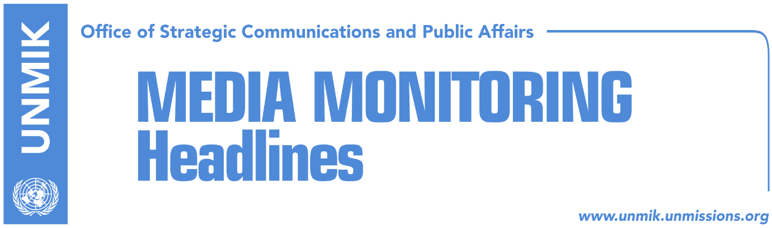

Main Stories 13 June 2018

- Thaci: Dialogue to end in agreement embodying European values (Zeri)
- “Impossible consensus” (Zeri)
- Apostolova criticizes members of government (media)
- Time for new chapter in Kosovo’s relations with the UN (Epoka)
- European Parliament confirms visa liberalization (Epoka)
- Haradinaj: Kosovo aspires to become part of NATO (Zeri)
- Pacolli reports to Assembly’s foreign affairs committee (Zeri)
- Journalists’ Association reacts against attack on reporter in Pristina (Express)
- Athens, Skopje reach deal after 27-year row (media)

Kosovo Media Highlights

Thaci: Dialogue to end in agreement embodying European values (Zeri)
President of Kosovo, Hashim Thaci, said in his remarks at the International Economic Forum of the Americas in Montreal that the Western Balkans has never had a better opportunity to build sustainable peace and should seize the momentum for getting closer to the EU. Thaci also spoke about the dialogue with Serbia saying it will pick up in the coming weeks and that though it will be difficult, there is no alternative to it. “The dialogue needs to end in a ‘win-win’ result for both Kosovo and Serbia, in an agreement that embodies European standards and values,” Thaci said.

“Impossible consensus” (Zeri)
The paper reports on the front page that the final stage of talks with Serbia is proving to be the most challenging one as political parties have not yet reached consensus on the issue and many oppose the idea of President Hashim Thaci leading the process. Facing uncertainty in securing enough votes at the Assembly, the government of Kosovo recently decided to withdraw platform for dialogue with Serbia while Prime Minister Ramush Haradinaj accused the opposition parties of not being concerned with the actual content of the platform but rather with who is part of the delegation. At the same time, analysts the paper has spoken to say political consensus is important for the final stage of the dialogue for normalisation of relations. Jeta Krasniqi from the Kosovo Democratic Institute think tank said political parties would have to agree and define the negotiating team, the timeline, discussion topics and, above all, expectations of the people of Kosovo regarding the outcome of talks.

Apostolova criticizes members of government (media)
Most media report that the head of the European Union Office in Kosovo, Nataliya Apostolova, criticized members of the Kosovo government. Apostolova, who attended the government meeting on Tuesday, was quoted as saying, “If you have carefully read the Strategy on Western Balkans, a document published a couple of months ago by the European Commission and which we consider the most important and brave document for all partners of the Western Balkans, you have seen that Kosovo’s membership and path toward the EU goes through the implementation of the Stabilization/Association Agreement. These priorities have timelines and you had one year to implement these timelines … you have lost one year. As a government, you have the opportunity before September 2018 to implement as many priorities as possible that fall under your scope of action and this is an opportunity for Kosovo to prove it is a reliable partner that implements its obligations”. Koha Ditore notes on its front page that government members acknowledged the criticism but some of them also blamed Brussels for the lack of an integration perspective for Kosovo. Deputy Prime Minister Enver Hoxhaj said that after the implementation of the European Reforms Agenda, Kosovo should be allowed to apply for membership.

Time for new chapter in Kosovo’s relations with the UN (Epoka)
Kosovo’s Principal Deputy Prime Minister and Minister for Foreign Affairs, Behxhet Pacolli, met on Tuesday with UN Assistant Secretary-General for Peacekeeping Operations, Bintou Keita. Pacolli said that Kosovo is grateful for the role and contribution of the United Nations during the state building process. During this meeting, Pacolli requested change of the format of the discussions on Kosovo, respectively reduction of the sessions, as they are being abused Serbia to impede Kosovo and to reduce UNMIK’s budget in Kosovo. “I am aware that you do not have the possibility to change dynamics of the UN Security Council, however the current format of discussions should change. Sessions should reduce from four, to one or two per year. Our wish is for them not to happen at all or to be held as a debate behind the closed doors. “We understand that this is not a decision made by you, but UNMIK’s budget cannot be spent on political, rule of law or other fields that might interfere government competencies,” Pacolli said. Pacolli is reported to have said in the meeting that the UN needs to transform its mission in Kosovo into a political office and “help the new country fulfil its aspirations of joining the community of free and peace-loving nations.”

European Parliament confirms visa liberalization (Epoka)
The President of the Assembly of Kosovo Kadri Veseli, is in an official visit to Strasbourg with regards to the process of visa liberalization for Kosovo people. On Tuesday he had a meeting with the President of the European Parliament Antonio Tajani, where he received full support for visa liberalization and discussed further steps expected to be undertaken during the following months. According to Veseli, Tajani pledged that the European Parliament is ready to proceed the decision of the Euro-deputies as soon as European Commission comes up with a positive report on visas.

Haradinaj: Kosovo aspires to become part of NATO (Zeri)
Prime Minister of Kosovo, Ramush Haradinaj, met NATO Deputy Assistant Secretary General for Operations, John Manza, and said Kosovo’s peace is a contribution of NATO and strategic allies. Haradinaj said he informed Manza of the progress the Kosovo Security Force has made and that it is ready to take on additional duties as an army in line with NATO standards. He also said Kosovo is ready to transform from an “absorber” of peace to contributing to it wherever required as integral part of the Alliance.

Pacolli reports to Assembly’s foreign affairs committee (Zeri)
Kosovo’s Foreign Minister, Behgjet Pacolli, was invited to report yesterday to the Assembly’s foreign affairs committee where he said that Kosovo was advised by Quint countries not to apply for Council of Europe membership at this time as it does not enjoy sufficient support and because the organization is currently facing a financial crisis. He said however that Kosovo will ‘soon’ apply to Interpol and that his ministry is working hard in securing more recognitions for independence of Kosovo.

Journalists’ Association reacts against attack on reporter in Pristina (Express)
The Association of Journalists of Kosovo (AJK) has reacted against an attack on Valon Rashiti, a reporter for T7, in the premises of Pristina Hospital on Tuesday. Rashiti was reporting on an incident between two people when the family members of one of the victims attacked him causing him head injuries. The AJK called on the police and prosecution to immediately address the case and bring the suspects to justice. The news website also notes that since January this year, there have been 12 threats and attacks against reporters.

Athens, Skopje reach deal after 27-year row (media)
All media report that Athens and Skopje have reached a historic agreement following a 27-year row over the name of the Former Yugoslav Republic of Macedonia (FYROM) which from now on will be called the Republic of North Macedonia. Macedonian Prime Minister Zoran Zaev told a press conference on Tuesday: “There is no going back now. We have a historic agreement between Greece and our country. With this agreement we will have our identity, language and culture. From now on we will not be called FYROM, but Macedonians. As of today, the new name will be the Republic of North Macedonia”. He also said that the agreement will pave Macedonia’s way to eventual membership of European Union and NATO. Zaev and his Greek counterpart, Tspiras, are expected to meet at the end of this week to sign the agreement. Kosovo leaders hailed the agreement on Tuesday. President Thaci said the agreement is good news for both countries and presents a new opportunity to further strengthen peace and stability in the region. Prime Minister Haradinaj said the leadership of both countries proved determined and visionary to resolve an open issue in the Western Balkans. Foreign Minister Hoxhaj said the agreement was great news for the Balkans.

Disclaimer
This media summary consists of selected local media articles for the information of UN personnel. The public distribution of this media summary is a courtesy service extended by UNMIK on the understanding that the choice of articles translated is exclusive, and the contents do not represent anything other than a selection of articles likely to be of interest to a United Nations readership. The inclusion of articles in this summary does not imply endorsement by UNMIK.

