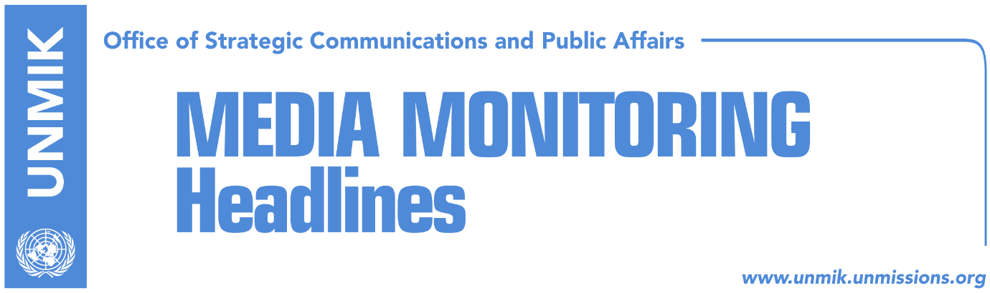

Main Stories 15 June 2018

- Formation of Kosovo Army, through constitutional amendments or law? (DW)
- “Work on drafting statute of Association/Community stepped up” (Koha)
- Serbian List representatives visit Washington (media)
- Serbian police still searching for missing reporter (media)

Kosovo Media Highlights

Formation of Kosovo Army, through constitutional amendments or law? (DW)
Leaders of Kosovo’s institutions say that the transformation of the Kosovo Security Force (KSF) into the Kosovo Armed Forces is an irreversible process, whereas Kosovo Serbs and the government in Belgrade are against the formation of the Kosovo Army, Deutsche Welle reports. The government in Pristina wants to transform the KSF through constitutional amendments or through a law if Serb MPs continue to reject constitutional amendments. The Constitution of Kosovo provides that every amendment requires 2/3 of votes from the 120 MPs and 2/3 of votes from Kosovo Serb representatives. In their efforts to persuade the Serbs, leaders of Kosovo’s institutions claim that the transformation of the KSF into the Armed Forces will strengthen peace in the region and that the KSF is ready to assume a role in regional and global security. Meanwhile, Kosovo Serb representatives are openly against the transformation and say they will coordinate their actions with the government in Belgrade. Serbia’s Defense Minister Aleksandar Vulin told Serbian media that Serbia will never agree to the transformation of the KSF into the Armed Forces, “because this constitutes a serious violation of all agreements reached so far”. Kosovo’s institutions meanwhile are not discouraged by Belgrade’s position on the matter. Burim Ramadani, KSF Deputy Minister and security expert, told the news agency that Kosovo’s institutions are making serious efforts and that he believes in a shared process. “It is very important that there is increased trust among the Kosovo Serb community in the KSF. This is evidence of a different position from that of the Serbian government which has recently stepped up its political pressure on Kosovo Serbs. The Kosovo Government, the KSF Ministry and all other institutions are engaged and coordinate on a daily basis with local and international stakeholders in the transitioning process,” Ramadani said. He added that the KSF will be transformed through a transparent process with NATO, Kosovo’s partners and all ethnic communities in Kosovo. “In any case, Kosovo’s institutions are interested and committed for this process to include constitutional amendments, whenever they will be made. But this does not necessarily rule out substantial changes that are needed through legal amendments … The transitioning of the KSF is done through legal amendments. And the constitutional amendments change the name and are aimed at securing maximal political support in parliament”.

“Work on drafting statute of Association/Community stepped up” (Koha)
The management team for forming the Association/Community of Serb-majority municipalities met today with Local Government Minister, Ivan Teodosijevic, and informed him that they have stepped up work on drafting the statute to meet the timeline set by the European Union. The management team said they hope they will have the opportunity to discuss their work with the implementation councils in Belgrade, Pristina and Belgrade, in line with the respective agreement and the mandate of the management team. Over the last two months, the management team met many teams of experts and discussed areas that will be covered by the statute of the Association/Community.

Serbian List representatives visit Washington (media)
Serbian List representatives, who are visiting Washington, told Voice of America that the position of the U.S. Administration is that there is no alternative to dialogue between Serbia and Kosovo and that there are no timelines for resolving the Kosovo issue. The Serbian List delegation is led by Dalibor Jevtic, Deputy Prime Minister of Kosovo and Minister for Communities and Returns. Kosovo Serb representatives met with Matthew Palmer, Director for South Central European Affairs at U.S. Department of State, and among other things discussed relations between Serbs and Albanians following the recent incidents in Kosovo.

Serbian police still searching for missing reporter (media)
Serbian media report that members of Serbia’s special police unit and helicopters joined on Thursday the search of missing reporter – Stefan Cvetkovic - in the northern town of Bela Crkva. Cvetkovic, who investigated numerous affairs, including the assassination of Kosovo Serb political representative Oliver Ivanovic, went missing during the night of June 13-14. Independent media associations said that the missing journalist reported a number of threats from political and criminal circles. A police statement said his car was found parked in the street with the doors open and lights on, adding that a search was underway. Belgrade-based Beta news agency reported that the car engine was still running and that witnesses said that his watch was found with the bracelet broken next to the car. His mobile phones were turned off.

Disclaimer
This media summary consists of selected local media articles for the information of UN personnel. The public distribution of this media summary is a courtesy service extended by UNMIK on the understanding that the choice of articles translated is exclusive, and the contents do not represent anything other than a selection of articles likely to be of interest to a United Nations readership. The inclusion of articles in this summary does not imply endorsement by UNMIK.

