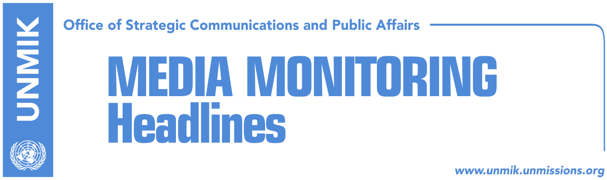

Main Stories 18 June 2018

- Government against ‘selective approach’ to dialogue (Koha Ditore)
- Arifi: Opening of the Mitrovica bridge, matter of political decisions (RTK)
- US, Germany insist KSF transformation should go through Constitution (Zeri)
- Mogherini expects Thaci and Vucic to reach final agreement (Bota Sot)
- PSD postpones political roundtable (Klan Kosova)
- Veseli travels to France to lobby for visa liberalisation (Zeri)
- EULEX chief: Kosovo responsible for the future (RTK, N1)
- Hoti: Serbia to be held accountable for war crimes (RTK)
- FYROM and Greece sign the historic agreement (Epoka)
- Kosovo leaders hail Macedonia and Greece signing name change agreement (Zeri)

Kosovo Media Highlights

Government against ‘selective approach’ to dialogue (Koha Ditore)
The paper reports on the front page that the government of Kosovo is viewing the resumption of dialogue with Serbia as “useless” unless the already signed agreement on energy is not properly addressed. The government’s coordinator for dialogue, Avni Arifi, told the paper that he will report to the EU authorities on agreements reached thus far but pointed out that it is “absurd” to think of continuing talks when agreements signed years ago have not yet been implemented. “We stick to the view that selective approach seriously harms the credibility of the process and overshadows talks. Any continuation of talks without [tackling] energy would be hard,” Arifi said.

Arifi: Opening of the Mitrovica bridge, matter of political decisions (RTK)
Kosovo government representative in the dialogue with Serbia, Avni Arifi said that works at the main MItrovica bridge are completed and there is no reason not to open it. He added that this is now only a matter of political decision. He added that Serbs have a ridiculous request to open the bridge. “Being that Suhodoll is in the map of Central Election Commission (CEC), they want that to become also a practical, municipal reality. This matter is not only unreachable but ridiculous as well. There is not a single reason, it is a political decision. At the moment the political decision reached, then opening of the bridge will become a matter of hours or days,” Arifi said.

US, Germany insist KSF transformation should go through Constitution (Zeri)
The embassies of the United States and Germany have reiterated the position that the transformation of the Kosovo Security Force into Kosovo Armed Forces needs to happen through constitutional changes, the paper reports on the front page. The US Embassy in Pristina said they support KSF transition into an armed force but underlined that this has to be done by changing the Constitution of Kosovo. The same view was echoed by the German Embassy which also stated that the process needs to have the support of NATO. However, members of the Assembly committee on KSF supervision say the international community is not categorically against the implementation of the so-called Plan B according to which the armed forces would be created by a bill that requires simple majority. “The international community is not against but simply said it would be better to proceed with constitutional changes,” said chairman of the committee Haxhi Shala.

Mogherini expects Thaci and Vucic to reach final agreement (Bota Sot)
The paper quotes reports from the Belgrade-based news agency Beta saying that the EU High Representative for Foreign Affairs and Security Policy, Federica Mogherini, has increased contacts with leaders in Pristina and Belgrade and is asking the two presidents, Hashim Thaci and Aleksandar Vucic, to implement agreements reached so far in the course of the dialogue for normalisation of relations and also reach a final agreement. She is to this end waiting for proposals from Kosovo and Serbia. Sources told Beta however that the text of the final agreement is expected to be drafted in Brussels but that ideas from the two sides will be welcomed.

PSD postpones political roundtable (Klan Kosova)
The Social Democratic Party (PSD) has announced that it was postponing the roundtable of political representatives as majority of the participants will be attending the funeral of Prime Minister Ramush Haradinaj’s father who passed away over the weekend. PSD spokesperson, Shkodran Hoti, said the meeting has been rescheduled for Wednesday, 20 June.

Veseli travels to France to lobby for visa liberalisation (Zeri)
Kosovo Assembly Speaker, Kadri Veseli, has travelled on an official visit to France in an effort to gain support for visa liberalisation. During his visit, Veseli is expected to meet his French counterpart, Francois de Rugy, a statement issued by the Assembly of Kosovo said.

EULEX chief: Kosovo responsible for the future (RTK, N1)
Head of the EU mission for the rule of law in Kosovo Aleksandra Papadopoulou, told regional broadcaster N1 that today, ten years later, the greatest success of the mission is that it is leaving Kosovo. “Not everything is perfect, but no one was expecting to build rule of law institutions in ten years,” Papadopoulou said. She added that Kosovo is now completely responsible for its future.

Hoti: Serbia to be held accountable for war crimes (RTK)
Asked about the division of Kosovo mentioned as a final option by Serbian politicians, deputy leader of the Democratic Party of Kosovo, Rexhep Hoti, told lajmi.net that division of Kosovo cannot happen without Kosovo gaining Sandjak and Presevo Valley. He added further that this is impossible. He added if this happened, then Vojvodina should separate from Serbia too. “Kosovo and Albanians have another geostrategic position, they have the U.S., Albania and NATO. They have Northern Macedonia as joint creation. They are officially recognized by all neighboring countries excluding Serbia, they have an organized structured state …division is not in the agenda,” Hoti said.

FYROM and Greece sign the historic agreement (Epoka)
Former Yugoslav Republic of Macedonia and Greece signed on Sunday an agreement for the long-disputed issue of name. The document which foresees the name Northern Macedonia, was signed in Prespa, northern part of Greece, by the ministers for Foreign Affairs, Nikola Dimitrov and Nikos Kotzias, in the presence of the Prime Ministers Zoran Zaev and Aleksis Tsiparis. The latter assessed the agreement as a very important for the future of both countries. “This is a patriotic agreement between the two populations. This resolves the contest of many years, strengthens trust between the two countries and nations, which will open a new page for the economic development of the two countries,” Tsiparis said. Zaev on the other hand assessed the agreement to be a historic one and very important for the European future. The agreement also defines the issues of the language and identity. As the agreement stresses, the Macedonian language belongs to the group of Slavic languages and it is in no way related to the antic and Greek Macedonian culture and past.

Kosovo leaders hail Macedonia and Greece signing name change agreement (Zeri)
President of Kosovo, Hashim Thaci, and Assembly Speaker, Kadri Veseli, have hailed the signing of the name agreement between the foreign ministers of the former Yugoslav Republic of Macedonia (FYROM) and Greece saying it contributes to peace in the region. In a Twitter post, Thaci said FYROM’s Euro-Atlantic integration is good for Kosovo while Veseli said he was pleased that the country’s international integration has now been unblocked.

Disclaimer
This media summary consists of selected local media articles for the information of UN personnel. The public distribution of this media summary is a courtesy service extended by UNMIK on the understanding that the choice of articles translated is exclusive, and the contents do not represent anything other than a selection of articles likely to be of interest to a United Nations readership. The inclusion of articles in this summary does not imply endorsement by UNMIK.

