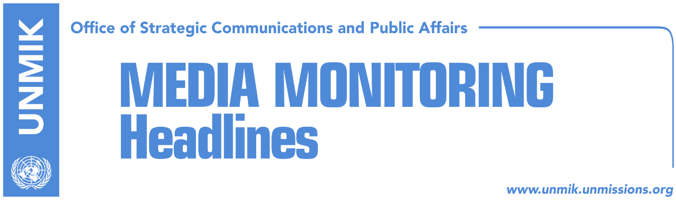

Main Stories 20 June 2018

- EU will call on Thaci, Vucic to urgently implement agreements (Koha)
- Thaci discusses dialogue with Quint ambassadors ahead of meeting Vucic (dailies)
- Collaku: Thaci, legitimate leader of dialogue with Serbia (Klan Kosova)
- Government reports to Brussels, low-level implementation of agreements (Koha)
- Avramopoulos: Kosovo close to visa liberalisation (media)
- Pacolli travels to Austria to lobby for visa liberalisation (Bota Sot)
- Serbia called to accountability for crimes in Kosovo (Zeri)
- Serbian authorities prevent cultural dialogue between Kosovo and Serbia (Koha)
- Gerxhaliu: Kosovo to urgently apply for WTO membership (Epoka e Re)

Kosovo Media Highlights

EU will call on Thaci, Vucic to urgently implement agreements (Koha)
The paper reports on its front page that as in previous occasions, Belgrade was the first to confirm the next high-level meeting in Brussels between Presidents Aleksandar Vucic and Hashim Thaci. The meeting will be held on Sunday, one day before the meeting of EU Foreign Ministers in Luxembourg. The latter are expected to adopt on Tuesday the conclusions for the Enlargement and the Stabilization/Association Process. The meeting between Thaci and Vucic will be held on Sunday because of busy schedules of EU High Representative Federica Mogherini and Vucic. The paper’s Brussels-based correspondent notes that EU officials do not hide that they are not pleased with what they call “extremely slow implementation of agreements reached in dialogue”. The correspondent claims to have seen the draft of the conclusions of EU foreign ministers which will call for the urgent implementation of agreements. In a different article related to the same issue, the paper reports that Kosovo is entering the finale of dialogue with Serbia without internal consensus. Democratic League of Kosovo (LDK) MP, Vjosa Osmani, told the paper that without a mandate from the Assembly, President Thaci cannot speak on behalf of Kosovo. She added that “the EU should be aware that with this experiment and by ignoring two thirds of the Assembly, we risk having agreements that cannot be implemented”. Democratic Party of Kosovo (PDK) MP, Memli Krasniqi, on the other hand, said he was optimistic that the next roundtable of political parties will result in a political deal on dialogue. Pristina-based Klan Kosova reports that President Thaci will host a press conference in Pristina today where he will talk about Sunday’s meeting with Vucic and Mogherini.

Thaci discusses dialogue with Quint ambassadors ahead of meeting Vucic (dailies)
President of Kosovo, Hashim Thaci, met representatives Quint countries and head of the EU Office in Kosovo, Nataliya Apostolova, ahead of his meeting with Serbian President Aleksandar Vucic on Sunday. Thaci informed the ambassadors of having received the invitation to attend the new round of talks and received support for beginning the final stage of talks for normalisation of relations.

Collaku: Thaci, legitimate leader of dialogue with Serbia (Klan Kosova)
Bekim Collaku, advisor to President of Kosovo Hashim Thaci, said in an interview with Klan Kosova that the final stage of dialogue between Kosovo and Serbia requires extraordinary contribution from the entire political spectrum. He said that Thaci has a legitimate right to lead the dialogue and that this role is being questioned for “personal grudges.” “Thaci does not go to Brussels to represent a certain group or clan. He represents the state of Kosovo and its citizens,” Collaku said. He stressed that Thaci has been entrusted with the role to lead the process by the Constitution and disputing this is “absurd” and “disappointing”.

Government reports to Brussels, low-level implementation of agreements (Koha)
In one of its front-page stories, the paper covers the Kosovo government’s “Report on progress and challenges of the implementation of the Brussels agreements”. In the 35-page document, Haradinaj’s government has listed the agreements which Serbia is avoiding implementing and the impact that it continues to have in Kosovo through its parallel structures. The government expresses its commitment to form the Association/Community of Serb-majority municipalities but also mentioned the opposition in Kosovo to the agreement. The government further acknowledges it will be difficult to achieve balance between the ruling of the Constitutional Court, which found violations in seven chapters of the agreement, and the requests of Serbs. “Opposition parties have protested strongly against the ACSMM. All parties oppose the so-called executive competencies for the ACSMM. It will be a challenge to balance the requests put forward by the Constitutional Court and the interests of the Serb community. The Kosovo Government encourages all members of the management team to discuss with the authorities of the ACSMM,” the report notes.

Avramopoulos: Kosovo close to visa liberalisation (media)
European Migration and Home Affairs Commissioner Dimitris Avramopoulos told media on Tuesday after a meeting with Western Balkans interior ministers, that Kosovo has made progress in fulfilling visa liberalisation and is close to getting visa-free regime. Avramopoulos praised Kosovo’s authorities for ratifying the border demarcation deal with Montenegro and said that they should continue meeting the final criteria – the fight against organized crime and corruption. “The European Commission is continuing to monitor the progress and we believe that Kosovo will continue its great work to get visa liberalisation for its citizens,” Avramopoulos is quoted as saying.

Pacolli travels to Austria to lobby for visa liberalisation (Bota Sot)
Kosovo’s Foreign Minister, Behgjet Pacolli, has begun a tour to several EU countries to lobby for visa liberalisation. In his first stop, Vienna, Pacolli met the Austrian Minister of Foreign Affairs, Karin Kneissl. The two reconfirmed excellent cooperation between Kosovo and Austria. “We look forward to the Austrian Presidency of the European Council and your role in brining the Western Balkans inside the EU agenda, in particular with regards to visa liberalisation and we hope the EU will decide on this during your presidency,” Pacolli told Kneissl.

Serbia called to accountability for crimes in Kosovo (Zeri)
The campaign in support of victims of sexual violence in conflict was launched in Pristina yesterday under the slogan “Be My Voice”. President of Kosovo Hashim Thaci said at the launch that Serbia will sooner or later answer for crimes it committed in Kosovo. He said although there has been considerable awareness-raising activity in Kosovo, institutions need to do more to support victims of sexual violence in conflicts. Former Kosovo president, Atifete Jahjaga, also attended the event and said that the issue of sexual violence during the conflict in Kosovo has been raised both locally and internationally. “We need to work on empowering those that are not able to speak on their own behalf, the state of Serbia needs to be publicly called to accountability for these crimes,” Jahjaga said.

Serbian authorities prevent cultural dialogue between Kosovo and Serbia (Koha)
In one of the front-page stories, the paper reports about publicist Shkelzen Maliqi not having been allowed entry to Serbia to take part in a cultural event there. Maliqi said he was given no justification as to why he cannot enter Serbia but said the move is part of Serbia’s attempts to disrupt any sign of something resembling normal communication between Belgrade and Pristina. “This is happening in an organised way. There is a tendency to sabotage even this type of communication,” Maliqi said.

Gerxhaliu: Kosovo to urgently apply for WTO membership (Epoka e Re)
Chairman of the Kosovo Chamber of Commerce, Safet Gerxhaliu, called on Kosovo institutions to apply for World Trade Organization (WTO) as soon as possible. “Kosovo is the only country in the region that has not made an official request for membership to WTO,” Gerxhaliu said adding that Kosovo would initially get an observer status. “WTO membership would have more of a political than economic dimension,” he added.

Disclaimer
This media summary consists of selected local media articles for the information of UN personnel. The public distribution of this media summary is a courtesy service extended by UNMIK on the understanding that the choice of articles translated is exclusive, and the contents do not represent anything other than a selection of articles likely to be of interest to a United Nations readership. The inclusion of articles in this summary does not imply endorsement by UNMIK.

