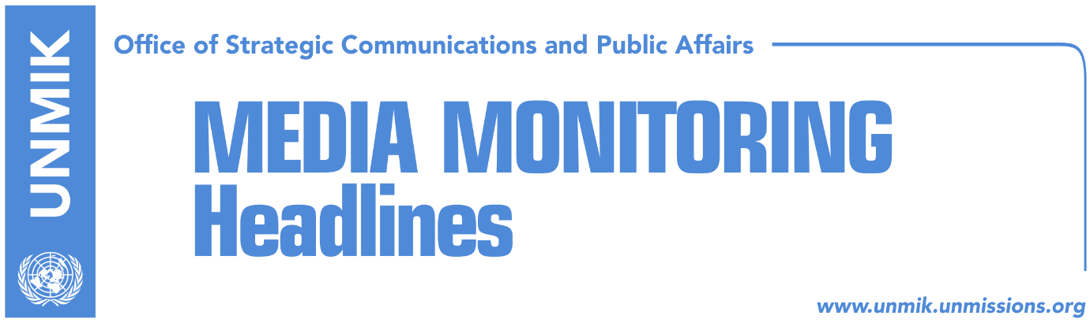

Main Stories 30 June 2018

- Thaci expects creation of negotiating team next week (media)
- Haradinaj: I am skeptical on result of the dialogue (RTK)
- Dealawie: You cannot be part of NATO or EU without agreement with Serbia (Lajmi.net)
- Vucic to Chepurin: Ready for compromise with Kosovo (RTK)
- O’Connell calls on political parties to engage on dialogue (media)
- NATO delegation with concrete messages in Pristina (media)

Kosovo Media Highlights

Thaci expects creation of negotiating team next week (media)
The President of Kosovo Hashim Thaci, reported to the governing cabinet about his meeting with Serbia’s President Aleksandar Vucic in Brussels. He said that his reporting represents his determination to be transparent in the final phase of the dialogue with Serbia.

“It was the same this round as well, I held two rounds of working meetings with the US representatives prior to the official meetings. These regular coordinative meetings with our main strategic partner, USA, and with the other powerful European nations, which play a supportive role in this process, are extremely important”, Thaci said.
He added that the operations of the Kosovo delegation in the dialogue process will be transparent, with regular reporting provided to the citizens and to the institutions.

“For this reason, even prior to my departure to the first meeting I have made my readiness to report clear to the Parliament of Kosovo as often as required”, he said.

He stressed that the parliament of Kosovo must be involved in this process in a direct manner, while the governing coalition, in cooperation with parliamentary political parties, both governing and opposition ones, agree on the modalities of this inclusion as soon as possible.

“I say this because the time is ticking, and this process cannot be stopped for many reasons. The widest possible political and social consensus, at this stage of the dialogue, would not only increase the confidence in the process, but would also strengthen the delegation of Kosovo. I hope that the leaders of political parties will understand their responsibilities towards the institutions of the country, and above all, towards citizens of the country”, Thaci stated.

He further pointed out that Kosovo has its own legitimate and democratic state institutions, therefore no one may pretend to question their constitutional and legal legitimacy.

He also recalled that prior to his departure for the first meeting in Brussels, he appealed publicly to political subjects to join Kosovo’s delegation, and that he is repeating the same now.

“Come and become a part of Kosovo’s delegation, and provide your knowledge and patriotism, at the discussion table. This would be the right act, most rational and courageous act, awaited by the citizens of Kosovo. Everything else, all baseless and pointless criticisms only show signs of fatigue, lack of responsibility and courage” Thaci said.

Speaking in relation to the meeting held in Brussels, Thaçi said that he has made it clear that Kosovo is devoted and deeply interested to the achievement of the final obligatory and legal agreement

Haradinaj: I am skeptical on the result of the dialogue (RTK)
The Prime Minister of Kosovo Ramush Haradinaj expressed skepticism at the constitution of the leading assembly of the Alliance for the Future of Kosovo (AAK), with regards to the dialogue between Pristina and Belgrade.

“I am skeptical that there can be a result in this dialogue, because it is the same people, it is Mogherini and Angelina Euchorst, the same ones for five years now, President Thaci and President Vucic, are the same. I do not understand how can something change all of a sudden, nothing has happened differently, I do not understand how can they move things immediately. The only way for something different to happen at the dialogue is entrance of a new power, something that has not happened so far. Otherwise, imagine: we go to Brussels and come back without the agreement on energy, that is even a minor issue. We have requested a new power in the dialogue, for Americans to come. If Americans claim that it is a matter of Europe, we will continue to sit at the tables, let a European state take things in its hands, let it help EU, not to take it over from EU, but let Germany help,” Haradinaj said.
According to him it is a mistake to think that by helping the dialogue process, the other significant processes for Kosovo would be reached more easily.

Dealawie: You cannot be part of NATO or EU without agreement with Serbia (Lajmi.net)
The U.S. Ambassador to Kosovo, Greg Delawie, said during the ceremony of marking the 242 anniversary of the independence of the United States of America, that this year is the year that Kosovo must overcome its differences with Serbia and negotiate a final dialogue agreement.
“For me, it means you have no real choice but to negotiate a final resolution of your relationship with Serbia, and the sooner the better. Right now, in 2018. The discussion must move past whether there will be an agreement and reasons “why not” to negotiate. Real leadership means focusing on how you find a way toward accomplishing your goals. There is growing momentum and genuine seriousness about finally achieving Kosovo-Serbia normalization. The EU has stressed for entry into the European Union, the two countries must strike a deal. That’s the best negotiating leverage Kosovo is ever going to get. But the European Union has elections in 2019, and no one can say what the next generation of EU leaders will do. It’s time now for Kosovo to come together with a sense of unity and national purpose for a final dialogue push,” Delawie said.

Vucic to Chepurin: Ready for compromise with Kosovo (RTK)
Aleksandar Chepurin, Russia’s Ambassador to Serbia informed during a meeting with Serbia’s President Aleksandar Vucic, that Russia’s President Vladimir Putin will be visiting Belgrade in autumn.
According to Serbian media, Vucic expressed appreciation for Russia’s support for Serbia. During this meeting, they reportedly discussed the dialogue process between Serbia and Kosovo. Vucic stressed that Serbia is ready for compromise, but only by preserving Serbian dignity and interests.

O’Connell calls on political parties to engage on dialogue (media)
Ruairi O’Connell, the Ambassador of the Great Britain to Kosovo, took to Facebook to appeal to all political parties to engage in the dialogue between Pristina and Belgrade.
“Nearly 20 years after the conflict, Kosovo and Serbia are held back by the lack of a normal relationship with each other. We strongly support the efforts of HR/VP Mogherini to help Kosovo and Serbia resolve their differences and forge a new and better relationship. It is positive that these efforts are entering a new phase. Kosovo needs to put in place structures to engage with this process, so that any outcome can be implemented and enjoy the confidence of Kosovo’s citizens. We urge all political actors to do what they can so that Kosovo engages seriously in the new phase of dialogue,” O’Connell wrote.

NATO delegation with concrete messages in Pristina (media)
A high level NATO delegation has brought concrete messages to Pristina. After meeting the leaders of Kosovo, NATO officials stressed that transformation of Kosovo Security Force into an army can happen only through constitutional changes.

Paolo Alli, President of NATO’s Parliamentary Assembly also said that Europe is not completed without Western Balkans as its part. He added that NATO’s presence in Kosovo contributes to the stability of the region.

Disclaimer
This media summary consists of selected local media articles for the information of UN personnel. The public distribution of this media summary is a courtesy service extended by UNMIK on the understanding that the choice of articles translated is exclusive, and the contents do not represent anything other than a selection of articles likely to be of interest to a United Nations readership. The inclusion of articles in this summary does not imply endorsement by UNMIK.

