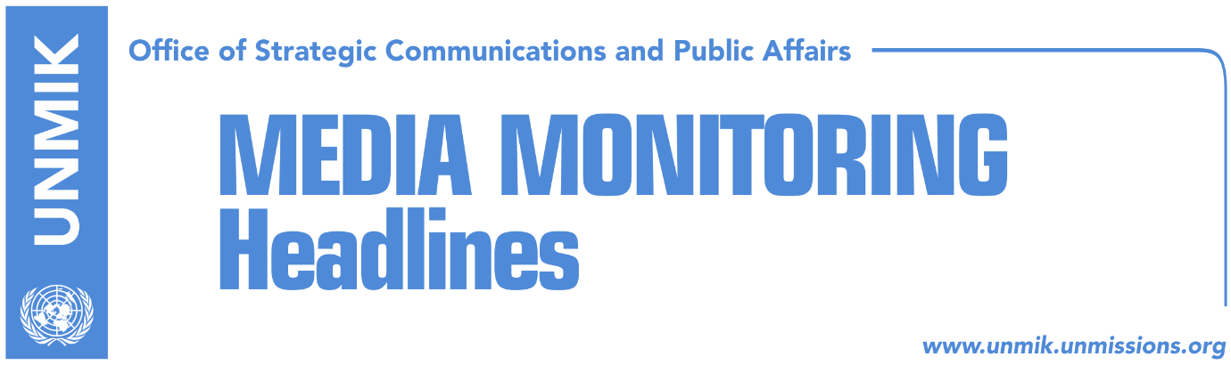

Main Stories 2 July 2018

- Political parties against Thaci’s lead role in negotiations (Zeri)
- Thaci, Hoxhaj welcome Austria’s EU presidency (Epoka)
- Norwegian PM: Kosovo, Serbia to benefit from normalization of relations (media)
- Serbia reveals aims for Kosovo’s partition (Zeri)
- Joksimovic: No EU membership without agreement with Kosovo (Zeri)
- Vulin: Kosovo wants to win everything and give away nothing (media)
- Vatican calls for peaceful solution between Kosovo and Serbia (Zeri)
- Kosovo, full member of WCO (Epoka)
- Kopac: “Kosova e Re” contract to be reviewed, but not by its authors (Koha)

Kosovo Media Highlights

Political parties against Thaci’s lead role in negotiations (Zeri)
Kosovo President Hashim Thaci said that early this week he will meet leaders of institutions and political parties to establish Kosovo’s negotiating team, the strategic team and other committees for dialogue with Serbia, the paper reports on its front page. Opposition parties however do not support Thaci’s leading role in the process and he also lacks support from the Social-Democratic Initiative, a party in the ruling coalition. Meanwhile, civil society representatives argue that Kosovo needs to build internal consensus and a platform on dialogue before proceeding to the finale of the process. Democratic League of Kosovo (LDK) deputy leader, Agim Veliu, told the paper on Sunday that his party has not received an invitation from President Thaci to a meeting for the negotiating team. “When we get the invitation, we will discuss it in our forums and then decide on the future course of action,” Veliu said. Representatives of the Vetevendosje Movement and the Social-Democratic Initiative meanwhile are categorically against Thaci’s role as chief negotiator and don’t even want to discuss the matter.

Thaci, Hoxhaj welcome Austria’s EU presidency (Epoka)
The President of Kosovo Hashim Thaci thanked Bulgarian Prime Minister Boyko Borissov for his country’s contribution during the presidency of the European Union and added that has full trust on Austrian Chancellor Sebastian Kurz’s vision and energy to move forward the European agenda of Kosovo and other Western Balkans countries now that Austria has taken over the EU presidency. “We have to continue with implementation of important political reforms, required for the irreversible journey towards EU membership,” Thaci said. Deputy Prime Minister Enver Hoxhaj also congratulated Chancellor Kurz saying that it is also “a momentum for Kosovo and Western Balkans countries in their journey towards the European Union.”

Norwegian PM: Kosovo, Serbia to benefit from normalization of relations (media)
The Prime Minister of Norway, Erna Solberg said both Kosovo and Serbia will benefit from normalization of relations. She believes that the current situation creates unsustainability in the region and a setback for both countries. Solberg told Belgrade daily Politika that sustainable solution for Kosovo would ensure better lives and opportunities for the citizens of both countries. “Of course, the obligations taken over have to be fulfilled, but some of them are interpreted differently in Serbia and Kosovo, therefore it is important to continue with negotiations, mediated by EU,” she said. She added that model of cooperation implemented by Scandinavian countries after World War Two is possible in Balkans. “We focused on improvement of lives of our nations in the future, which was a recipe of success for Scandinavian cooperation and I think it would be effective in Balkans,” Solberg explained.

Serbia reveals aims for Kosovo’s partition (Zeri)
Kosovo’s partition is one of Serbia’s objectives at the EU-brokered dialogue in Brussels and this was recently confirmed by Serbian President Aleksandar Vucic, who said that it would be a success to return even a single meter from what Serbia has lost “because right now we have nothing”, the paper reports on page four. The ruling parties in Kosovo meanwhile say everyone knows Serbia’s objectives but that Kosovo’s territorial integrity and sovereignty will remain untouchable. Opposition representatives on the other hand say that they fear more President Hashim Thaci than his Serbian counterpart. They also express concern over Thaci’s recent remarks that there will be no red lines in the finale of talks with Serbia.

Joksimovic: No EU membership without agreement with Kosovo (Zeri)
Serbia’s Minister for European Integration, Jadranka Joksimovic, said Serbia won’t be able to join the European Union without reaching a final agreement with Kosovo. Joksimovic told Politico on Sunday that it was very important for dialogue between the two sides to continue. “As far as dialogue between Pristina and Belgrade is concerned, the framework of the EU is clear: a legally-binding agreement for normalization of relations must be reached before membership,” she said. “The agreements must be implemented. The Association/Community of Serb-majority municipalities is important and we have yet to see concrete steps from Pristina”.

Vulin: Kosovo wants to win everything and give away nothing (media)
Serbia’s Defense Minister, Aleksandar Vulin, told Radio Television of Serbia on Sunday that he is pessimistic about a possible compromise between Kosovo and Serbia in the EU-brokered dialogue in Brussels, “because Kosovo wants to win everything and give away nothing”. Asked why he was barred from visiting Kosovo recently, Vulin said: “what we know is that they are scared from what I say or might say. I find it interesting not because Albanians are afraid of my words, because I know what they are going to say, but it is very interesting that the EU mediators, who should be informed about the ban, are also afraid of my words”.

Vatican calls for peaceful solution between Kosovo and Serbia (Zeri)
Cardinal Pietro Parolin, Vatican Secretary of State, during a visit to Belgrade called for a peace agreement between Kosovo and Serbia. He said he hopes that dialogue between the two sides will result in a real solution of compromise with respect for peace and stability. Serbian President Aleksandar Vucic said Belgrade wants to reach a peaceful solution with Kosovo but that it also wants to protect its national interests.

Kosovo, full member of WCO (Epoka)
Representatives of Kosovo are attending the 132nd session of the World Customs Organisation Council, which is being held in Brussels with participation of 182 countries. This is the fourth time that Kosovo is participating, however this time it is participating as a full member. The full membership was gained in January 2017.

Kopac: “Kosova e Re” contract should be reviewed, but not by its authors (Koha)
Janez Kopac, director of the Energy Community Secretariat, said in an interview to the paper that the contract for the power plant “Kosova e Re” constitutes a violation of the European Union’s energy legislation and that it should be reviewed, “but not by the people in government who provided advantages to the U.S. company Contour Global”. Kopac highlighted a series of risks that Kosovo and the consumers would be faced once the new power plant would go into operation. He also said that the government must review the contracts that has been signed and ensure that they are compatible with European regulations.

Disclaimer
This media summary consists of selected local media articles for the information of UN personnel. The public distribution of this media summary is a courtesy service extended by UNMIK on the understanding that the choice of articles translated is exclusive, and the contents do not represent anything other than a selection of articles likely to be of interest to a United Nations readership. The inclusion of articles in this summary does not imply endorsement by UNMIK.

