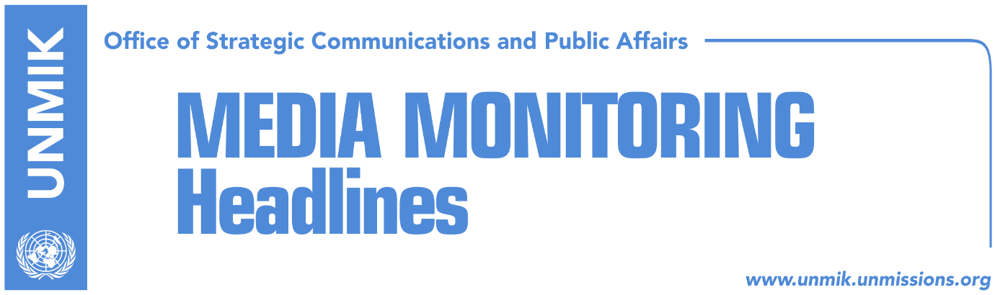

Main Stories 3 July 2018

- Thaci and Mitchell agree on intensifying Pristina-Belgrade dialogue (media)
- Haradinaj: Kosovo recognition by Serbia becoming difficult to delay (Telegrafi)
- Thaci’s initiative to set up unity team heading towards failure (Zeri)
- Konjufca: Assembly to set red lines to Thaci for dialogue with Serbia (Zeri)
- EU: Association, according to Kosovo laws and 2015 agreement (Koha)
- Arifi: Unification of political forces for dialogue, necessary (Epoka)
- Former President Jahjaga suggests conditions for dialogue with Serbia (RTK)
- Eight Serb members of KSF want to resign due to pressure from Belgrade (media)
- Ministry of Internal Affairs receives U.S. Department of State report (Epoka)
- Hahn: Kosovo is not the only issue for Serbia’s progress towards EU (Epoka)

Kosovo Media Highlights

Thaci and Mitchell agree on intensifying Pristina-Belgrade dialogue (media)
Pristina-Belgrade dialogue was the central topic of a telephone conversation between the President of Kosovo, Hashim Thaci, and the US Assistant Secretary of State for Europe and Eurasia, Wess Mitchell, media report. In a Facebook post, Thaci revealed that the two agreed to intensify the dialogue and on the need to reach a final, legally-binding agreement with Serbia. Thaci said a final settlement paves way to Euro-Atlantic integrations for Kosovo and ensures peace and stability in the Western Balkans.

Haradinaj: Recognition of Kosovo by Serbia becoming difficult to delay (Telegrafi)
Prime Minister of Kosovo, Ramush Haradinaj, said in an interview with Sarajevo-based paper Dnevni Avaz that it is becoming increasingly difficult for Serbia to delay recognition of Kosovo as an independent country. The same applies for Bosnia and Herzegovina too, Haradinaj added. He said it was important for the dialogue with Serbia to conclude as soon as possible. “Delays are not good and it has implications in our internal situation which in a way depends on the dialogue with Belgrade. It is therefore important for Brussels to be actively involved in negotiations,” Haradinaj said. “Kosovo is ready for lasting peace. There can be no return to the past,” he noted.

Thaci’s initiative to set up unity team heading towards failure (Zeri)
Following the announcement of President of Kosovo Hashim Thaci that he plans to meet this week leaders of political parties in an effort to set up a so-called unity team for talks with Serbia, so far only his former Democratic Party of Kosovo (PDK) and Ramush Haradinaj’s Alliance for the Future of Kosovo (AAK) have positively responded to the call, the paper reports on the front page. Meanwhile, Vetevendosje has said it opposes the idea of meeting Thaci, the Social Democratic Initiative (NISMA) considers Thaci leading the talks is unacceptable whereas the Democratic League of Kosovo (LDK) and the Social Democratic Party (PSD) have yet to come out with a position on the matter.

Konjufca: Assembly to set red lines to Thaci for dialogue with Serbia (Zeri)
Head of Vetevendosje parliamentary group, Glauk Konjufca, said the statement of President of Kosovo, Hashim Thaci, that there are no red lines in the dialogue with Serbia are concerning and that the Assembly of Kosovo needs to determine these red lines. “The dialogue is changing only because Thaci has changed his political post. This is unacceptable for us and needs to be stopped. We saw that the president has removed red lines to Serbia. Vetevendosje considers that these lines will now have to be reasserted by the Parliament,” Konjufca said in a press conference. He added that Thaci considers the dialogue with Serbia to be a way for him to cling to power and to also postpone the work of the Specialist Chambers.

EU: Association, according to Kosovo laws and 2015 agreement (Koha)
The European Union Office in Kosovo did not specifically mention the ruling of the Constitutional Court when asked about documents that will serve as guidelines to draft the statute of the Association/Community of Serb-majority municipalities, the paper reports on its front page. In a written reply, the EU Office referred to Kosovo’s “legal framework” and the August 2015 agreement for the Association/Community of Serb-majority municipalities. “The Association/Community will be formed within Kosovo’s legal framework, based on the Brussels Agreement and the key elements/principles of the Association of Serb-majority municipalities reached between the parties in August 2015. Kosovo gave the Management Team the mandate to draft the statute of the Association/Community. Their work is ongoing … The European Union expects all agreements reached in the EU-brokered dialogue to be implemented without further delay, especially the Agreement on the Association/Community and the Energy,” the EU Office said.

Arifi: Unification of political forces for dialogue, necessary (Epoka)
Head of Kosovo’s delegation for technical dialogue with Serbia, Avni Arifi, said in an interview to the paper that Belgrade is not showing readiness to hold meetings aimed at implementing the agreements that have already been reached in Brussels. He said Pristina has called on the EU and its member states to pressure Serbia into the implementing the agreements, “but all requests have fallen in def ears”. Arifi also said that Kosovo’s political forces must join forces for dialogue with Serbia. According to him, the government and opposition political parties should find a formula in order for the dialogue to conclude as soon as possible and in a successful manner.

Former President Jahjaga suggests conditions for dialogue with Serbia (RTK)
Former Kosovo President, Atifete Jahjaga, said in an interview to RTK that, dialogue between Kosovo and Serbia must continue but not without conditions. Jahjaga said the fate of all missing persons from the conflict must be resolved, criminals of rape victims must be brought to justice and compensation must be sought for the crimes the Serbian regime committed against civilians in Kosovo. She argued that sustainable peace can be achieved only if Serbia meets Kosovo’s rightful conditions. Jahjaga also called on Kosovo society and institutions to support war rape victims.

Eight Serb members of KSF want to resign due to pressure from Belgrade (media)
The news website reports that eight Serb members of the Rapid Reaction Brigade of the Kosovo Security Force (KSF) have asked to be demobilized citing pressure from authorities in Belgrade. KSF Deputy Minister Agim Ceku and Brigade commander Berat Shala held a meeting with the Serb members in an effort to persuade them to not leave the force. Ceku told the news website over the phone that their request for demobilization will be reviewed in six months.

Ministry of Internal Affairs receives U.S. Department of State report (Epoka)
Bejtush Gashi, Kosovo’s Minister of Interior, received on Monday the annual report of the U.S. State Department on human trafficking for 2018. The report stresses ten recommendations that would increase efficiency on preventing and combating human trafficking as well as looking after the victims of trafficking. According to the report, Kosovo continues to rank at level two from the three essential levels. According to the report Kosovo has marked significant progress compare to the last year. Minister Gashi pledged that he will fulfil the ten recommendations of the report.

Hahn: Kosovo is not the only issue for Serbia’s progress towards EU (Epoka)
The EU Commissioner for Enlargement Johannes Hahn, told Serbian authorities that normalization of the relations with Kosovo is not the only issue for Serbia’s progress towards EU integration. Speaking after the meeting with Serbia’s President Aleksandar Vucic, Hahn stressed the importance of the Kosovo issue. “It is clear that this is a current issue, but that is not the only important issue for Serbia’s progress in the Euro-integration path. There are also other elements that are important. Rule of law is in the heart of the negotiations with EU,” Hahn said.

Disclaimer
This media summary consists of selected local media articles for the information of UN personnel. The public distribution of this media summary is a courtesy service extended by UNMIK on the understanding that the choice of articles translated is exclusive, and the contents do not represent anything other than a selection of articles likely to be of interest to a United Nations readership. The inclusion of articles in this summary does not imply endorsement by UNMIK.

