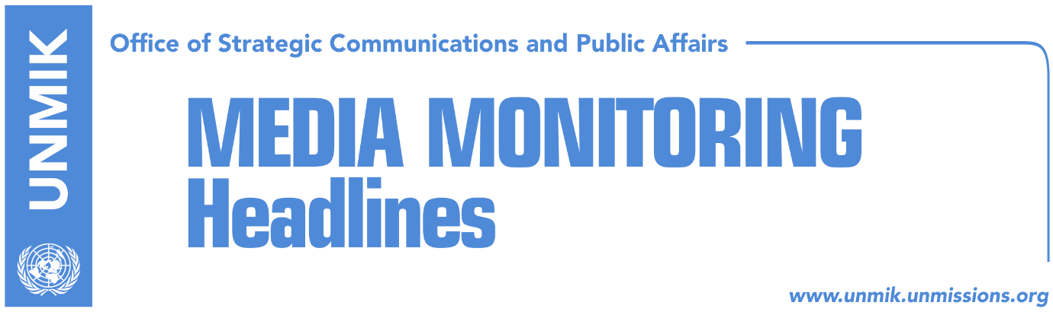

Main Stories 6 July 2018

- Haradinaj: Serb KSF members facing direct pressure from Belgrade (media)
- A Serb member: I was forced to leave KSF (RFE/Kosova Sot)
- War time amnesty, part of Kosovo – Serbia agreement (Koha)
- “Serbia should recognize Kosovo, otherwise EU does not accept it” (Kosova Sot)
- Pacolli rejects claims Papua New Guinea has revoked recognition (Klan Kosova)
- Minister Hoxha visits Germany to rally support for visa liberalisation (Zeri)
- Haradinaj: The €53 million were created by Mustafa’s government (Epoka)
- Assembly to vote on Constitutional Court judges today (Zeri)
- Panelists suggest conflict related sexual violence be included in dialogue (dailies)
- Philip S. Kosnett to succeed Delawie as new US ambassador in Pristina (media)
- Gashi calls for implementation of anti-terror strategy (Epoka)

Kosovo Media Highlights

Haradinaj: Serb KSF members facing direct pressure from Belgrade (media)
Prime Minister of Kosovo Ramush Haradinaj’s statement that Serb members of the Kosovo Security Force (KSF) have been facing direct pressure from Belgrade to resign their posts has been picked up by majority of daily papers today. Haradinaj made the remarks yesterday after an extraordinary meeting of the National Security Council convened to discuss security situation in face of a number of recent resignations of Serb KSF members. Haradinaj said that the government has been aware for a while now of cases of intimidation against Serb members of the KSF which has led several of them requesting to be discharged from service. “Majority of them list under the description of motives direct pressure from Belgrade authorities,” Haradinaj said. He said this pressure is exercised in the form of freedom of movement restriction, questioning, threats directed towards the Serb KSF members as well as their families. Haradinaj however said this has not undermined the security situation in Kosovo and that relevant institutions have taken on all necessary measures to clarify such “unacceptable” actions.

A Serb member: I was forced to leave KSF (RFE/Kosova Sot)
Around twenty members of the Kosovo Security Force (KSF) from the Serb community have submitted a collective request to leave KSF. They are all from Gjilan/Gnjilane region, and do not prefer to talk to the media. Some of them claim they resigned for personal reasons while the others say they have made the decision “for Serbia.” One of these members, who insisted to remain anonymous, told Radio Free Europe that the decision was made in a collective manner therefore he could not decide differently. “They all left it, so I was forced to do the same. They do not allow us at the border to cross to Serbia, so we had to do this,” said this Serb member who had just decided to leave KSF.

War time amnesty, part of Kosovo – Serbia agreement (Koha)
The paper reports on its front page that some international diplomats were shocked to hear that an amnesty for the war period could be part of a final agreement between Kosovo and Serbia. Reliable diplomatic sources told the paper that they heard about the option from officials in Pristina and that there is readiness among negotiators from both Kosovo and Serbia to achieve this. The same sources said the amnesty would include both sides involved in the conflict and that as a result the Special Court could be undone. The press and information office of Kosovo President Hashim Thaci indirectly confirmed that amnesty could be part of a package agreement. “Certainly, if there will be an agreement it will include many issues, namely special protocols. Amnesty and reconciliation could be one of these special issues,” the office told the paper in a reply on Thursday. “One thing is certain however. Kosovo is a democratic state that respects international conventions and laws. So if there is an agreement on amnesty between the two countries, this can include only certain crimes or penal acts and it cannot be applied to war crimes because it falls in contravention with international law. Kosovo fully respects international conventions and international law. Amnesty can be acceptable only for a number of certain penal cases. But under no circumstance can it include those who committed crimes, ethnic cleansing, torture or rape. These crimes are sanctioned with international law and Kosovo has harmonized its criminal law in line with international laws and conventions”. The paper contacted the government but its representatives refused to comment on the issue. Representatives of ruling parties also refrained from commenting until the topics of the final talks between Kosovo and Serbia are officially announced.

“Serbia should recognize Kosovo, otherwise EU does not accept it” (Kosova Sot)
The paper carries an article published on Thursday on The Independent, which stresses that “in theory, both sides must recognise each other’s “rights” – which means that Serbia must recognise Kosovo – because Brussels is not going to have two hostile members joining its hygienic ranks for the sake of its “Western Balkans stabilisation and association process”. As for both Serbia and Kosovo, of course, they want the EU’s moolah”. https://www.independent.co.uk/voices/serbia-belgrade-kosovo-eu-membership-tony-blair-vucic-a8432801.html

Pacolli rejects claims Papua New Guinea has revoked recognition (Klan Kosova)
Kosovo’s Minister of Foreign Affairs, Behgjet Pacolli, has refuted claims by Serbian Foreign Minister, Ivica Dacic, that Papua New Guinea has revoked recognition of Kosovo. In a Facebook post, Pacolli called Dacic’s statement “fabrication”. “Republic of Kosovo, through it diplomatic service, maintains continuous contacts with all world countries, including PNG,” Pacolli wrote saying that everything will be confirmed in the coming days.

Minister Hoxha visits Germany to rally support for visa liberalisation (Zeri)
In a visit to Germany, Kosovo’s Minister of European Integration, Dhurata Hoxha, met the country’s Minister for Europe, Michael Roth, and urged Germany to support Kosovo in its visa liberalisation process underlining that all requirements have been met. A statement issued by the Kosovo ministry states that Hoxha informed her German counterpart of Kosovo’s efforts in fighting organised crime and corruption adding that this commitment will continue beyond the visa liberalisation decision.

Haradinaj: The €53 million were created by Mustafa’s government (Epoka)
The governing coalition and the opposition political parties clashed on Thursday at the Assembly of Kosovo over the €53 million paid to the Bechtel Enka company for the Pristina-Hani i Elezit motorway. Prime Minister Ramush Haradinaj accused the previous government led by Isa Mustafa for the accumulated debts to this company. “This unexploded mine on the table of Haradinaj’s government was left by LDK’s government, former PM Mustafa, former minister Lutfi Zharku and Avdullah Hoti,” Haradinaj said.

Assembly to vote on Constitutional Court judges today (Zeri)
Kosovo Assembly is set to vote today on candidacies for three new judges at the Constitutional Court after it failed to do so a month ago. Assembly’s Deputy Speaker, Xhavit Haliti, said the issue requires political agreement. “This is an issue that can be resolved quickly but the problem is that in the absence of a political agreement they [judges] will never be appointed,” he stated for the paper. He also said the election procedure of Constitutional Court judges ought not to go through the Assembly but rather be decided by the Judicial Council. At present, the Constitutional Court’s decision-making process is deadlocked for the lack of quorum.

Panelists suggest conflict related sexual violence be included in dialogue (dailies)
In coverage of a conference that took part in Pristina yesterday on the issue of justice for survivors of conflict related sexual violence, organised by UN Women, Kosova Sot reports that panelists said this issue needs to be included in the dialogue between Pristina and Belgrade for normalisation of relations. The UN Development Coordinator, Ulrika Richardson, said at the conference that the failure to bring before justice perpetrators of sexual violence is a barrier for stability and peace. She called on the government of Kosovo to strengthen mechanisms that deal with this issue. Zeri meanwhile quotes former President of Kosovo, Atifete Jahjaga, saying that no one has yet been convicted for conflict related sexual violence and that only three indictments have been raised so far. Jahjaga said survivors of sexual violence in conflict are discriminated by the society and furthermore they faced physical and psychological violence. “Perpetrators of these crimes live free, in contrast to the survivors,” Jahjaga said. Head of UN Women for Kosovo, Flora Macula, meanwhile pointed out that sexual violence was related to the conflict in Kosovo and that it was neglected because of the stigma surrounding it.

Philip S. Kosnett to succeed Delawie as new US ambassador in Pristina (media)
Most news websites report that Philip S. Kosnett will be the new United States Ambassador in Kosovo. During his career in the Foreign Service, Kosnett has served in missions in Europe, Asia and the Middle East, and has held senior positions in the State Department.

Gashi calls for implementation of anti-terror strategy (Epoka)
Kosovo’s Minister of Internal Affairs, Bejtush Gashi requested on Thursday support of all competent authorities for implementation of the Strategy against terrorism. During his meeting with the group for strategic support against terrorism and prevention of violent extremism which leads towards terrorism, he requested closer cooperation and inter-institutional coordination in order to react in time towards challenges that might occur. Participants also discussed return of citizens from the conflict zones as well as the process of establishment of a division for prevention and re-integration of radicalized individuals.

Disclaimer
This media summary consists of selected local media articles for the information of UN personnel. The public distribution of this media summary is a courtesy service extended by UNMIK on the understanding that the choice of articles translated is exclusive, and the contents do not represent anything other than a selection of articles likely to be of interest to a United Nations readership. The inclusion of articles in this summary does not imply endorsement by UNMIK.

