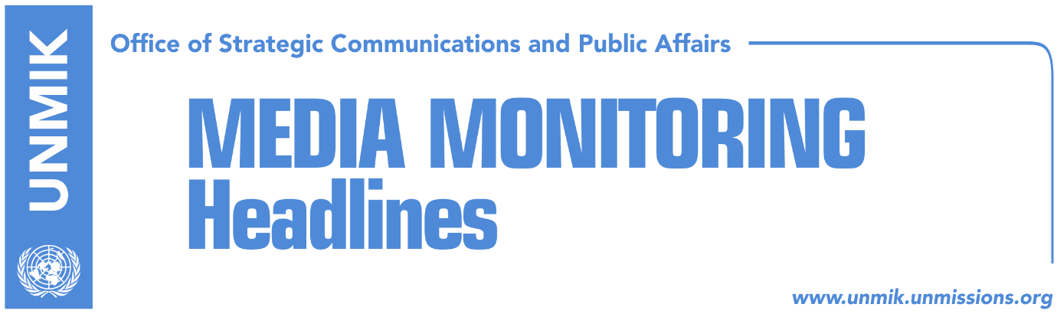

Main Stories 11 July 2018

- Haradinaj: We need a political ceasefire with Serbia (Koha)
- Prosecution: Serbs were released as police evidence was not sufficient (Koha)
- In London, Kosovo PM Haradinaj meets British PM May (media)
- Haradinaj requests Merkel’s help on visas, dialogue and army (Epoka)
- Haradinaj meets Austrian Chancellor Kurz (RTK)
- Pacolli to FT: Kosovo can join EU by 2025 (RTK)
- “Report for assessment of criteria for visas, has not concluded yet” (Kallxo.com)
- Draft statute for Association/Community, ‘unconstitutional’ (Zeri)
- Ireland supports Kosovo’s membership in EU, UN (RTK)

Kosovo Media Highlights

Haradinaj: We need a political ceasefire with Serbia (Koha)
Kosovo Prime Minister, Ramush Haradinaj, said on Tuesday that at the end of the EU – Western Balkans Summit in London, he raised the issue of Serbia’s pressure on Serb members of the Kosovo Security Force to leave this force. “We understand the sensitivity of relations between Kosovo and Serbia and we are ready to preserve these relations. But we need a political ceasefire; if there will be dialogue, there needs to be a political ceasefire too,” Haradinaj told KTV.

Prosecution: Serbs were released as police evidence was not sufficient (Koha)
Five Kosovo Serbs were arrested by Kosovo Police in Gjilan on Tuesday under the suspicion that they threatened, blackmailed and pressured Serbs into resigning from the Kosovo Security Force, the paper reports on page two. After they were interviewed, the suspects were released in regular procedure as the prosecution said the evidence provided by police was not sufficient to keep them in detention. Commenting on the arrest, Kosovo Assembly President Kadri Veseli wrote in a Facebook post on Tuesday: “threatening families of Serb members of the Kosovo Security Force is unacceptable. We condemn all acts aimed at destabilizing Kosovo and threatening the lives of our citizens. We assure all citizens of the Republic of Kosovo, regardless of their ethnicity, that we shall protect them. Today, the law enforcement institutions of Kosovo have carried out their duty by arresting five persons suspected of threatening security and the rule of law. The continuous attempts of Serbian politics to obstruct and damage the integration of Kosovo Serbs is in opposition with the principles of good neighborly relations, the interests of Serb citizens in Kosovo, European values and aspirations for EU integration. Kosovo’s institutions are always ready for dialogue and good neighborly relations. Every provocation by Serbia that damages this process does not contribute to the interests of our countries which want normalization of relations and stability and peace in the Balkans”. Marko Djuric, head of the Serbian Government’s office for Kosovo, said on Tuesday that if the five Serbs were not immediately until the evening “there would be no dialogue between Pristina and Belgrade for a very long time”.

In London, Kosovo PM Haradinaj meets British PM May (media)
Prime Minister of Kosovo, Ramush Haradinaj, met at the sidelines of the EU-Western Balkans Summit in London the British Prime Minister, Theresa May. In a Facebook post, Haradinaj said the meeting was fruitful. “Great Britain has helped Kosovo in all the state-building stages and it is time to strengthen economic and trade cooperation even further,” Haradinaj said adding that Kosovo is committed to its Euro-Atlantic integration and Great Britain’s support in this process is of special importance.

Haradinaj requests Merkel’s help on visas, dialogue and army (Epoka)
The Prime Minister of Kosovo Ramish Haradinaj met during his visit to London the German Chancellor Angela Merkel. According to the Office of the Prime Minister, they discussed bilateral relations, possibilities to extend cooperation and processes in Kosovo. Haradinaj reportedly spoke about Germany’s important role on Kosovo’s state-building and expressed appreciation to Chancellor Merkel for her and her country’s strong support. “Your leadership was determinant in many processes that Western Balkans is experiencing, therefore we request your support at this significant phase of the process of European integrations, visa liberalization, to be a strong voice for the prosperous future of Kosovo,” Haradinaj is quoted as saying.

Haradinaj meets Austrian Chancellor Kurz (RTK)
The Prime Minister of Kosovo Ramush Haradinaj met in London with the Austrian Chancellor Sebastian Kurz. He informed the Chancellor about developments in Kosovo, commitment of instriutions to strengthen the rule of law, war against corruption and organized crime, economic development European reform agenda, and dialogue process with Serbia where Haradinaj stressed that it should conclude with reciprocal recognition. He praised Austria for its role in Kosovo’s progress. “We expect you to continue to play your role in advancing democratic processes and overall development of our country,” Haradinaj reportedly said.

Pacolli to FT: Kosovo can join EU by 2025 (RTK)
In an interview with Financial Times, Kosovo’s Foreign Minister Behgjet Pacolli said that Kosovo could be ready to join the EU by 2025. “Of course, this may sound premature but the wish can serve as a motive,” Pacolli said. he noted that the EU diplomacy has contributed to the Kosovo-Serbia dialogue but that talks cannot last indefinitely. “Dialogue with Serbia has started to go in a better way. I believe this dialogue need not go on for years and years in order for us to reach an agreement,” Pacolli said. He also spoke about the idea of creating a free economic zone in the north of Kosovo which he said is his personal view and not that of the government of Kosovo. According to him, this zone would be administered by officials from both sides and would be free of politics.

“Report for assessment of criteria for visas, has not concluded yet” (Kallxo.com)
Gernot Pfandler, Austrian Ambassador to Kosovo, said during the presentation of the priorities of his country during the EU presiding that in the six-month period, Austria will work on deepening relations with Kosovo and the region. “As you know, Austria has strong historic relations with the region and we are more than dedicated as an EU member country to the European perspective of Kosovo and the other countries of the region,” he said. “There is possibility for the dialogue to move forward during the following days and months and Kosovo political leaders are aware of this and they want to reach progress in the process facilitated by Mogherini and the Presidency is ready to support if required. Visa liberalization is important. Citizens currently are waiting for the report of the Commission and if the criteria are fulfilled, and as soon as the report is completed, it will be proceeded to the Council and Parliament for further actions,” Pfandler said.

Draft statute for Association/Community, ‘unconstitutional’ (Zeri)
The paper reports on the front page that the draft statute of the Association/Community of Serb-majority municipalities submitted to the government of Kosovo by the Management Team which prepared contains provisions that are in violation to the Constitution of Kosovo. Government officials are quoted as telling the paper that the version of the Association/Community draft statute that they’ve received is ‘unlawful’ and ‘unconstitutional’ and will therefore be rejected. The document is said to have been prepared with reference to the Brussels Agreement and not the Constitutional Court ruling. “They have come up with a politically incorrect draft which can never be implemented in Kosovo,” said government in a reply to the paper.

Ireland supports Kosovo’s membership in EU, UN (RTK)
Ireland’s Minister of Defence, Paul Kehoe, in a visit to Irish troops deployed to Kosovo as part of KFOR, said that his country will support Kosovo in its journey to join the European Union and United Nations. In his remarks after meeting Kosovo Security Force Minister, Rrustem Berisha, Kehoe said he believed good days are ahead for Kosovo and that he was looking forward to a greater cooperation between Kosovo and Ireland.

Serbia interferes in Kosovo’s original documents (Koha)
The paper reports on its front page that since December 2012, Kosovo and Serbia have an agreement for mutual legal cooperation; however, since then, unilaterally and in opposition with the agreement in Brussels, Belgrade covers the emblem and constitutional denomination of Kosovo in the documents that are exchanged as part of the agreement. In parts where there are Kosovo logos and seals, Belgrade puts a special seal with the text “Republic of Serbia – Kosovo and Metohija – under the administration of the United Nations according to Resolution 1244”. Kosovo authorities have expressed their concern about this but have never applied measures of reciprocity. The European Union Office in Pristina, which assists in the exchange of documents, is also silent on the matter.

Disclaimer
This media summary consists of selected local media articles for the information of UN personnel. The public distribution of this media summary is a courtesy service extended by UNMIK on the understanding that the choice of articles translated is exclusive, and the contents do not represent anything other than a selection of articles likely to be of interest to a United Nations readership. The inclusion of articles in this summary does not imply endorsement by UNMIK.

