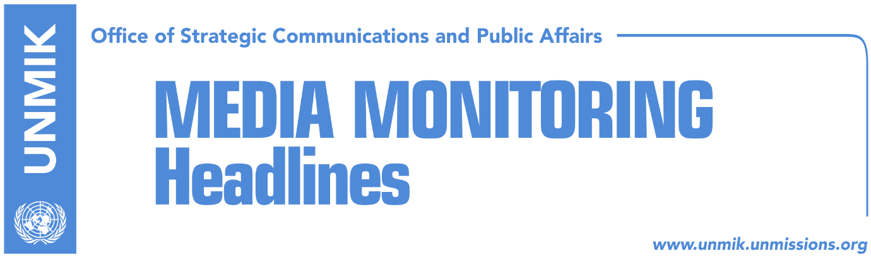

Main Stories 17 July 2018

- President suggests platform to parliamentary parties, but not to himself (Koha)
- “Government – opposition cooperation on dialogue has no alternative” (Epoka)
- Ruling coalition expects positive recommendation on visa liberalization (Telegrafi)
- EU: ACSMM in line with Kosovo laws and Brussels agreement (Zeri)
- LDK with a strategy to bring the government down (RTK)
- Vetevendosje: Mitrovica wall, daunting (Zeri)
- Kosovo, UK to cooperate in addressing sexual violence in conflict (Bota Sot)
- Ragmi Mustafa: Dialogue to be interrupted if Presevo Valey is not discussed (T7)
- Gashi discusses war against terrorism with the British Minister (RTK)

Kosovo Media Highlights

President suggests platform to parliamentary parties, but not to himself (Koha)
Kosovo President Hashim Thaci has suggested to parliamentary parties the platform on dialogue with Serbia presented by Assembly President and PDK leader Kadri Veseli, but he did not say if he will support the document in the final phase of talks which will resume on Wednesday, the paper reports on the front page. Thaci’s office told the paper in a written reply: “The Office of the President carefully analyzes every document or platform related to dialogue, proposed and made public by political parties, civil society, etc. The platform proposed by Assembly President, namely the PDK leader, Kadri Veseli, has also been taken into account and analyzed … We view this document as a good-will effort which can probably serve the parliamentary parties as a good basis to build the highly-necessary political consensus … Time is running fast, and opposition parties are running inexcusably late in becoming part of the dialogue process. We are still waiting for them to unite when issues of national interest are at stake”. Meanwhile, the government has called for a greater role for the Assembly in dialogue with Serbia. “The government believes that the Kosovo Assembly must assume a greater role on dialogue, and we do not comment on statements by political parties,” the Office of the Prime Minister told the paper on Monday.

“Government – opposition cooperation on dialogue has no alternative” (Epoka)
Bilall Sherifi, caucus of the Social-democratic Initative (NISMA) believes that the government and opposition will reach a consensus for the final phase of dialogue with Serbia. He told the paper that their cooperation has no alternative and that his political party has not changed its position on the matter. According to him, only creation of a unity team among the political parties would be adequate to face challenges that await Kosovo during this final phase of the dialogue. He pointed out that the phase of the discussions between political parties is not over.

Ruling coalition expects positive recommendation on visa liberalization (Telegrafi)
Kosovo Prime Minister Ramush Haradinaj said on Monday that the European Commission is expected to give its recommendation on visa liberalization for Kosovo this week, either on Tuesday or Wednesday. “The pressure on visa liberalization is mounting. We can all feel the pressure. On 17 and 18 July, the European Commission is expected to give its recommendation for moving forward with the implementing phases,” Haradinaj said. President Hashim Thaci said recently he hopes that Kosovo will very soon receive good news from the EU on visa liberalization. He also said that Kosovo has met all the visa liberalization requirements. Assembly President Kadri Veseli too said he was optimistic for a positive recommendation. He told the news website on Monday: “Kosovo’s citizens and its institutions expect a positive recommendation because of the progress made so far and because Kosovo has met the technical requirements. We have received signs from our friends and partners that there will be a positive recommendation”.

EU: ACSMM in line with Kosovo laws and Brussels agreement (Zeri)
European Union has made its position clear with regards to the Association/Community of Serb-majority municipalities saying that it needs to be in line with Kosovo laws and the 2015 Brussels Agreement. At the same time, the government of Kosovo insists the Association/Community need not conform to the Brussels Agreement after the Constitutional Court ruled some of its provisions are in violation of the Constitution of Kosovo. The government also said that the EU has stated it supports the formation of the ACSMM in line only with the Constitution of Kosovo.

LDK with a strategy to bring the government down (RTK)
Avdullah Hoti, caucus of the Democratic League of Kosovo (LDK), took to Fecebook to write that “we are drafting today with the LDK parliamentary group the action strategy of our group for the following weeks and months. The group is committed for a strong opposition and stopping this bad governing. Our behavior at the sessions will be clear and determined. The will exists, and support has never been greater,” Hoti wrote.

Vetevendosje: Mitrovica wall, daunting (Zeri)
The paper writes on the front page that the 70cm-high wall being constructed in Mitrovica North is being seen as “dauting” by opposition representatives but the government of Kosovo insists it is all part of the EU-funded project for pedestrianizing a street in Mitrovica. The Ministry of Environment and Spatial Planning told the paper that the construction works are going as planned and are in accordance to the agreement between Mitrovica North local leadership and central Kosovo institutions. Opposition Vetevendosje however claims the wall is “cementing” partition of Kosovo and as such is “unacceptable”.

Kosovo, UK to cooperate in addressing sexual violence in conflict (Bota Sot)
Kosovo’s Deputy Prime Minister and Foreign Minister, Behgjet Pacolli, met the United Kingdom’s Special Representative on Preventing Sexual Violence in Conflict and Minister of State for the Commonwealth and the United Nations, Lord Ahmad and his team. In a statement following the meeting, Kosovo’s Foreign Ministry said the meeting was a follow-up of the previous discussions on the sidelines of the EU-Western Balkans Summit in London and that the two officials discussed ways to further cooperation in tackling the issue of sexual violence in conflict.

Ragmi Mustafa: Dialogue to be interrupted if Presevo Valey is not discussed (T7)
The leader of the Albanian Democratic Party in Presevo Valley Ragmi Mustafa told T7 broadcaster that the negotiations between Kosovo and Serbia should be interrupted today, if Presevo Valley is not part of the discussions. He added that Kosovo delegation led by President Hashim Thaci should take seriously the request of Albanians in Presevo Valley to discuss their matter in Brussels. Shaip Kamberi, mayor of Bujanovc also said that the rights of Albanians in Presevo Valley have been violated for years, despite the reached agreements to respect them.

Gashi discusses war against terrorism with the British Minister (RTK)
Kosovo’s Minister of Internal Affairs, Bejtush Gashi, hosted today a meeting with the British Lord, Tariq Ahmad and the UK Ambassador to Kosovo Ruairi O’Connell. He informed them about the engagements of this ministry on the rule of law and efforts to combat organized crime and corruption. The interlocutors especially focused on the challenge of combatting violent extremism that leads to terrorism. They discussed Kosovo’s efforts to manage terrorism and especially programs of de-radicalisation of the individuals returned from the war zones.

Disclaimer
This media summary consists of selected local media articles for the information of UN personnel. The public distribution of this media summary is a courtesy service extended by UNMIK on the understanding that the choice of articles translated is exclusive, and the contents do not represent anything other than a selection of articles likely to be of interest to a United Nations readership. The inclusion of articles in this summary does not imply endorsement by UNMIK.

