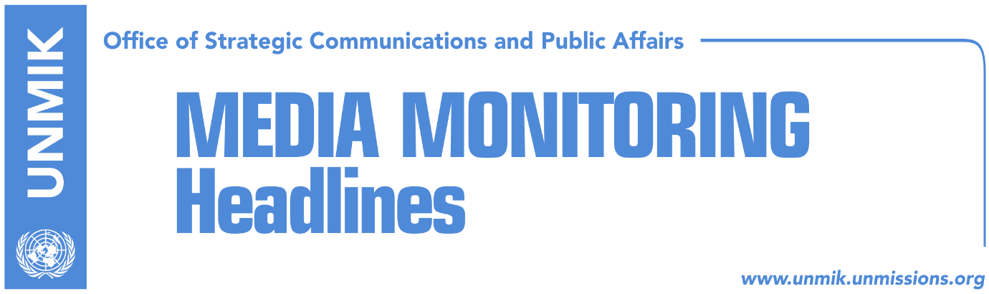

Main Stories 21 July 2018

- Veseli invites political parties to discuss dialogue (RTK)
- Thaci’s announcements on dialogue with Serbia (media)
- What awaits Pacolli today in Serbia? (Gazeta Express)
- Delawie clarifies his statement on exchange of territories (media)
- The missing and war damages at another phase of dialogue (RTK)
- Lutfi Haziri responds to Hardinaj on Presevo, calls him a coward (RTK)
- Putin and Vucic in continuous talks on Kosovo (media)

Kosovo Media Highlights

Veseli invites political parties to discuss dialogue (RTK)
The broadcaster has learned that the Assembly President Kadri Veseli, with the request of the European Union Office in Kosovo and international ambassadors, will organize a meeting with the political parties to discuss dialogue with Serbia. The meeting was called for the 23 July and it will take place in one of the Assembly halls.
The invitation stresses that Kosovo political specter, united, government and opposition, should be consolidated, united and prepared. It also notes that the Assembly of Kosovo will have the key role on supervision and decision-making of this important process.
A document published a few days ago and submitted by Veseli to the leaders of political parties, determines in detail principals, deadline, aims and objectives as well as red lines of Kosovo in the dialogue with Serbia.

Thaci’s announcements on dialogue with Serbia (media)
The President of Kosovo Hashim Thaci, said on Friday during a discussion with Prisitna University students that the dialogue between Kosovo and Serbia will result with recognition of the independence of Kosovo. However, Thaci also said that the final agreement between Kosovo and Serbia will be difficult and very painful. RTK reports that he did not want to explain why the agreement would be painful however he added that the entire political specter of Kosovo should support the process, “because Kosovo should not dare fail in this dialogue.”

What awaits Pacolli today in Serbia? (Gazeta Express)
Behgjet Pacolli, Kosovo’s Deputy Prime Minister and Minister for Foreign Affairs, has decided to respond positively to the invitation of the President of Sandjak Council, Sulejman Ugljanin, for a two-day visit, despite the fact that he has not received a permission of Serbian authorities.
Pacolli’s adviser, Jetlir Zyberaj, said that based on Brussels agreement, lack of a response on a request, means approval of a visit. Pacolli is expected to enter Serbia from Brnjak border crossing today in the afternoon and his visit will conclude on Sunday.

Delawie clarifies his statement on exchange of territories (media)
The U.S. Ambassador to Kosovo Greg Delawie rebutted the news claiming that he said exchange and division of territories is part of the political discussions in Brussels.
“Ignore the fake news. Here's what I said, “Kosovo needs to figure out what its goals are, it needs to try to achieve some kind of consensus on those goals, and that is what I am focusing on right now.” Read my interview on Rubikon KTV for yourself,” wrote Delawie on his Twitter account and attached the link to the web page of the U.S. Embassy in Kosovo, where the entire interview is published.

The missing and war damages at another phase of dialogue (RTK)
Avni Arifi, head of the Kosovo delegation at the technical dialogue between Pristina and Belgrade, said that compensation of war damages, the missing and share of former Yugoslav properties, will not be discussed in the Brussels dialogue without prior complete implementation of the so far reached agreements.
“We consider that the existing agreements have to implement, we are not aiming opening of new subjects; This process that I have found has to conclude, we have to conclude these and then political factors of Kosovo, parliamentary political parties, the government, should think, clarify what new process should they start to implement the agreements that should proceed,” Arifi said.
He added that the above mentioned issues are of interest for Kosovo and that they have to be discussed with the Serbian party, but in a future process.
Lutfi Haziri responds to Hardinaj on Presevo, calls him a coward (RTK)
During an interview on Friday, the Prime Minister of Kosovo Ramush Haradinaj called deputy leader of the democratic League of Kosovo (LDK) Lutfi Haziri, a joker, when asked about Haziri’s proposal to exchange northern Kosovo for Presevo Valley with Serbia. Haradinaj also said that Haziri is making these announcements in order to gain votes from Presevo Valley.
Haziri responded to these comments saying that the time has come to resolve the issue of Presevo Valley. “To me, it is only a political debt and historic injustice not to resolve this matter. The time has come. But unfortunately ‘the coalition of major decisions’ and cowards is leading, if this is an issue of jokers,” Haziri wrote.

Putin and Vucic in continuous talks on Kosovo (media)
Maria Zakharova, Spokesperson at the Russian Foreign Ministry told Beta news agency that Moscow is decisively engaged against dialogue with artificial deadlines between Belgrade and Pristina. “We decisively object artificial deadlines of the dialogue between Belgrade and Pristina, starting from the fact that a solution for Kosovo problem is possible only with the condition of being accepted by Serbia.”

“Russia’s position is that this process should respect the international right and that the cornerstone of resolving the Kosovo issue is Resolution 1244, according to which Kosovo is integral part of Serbia,” Zakharova said. She added that situation in Kosovo is part of the regular discussions of Russia’s President Vladimir Putin with Serbia’s President Aleksandar Vucic, as well as among the discussions of the foreign ministers of both countries.

Disclaimer
This media summary consists of selected local media articles for the information of UN personnel. The public distribution of this media summary is a courtesy service extended by UNMIK on the understanding that the choice of articles translated is exclusive, and the contents do not represent anything other than a selection of articles likely to be of interest to a United Nations readership. The inclusion of articles in this summary does not imply endorsement by UNMIK.

