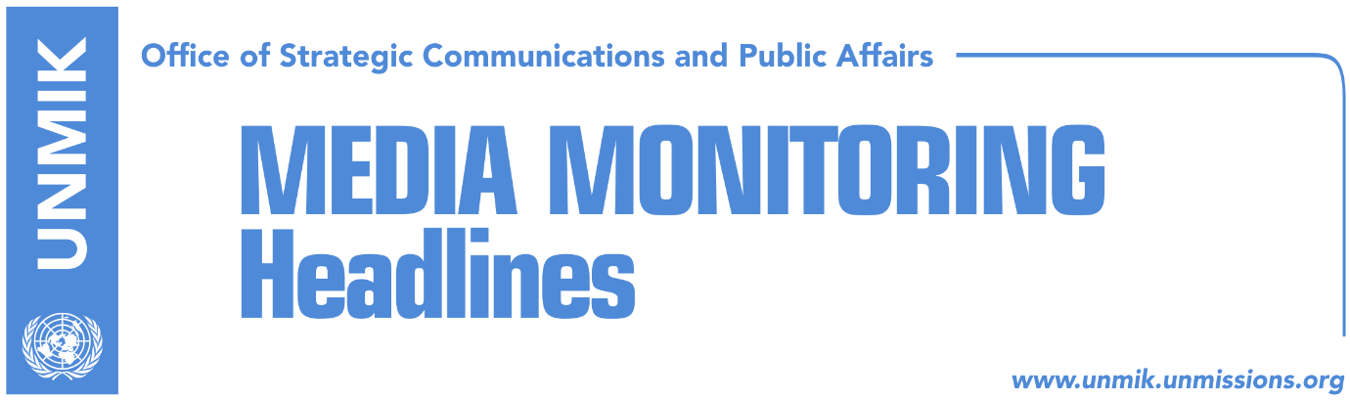

Main Stories 31 July 2018

- Thaci does not comment on territorial swap reports (media)
- In Brussels, Kosovo to seek rights for Presevo Valley not unification (Zeri)
- LDK, Vetevendosje oppose PSD’s resolution on dialogue with Serbia (media)
- Hoti: Legitimate institutions created after elections to lead dialogue (media)
- Arifi: Serbia’s actions in conflict with spirit of dialogue (RFE/Klan Kosova)
- Djuric: Kosovo’s foreign minister and KSF minister cannot enter Serbia (Zeri)
- Serbian List: We’re in the opposition, it matters not where we sit (Lajmi)
- Hahn: 2025 is not far for countries that want to join EU (Kosova Sot)
- Damka to Haradinaj: Dismiss Dedaj or lose our votes in Assembly (Telegrafi)
- A decrease in number of reported human trafficking cases (Epoka)

Kosovo Media Highlights

Thaci does not comment on territorial swap reports (media)
Speaking to reporters after laying flowers on the grave of activist Adem Demaci who died last week, President of Kosovo Hashim Thaci was asked to comment on yesterday’s reporting in Koha Ditore that exchange the northern-most municipality of Leposavic and Lesak with Presevo and part of Bujanovac is one of the options for the final agreement between Kosovo and Serbia to which he replied: “I do not comment on media opinions that have no address but what I want to note is that Kosovo institutions, political parties, citizens, civil society, media should all work to continue the process of dialogue through a broad consensus.” He said ‘fake news’ are causing confusion with the public and that Kosovo’s objective in the dialogue is recognition from Serbia and UN membership. “There can be no moving forward without stabilization of relations,” Thaci said.

In Brussels, Kosovo to seek rights for Presevo Valley not unification (Zeri)
Office of President Hashim Thaci explained that in the EU-facilitated dialogue with Serbia taking place in Brussels, Kosovo side will seek to discuss the issue of the rights of Albanians in the Presevo Valley but did not say that they will push for the Valley’s unification with Kosovo. Chief of Staff, Bekim Collaku, said Serbia is obliged to respect and promote rights of communities, Albanians in this case, in line with highest European standards. “For as long as Kosovo respects the rights of Serbia to show interest about the Serb community living in Kosovo, it is expected for Serbia to also respect the right of Kosovo to show interest for Albanians living in Presevo, Medvedja, and Bujanovac,” Collaku said. Asked whether partition of Kosovo or territorial exchange will be discussed in upcoming rounds of talks in Brussels, Collaku said “early speculations and particularly irrational ones, such as the option of partition, do not help the process” and added that he would therefore prefer not to comment.

LDK, Vetevendosje oppose PSD’s resolution on dialogue with Serbia (media)
Opposition parties, the Democratic League of Kosovo (LDK) and Vetevendosje, have come out against the draft resolution sponsored by the Social Democratic Party (PSD) on the dialogue with Serbia. Vetevendosje MP Liburn Aliu said the draft resolution refers to the dialogue as having entered the final stage which according to him implies endorsement of the past stages of the process. “I still cannot believe you wrote this text, I suspect someone else has written it for you. I ask you to withdraw it and then speak properly but not to support this damaging process and play naïve,” Aliu told PSD MPs who were all part of the same political entity until not so long ago. PSD MP Visar Ymeri said the discussion shows how important is for the Assembly to come up with a platform of talks with Serbia and not leave this to a small group of people, or President Hashim Thaci. Avdullah Hoti from the LDK said meanwhile that such resolutions as the one proposed by PSD lead nowhere.

Hoti: Legitimate institutions created after elections to lead dialogue (media)
Head of the Democratic League of Kosovo (LDK) parliamentary group, Avdullah Hoti, said that his party remains committed to a serious dialogue which would enjoy consensus and would remain within constitutional framework. In a Facebook post, Hoti said the final agreement with Serbia would have to imply full normalisation of relations which can only be achieved through mutual recognition. “The agreement should enable Kosovo immediate UN membership, and pave way for EU and NATO integration,” Hoti said. He further stated that dialogue needs to be led by Kosovo institutions that have political legitimacy. “We are ready to be active part of the dialogue but only after citizen legitimization through free vote,” he wrote.

Arifi: Serbia’s actions in conflict with spirit of dialogue (RFE/Klan Kosova)
Avni Arifi, head of Kosovo’s technical team in dialogue with Serbia, said that the recent moves by Serbian authorities in preventing sports players, artists and politicians from visiting Serbia are completely in violation of the spirit of dialogue for normalisation of relations and the agreements reached so far in the process. “What we are seeing is that the Government of Serbia for a while now has entirely or to a large degree degraded freedom of movement with many citizens of the Republic of Kosovo prevented from entering the territory of the Republic of Serbia,” Arifi said.

Djuric: Kosovo’s foreign minister and KSF minister cannot enter Serbia (Zeri)
Head of the Serbian Government’s Office for Kosovo, Marko Djuric, said Kosovo officials could visit Serbia if they abide by the agreements regulating this issue but noted that Kosovo’s foreign minister and that of the Kosovo Security Force will not be granted permission to visit. He justified this by stating that “the southern province cannot have such post,” Belgrade-based Vecernje Novosti reported.

Serbian List: We’re in the opposition, it matters not where we sit (Lajmi)
Serbian List MP, Igor Simic, said MPs of this party work as a true opposition and they are not in power. Simic criticized Kosovo media of speculating that the Serbian List is still part of the ruling coalition because of where they sit in the Assembly. He added that the irresponsibility of the media in Kosovo is constantly undermining the Serbian List. “They create a campaign against Serb political leaders in Kosovo and are also speculating if Serbian List MPs are part of the ruling coalition or the opposition,” he added.

Hahn: 2025 is not far for countries that want to join EU (Kosova Sot)
The EU Enlargement Commissioner, Johannes Hahn, said on Monday that 2025 is not far for countries that want to join the European Union and that it is crucial for these countries to implement their reforms. “If we take into account the required procedures, we must admit that this date is ambitious but possible too … The Western Balkans is surrounded by EU member states and it belongs in Europe in terms of geography, history and culture. It is in the interest of the EU to ensure stability and prosperity in the Western Balkans,” Hahn said.

Damka to Haradinaj: Dismiss Dedaj or lose our votes in Assembly (Telegrafi)
The news website reports that Kosovo’s Deputy Foreign Minister, Gjergj Dedaj, wrote in a Facebook post on Sunday that Turkey and Serbia are attempting to return to Kosovo and referred to these countries as “witches of the Balkans”. Representatives of the Turkish community in Kosovo reacted to Dedaj’s remarks, and Turkish MP Fikrim Damka called on Prime Minister Haradinaj to dismiss Dedaj. Turkish MPs said that if Haradinaj doesn’t dismiss Dedaj, the ruling coalition will no longer have the votes of 6+ parliamentary group. “We expect the Prime Minister to make the right step. If he doesn’t act on the matter, we have told him that we will reconsider our votes in the ruling coalition. We don’t think this person [Dedaj] deserves to be a deputy minister or hold any state post,” Damka said after meeting Haradinaj on Monday.

A decrease in number of reported human trafficking cases (Epoka)
On the World Day against Trafficking in Persons, in Kosovo there is an overall decrease in the number of reported cases of trafficking, thanks to the successful implementation of strategic initiatives against trafficking, awareness-raising and the capacity building of institutions and organizations involved in the fight against trafficking. According to the Ministry of Interior Affairs, in 2017 there were 16 identified victims of trafficking and 12 lawsuits whereas in 2018 there have been six victims of trafficking and five lawsuits.

Disclaimer
This media summary consists of selected local media articles for the information of UN personnel. The public distribution of this media summary is a courtesy service extended by UNMIK on the understanding that the choice of articles translated is exclusive, and the contents do not represent anything other than a selection of articles likely to be of interest to a United Nations readership. The inclusion of articles in this summary does not imply endorsement by UNMIK.

